

WCL RVP Hardware Architecture Specification

Revision 1.1

May 2025

Intel Confidential. For Internal Use Only.

Revision History

|  |  |  |
| --- | --- | --- |
| **Revision Number** | **Description** | **Date** |
| 0.4 | Initial document | December, 2023 |
| 0.5 | Updated HAS as per Landing Zone rev0.5 | February, 2024 |
| 0.7 | Updated HAS as per Landing Zone and Delta PRD request.  - Updated block diagram in Figure1 and Figure2  - Updated Table 6: Preferred Part List – Memory  - Updated Table 20: USB OC Mapping  - Updated Chapter 23 Debug and Validation Hooks  - Updated on the ISH module support  - Updated on the Chrome FPS support  - Updated LPSS I2C mapping table  - Updated WLAN modules supported, and Flash part supported in Windows and Chrome  - Update on UCIe LDO  - Update on Power map  - Update on Voltage margining  - Update on Power accumulator  - Update on PnP PMR resistor  - Updated WCL RVP TCP0 config3 module  - GBR retimer section and address details added  - Updated Chrome requirements section with new feature requirements | April, 2024 |
| 0.8 | -Updated block diagram in Figure1 and Figure2  -Updated the SPI flash topology with FET  -Updated WWAN for RVP1 topology  -Updated Audio section for Chrome SKU  -Updated the FPS section for Chrome  -Updated the GPIO numbers for WCL  -Updated Table 8 and Figure 9 in Display section  -Updated Table 20 : HSIO Mapping on WCL RVP's  -Updated Figure 16 : RVP1 WCL DDR5 SODIMM T3 RVP : HSIO Mappings  -Updated Figure 17 : RVP2 WCL LP5x Memory DownT3 RVP : HSIO Mappings  -Updated Table 21 : WCL RVP-1 & RVP-2 USB 2.0 port mapping  -Updated Figure 18 : WCL RVP1 & RVP2: USB2 Mappings  -Updated Table 22: OC Protection from the individual OC protection controllers in WCL RVP  -Updated Figure 19 : RVP1 GEN4 SOC CLKOUT / SRCCLKREQ Mappings  -Updated Figure 20 : RVP2 GEN4 SOC CLKOUT / SRCCLKREQ Mappings  -Updated Table 26 : Storage options supported on WCL  -Updated Figure 21 : RVP1 : WCL DDR5 SODIMM T3 RVP : Storage support  -Updated chapter 10.4 UFS3.1 & Figure 27 : WCL UFS AIC CONN high level block diagram  -Updated Figure 24 : NIST193 Recovery Hardware implementation block diagram  -Updated Table 5: Memory Support for various RVPs  -Updated Table 6: Preferred Part List – Memory  -Updated Figure 48: LPSS UART Block Diagram  -Updated section 28.5 for Chrome memory support  -Updated Table 72: Validation Hooks on SMP  -Updated Table 96: Memory Module Supported on Chrome RVP  -Updated Section 28.3: Chrome USB C support  -Updated Figure 77: WCL Chrome CCD support  -Updated 6.5.1.3: Gothic Bridge Retimer I2C addressing  -Updated Acronyms  -Updated Table 84: Power Sources & Priority on WCL RVP  -Updated Table 86: Processor Line Power Specifications  -Updated Table 87: Critical Voltage Rails with default regulated voltage  -Updated Figure 71&72: Power map for RVP1 and RVP2  -Updated Figure 73: WCL VAL rails Power flow diagram  -Updated Table 89: Voltage Margining support on WCL RVP  -Updated Table 90-94: Power meter mapping | September, 2024 |
| 1.0 | -Updated Platform block diagram in Figure1 and Figure2  -Section 4: Updated iPOR and Memory part number  -Added Section 8.5 USB2.0 Front Panel HDR Cable  -Updated Table 21: WCL RVP-1 & RVP-2 USB 2.0 port mapping  -Updated Figure 18: WCL RVP1 & RVP2: USB2 Mappings  -Updated Figure 20: RVP2 GEN4 SOC CLKOUT / SRCCLKREQ Mappings  -Updated Figure 21, Figure 22, Figure 29, and Figure 30.  -Updated Figure 27: WCL RVP1 UFS AIC CONN high level block diagram -Added Section 28.7 Chrome TCSS Module Support  -Updated Figure 29, Figure 30 Connectivity block diagram  -Updated Figure 44 with the SPI0 topology for RVP1 and RVP2 -Updated Table 16: PD-PMC and PD-retimer address updated  -Updated Table 71: PCH Hardware Straps Options  -Updated Figure 11: SMLINK1 is updated to USBC_SML  -Updated Figure 12: SMLINK1 is updated to USBC_SML  -Updated Figure 41: Block diagram updated | November, 2024 |
| 1.1 | -Updated Figure 1 and Figure 2: WCL RVP1 and RVP2 Block Diagram  -Updated Table 21 : WCL RVP-1 & RVP-2 USB 2.0 port mapping  -Updated Figure 18 : WCL RVP1 & RVP2 USB2 Mappings  -Updated Chapter 8.2 USB Overcurrent (OC) Protection  -Updated Table 22: OC Protection from the individual OC protection controllers in WCL RVP  -Updated Figure 20 : RVP2 GEN4 SOC CLKOUT / SRCCLKREQ Mappings  -Updated Figure 21 : RVP1 WCL DDR5 SODIMM T3 RVP Storage support  -Updated Figure 22 : RVP2 WCL LP5x Memory Down T3 RVP Storage support  -Updated chapter 10.2.3 BIOS recovery architecture  -Updated chapter 10.4 UFS3.1  -Updated Table 6: LPDDR5x Memory B-die MPN to C-die MPN  -Updated Table 8: HDMI ALS changed to default config and CRLS as rework config  -Updated Figure 9: HDMI ALS changed to default config and CRLS as rework config  -Updated Table 72: SMP mapping  -Updated Figure 19 : RVP1 GEN4 SOC CLKOUT / SRCCLKREQ Mappings  -Updated Chapter 10.4 to reflect latest UFS AIC Fab3 IPN  -Updated Figure 1 : WCL RVP1 UFS AIC CONN high level block diagram  -Updated Figure 2: LPSS I2C/I3C high level Block Diagram  -Updated Touch screen default as I2C for both ports as SPI got ZBB’ed  -Updated Audio mic privacy support block diagram  -Updated Figure 48: LPSS I2C/I3C high level Block Diagram  -Updated Figure 41: WCL RVP SMBus & SMLink support  -Updated Table 56: I2C/I3C device details  -Default path for Touch panel 1 is made as I2C and SPI got ZBB’ed | May, 2025 |

Contents

Revision History 2

Contents 5

List of Figures 10

List of Tables 13

Reference Documents/ Links 16

Document Conventions 16

Acronyms 16

1 Introduction 18

1.1 Design Team 18

1.2 RVP Design SKUs 19

2 Feature Set & HW-BOM 20

2.1 RVP Landing Zone 20

2.2 Platform HW BOM 20

2.3 Platform Validation Configuration 20

3 General Architecture 21

3.1 Platform Block Diagram 21

3.2 Wildcat Lake SoC Overview 22

3.3 WCL RVP Platform SoC/ Interface Support Overview 23

3.4 Form Factor 25

4 Main Memory 26

4.1 Memory Controller 26

4.2 Memory Device BOM options 26

4.3 Memory SPD 26

4.4 Routing Topology 27

4.4.1 Topology for DDR5 28

4.4.2 Topology for LPDDR5x MB Down 28

5 Display 30

5.1 Display Topology 30

5.1.1 WCL RVP Display Topology 30

5.1.2 OLED Panel Support 31

5.2 Display Topology from TCSS ports 31

5.3 3rd Party display re-driver support details. 31

5.4 DG Support 32

6 Type-C & Thunderbolt 33

6.1 WCL RVP TCSS port configuration details 33

6.2 Modular TCSS AIC support 35

6.2.1 List of POR TCSS Modules 37

6.3 Discrete TBT Barlow Ridge support 37

6.4 BSSB/I3C debug 37

6.4.1 I3C debug impact 37

6.5 TBT Repeaters Support 37

6.5.1 Hayden Bridge Retimer (HBR) 38

6.5.2 Retimer Flash Sharing 41

6.5.3 Legacy Display ports Support 42

6.6 PD Controller Support 42

6.6.1 On Board PD Controller 42

6.6.2 Power Delivery Add-In-Card (PD AIC) Support 42

6.6.3 SPR and EPR AIC support on WCL 43

6.6.4 PD Controller Communication 43

6.6.5 PD and Retimer Debug Support 43

6.7 Download & Execute (DnX) Support 44

6.8 Feature list supported on WCL RVPs 45

6.9 Chrome Connector Support 46

6.10 Protection Circuit 46

7 HSIO 47

7.1 WCL Platform HSIO support details 47

7.1.1 PCIe device support on WCL RVP 47

7.1.2 HSIO configurations in WCL RVP’s 47

7.2 WCL RVP: HSIO Mapping 48

8 USB2.0 50

8.1 WCL RVP: USB 2.0 Mapping 50

8.2 USB Overcurrent (OC) Protection 51

8.3 USB Signal Protection 52

8.4 USB Debug Support 52

8.5 USB2.0 Front Panel HDR Cable 52

9 Clocks 53

9.1 WCL RVP : SRC Clock and CLK REQ Mapping 54

10 Storage 55

10.1 WCL RVP: Storage support Mapping 55

10.2 M.2 Key-M Connector 56

10.2.1 Dynamic M.2 Key-M SSD sideband GPIO voltage level switching (3.3V vs 1.8V) 56

10.2.2 Power Loss Notification (PLN) Support 56

10.2.3 BIOS recovery architecture 57

10.3 SD 7.0 card over PCIe 61

10.4 UFS3.1 61

11 Connectivity 64

11.1 Connectivity Integration (CNVi) 65

11.1.1 M.2-1A Key E Connector 67

11.2 WWAN M.2 Module (Non- POR) 67

11.2.1 M.2-1A Key B Connector 70

11.3 GbE LAN 70

11.3.1 Jackson Ville Controller 71

11.3.2 Foxville Controller (Non-POR) 71

11.3.3 Connectivity (RVP/SiV) Test plan 71

12 Audio 72

12.1 ALC722 SNDW on-board CODEC 74

12.2 Audio AIC validation configurations 75

12.3 Audio Headers 75

12.3.1 JA Header[HDA/I2S header] 76

12.3.2 JD Header 77

12.3.3 JE Header 77

12.3.4 JH Header 78

12.3.5 JS Header (On-board audio codec DMIC & SPKR Header) 78

12.4 Privacy Microphone Protection Feature 79

13 Serial Interfaces- SPI, eSPI, SMBus, SM Link, MLink/CLink 82

13.1 SPI & THC SPI Ports 82

13.2 eSPI Port 83

13.3 SMBus & SMLink 84

13.4 MLink / CLink 86

14 Embedded Controller 87

14.1 MECC AIC Support 90

14.2 Flash Sharing 90

14.3 EC – I2C IO Expander 91

14.4 EC – Headers 92

14.4.1 eSPI Sideband Header 92

14.4.2 PS2 KB HEADER 92

14.4.3 Scan Matrix Keyboard Header 93

14.4.4 Keyboard Backlight Header 93

14.4.5 Fan Header 94

14.5 Front Panel Header 94

14.6 PM Sideband Header 95

15 BIOS Flash Interface (SPI) 96

15.1 EC Flash Topology 97

15.1.1 G3 Flash Sharing 97

16 Low Power Sub Systems (LPSS) 101

16.1 I2C/I3C 101

16.1.1 I2C Device Details 103

16.2 UART 104

16.3 GSPI 105

17 Integrated Sensor Hub (ISH) 106

17.1 ISH Sensors 106

17.2 Integrated Sensor Hub 107

17.2.1 ISH I2C/I3C 108

17.2.2 ISH UART 109

17.2.3 ISH SPI 109

17.2.4 ISH GPIOs 109

17.2.5 ISH Header 109

18 Touchscreen & Touchpad 111

18.1 Touchscreen 111

18.1.1 Touchscreen SPI / I2C header 111

18.1.2 Touchscreen Interrupt & Reset Mapping 112

18.2 TouchPad 113

18.2.1 Touchpad I2C Header 113

19 Security 114

19.1 SPI based TPM 114

20 PSS 115

21 GPIOs 116

21.1 RCOMPs 117

22 On board Hardware Straps 118

22.1 SOC Hardware Straps 118

22.2 CPU Hardware Straps 119

23 Debug and Validation Hooks 120

23.1 SoC Debug architecture - Introduction 120

23.2 Debug interfaces supported by SoC 121

23.2.1 SMP Mapping of Validation Hooks 121

23.3 Generic RVP debug features 122

23.3.1 Open Chassis Debug 122

23.3.2 Closed Chassis Debug 124

23.3.3 Debug features supported in RVP 127

23.4 Programming capabilities: 136

23.5 Details of debug tools 137

23.5.1 Box Stress Tool 137

23.6 SINAI to CPU sideband optimization 139

24 Power Delivery & Sequencing 141

24.1 Power Sources 142

24.1.1 Standard AC adapter 142

24.1.2 Type C Adapter 142

24.1.3 Battery Pack 142

24.2 Key Power Delivery Subsystems 143

24.2.1 Energy Management Sub-System 143

24.2.2 Rest of the Platform Power Delivery 144

24.2.3 IMVP9.3 Sub-system 144

24.2.4 UCIe LDO 145

24.3 Critical Rails and Default Voltage Levels 146

24.4 Power Map for WCL 147

24.5 Power Sequencing 149

25 Power n Performance 150

25.1 PRD from PnP for power measurements 150

25.2 Voltage margining 150

25.3 Additional Current support (for stress tests) 151

25.4 PnP PMR resistor 151

25.5 Power Accumulator 152

26 PPV (Processor/Product Platform Validation) 157

26.1 PPV support on WCL RVP 157

27 Mechanical 158

27.1 Form Factor 158

28 Chrome Requirements 159

28.1 Chrome EC support on WCL RVP 159

28.2 GSC-Servo AIC 160

28.3 Chrome USB-C support 161

28.4 Fingerprint Sensor 162

28.5 Memory Support 163

28.6 SPINOR Flash support. 164

28.7 Chrome TCSS Module support. 164

29 Regulatory & Product Ecology 166

30 RVP Health DAC 168

30.1 RVP Health DAC: A novel way to access remote hardware & accelerate debug 168

30.2 RVP DAC (Debug Acceleration Card) Goal is to enable “Remote debug and accessibility” of deployed RVP to validation customers. 168

30.3 The RVP Health DAC solution can be divided into two parts: 169

30.3.1 Hardware Interface 169

30.3.2 Software interface 170

31 UCP-SQUID 172

31.1 Low cost, Multi-Protocol and Remote programming solution 172

31.2 Solution 173

31.2.1 Hardware 174

31.2.2 Software 174

31.3 Cost of Solution 176

32 RVP NEST 177

32.1 Introduction 177

List of Figures

Figure 1 : RVP1 WCL T3 DDR5 RVP Block Diagram 21

Figure 2 : RVP2 WCL T3 LP5x RVP Block Diagram 22

Figure 3 : WCL SoC Block Diagram 23

Figure 4 : LP5x Memory Down SPD EEPROM Schematic 27

Figure 5 : SPD EEPROM level translation option 27

Figure 6 : DDR5 SODIMM Routing Topology for RVP1 28

Figure 7 : LP5x Memory Down Routing Topology for RVP2 28

Figure 8 : WCL DDR5 SODIMM RVP1 display block diagram 30

Figure 9 : WCL LP5x MD RVP2 display block diagram 31

Figure 10 : OLED PMIC AIC support 31

Figure 11 : WCL DDR5 SODIMM T3 RVP TCSS and Display high level clock diagram 34

Figure 12 : WCL T3 LP5x RVP TCSS and display high level block diagram. 35

Figure 13 : I2C addressing scheme for Hayden Bridge re-timers 39

Figure 14 : I2C addressing scheme for Gothic bridge re-timers 41

Figure 15 : PD/Retimer I2C debug headers 43

Figure 16 : RVP1 WCL DDR5 SODIMM T3 RVP HSIO Mappings 48

Figure 17 : RVP2 WCL LP5x Memory Down T3 RVP HSIO Mappings 49

Figure 18 : WCL RVP1 & RVP2 USB2 Mappings 51

Figure 19 : RVP1 GEN4 SOC CLKOUT / SRCCLKREQ Mappings 54

Figure 20 : RVP2 GEN4 SOC CLKOUT / SRCCLKREQ Mappings 54

Figure 21 : RVP1 WCL DDR5 SODIMM T3 RVP Storage support 55

Figure 22 : RVP2 WCL LP5x Memory Down T3 RVP Storage support 56

Figure 23 : Power Loss Notification circuit implementation 57

Figure 24 : NIST193 Recovery Hardware implementation block diagram 59

Figure 25 : MAF Recommended Platform Flow 60

Figure 26 : SAF/G3 Mode recommended Platform Flow 61

Figure 27 : WCL RVP1 UFS AIC CONN high level block diagram 62

Figure 28 : WCL RVP2 UFS AIC CONN high level block diagram 63

Figure 29 : RVP1 WCL DDR5 SODIMM T3 RVP Connectivity Block Diagram 65

Figure 30 : RVP2 WCL LP5x Memory down T3 RVP Connectivity Block Diagram 65

Figure 31 : WCL RVP M.2 Key E WLAN implementation high level block diagram 66

Figure 32 : New M.2-1A design 67

Figure 33 : WCL RVP1 M.2 Key-B WWAN implementation high level block diagram 68

Figure 34 : New M.2-1A design 70

Figure 35: WCL RVP Audio high level block diagram 73

Figure 36: WCL RVP Audio ALC722 on-board configuration 74

Figure 37: Privacy microphone protection conceptual diagram 80

Figure 38: WCL RVP audio MIC privacy support block diagram 81

Figure 39: WCL RVP SPI & THC SPI Interface support 83

Figure 40: WCL RVP eSPI Interface support 84

Figure 41: WCL RVP SMBus & SMLink support 85

Figure 42: Embedded Controller Block Diagram 87

Figure 43: EC- I2C Block Diagram 91

Figure 44: BIOS Flash interface (SOC-SPI0) for RVP1 and RVP2 97

Figure 45 : G3 Flash Sharing high level block diagram 98

Figure 46 : MAF high level block diagram 99

Figure 47 : SAF high level block diagram 100

Figure 48: LPSS I2C/I3C high level Block Diagram 103

Figure 49: LPSS UART Block Diagram 105

Figure 50: LPSS GSPI High level Block Diagram 105

Figure 51: ISH Sensor Header high level block diagram 108

Figure 52 : Touch Panel high level block diagram 111

Figure 53: Touchpad high level block diagram 113

Figure 54: PSS Circuit high level block diagram 115

Figure 55: WCL Architectural overview 120

Figure 56: MIPI60 Debug Port (Samtec QSH-030-01 series) 122

Figure 57: WCL RVP VISA connections 123

Figure 58: Illustrates the most basic connection between DTS and TS using just a USB Debug cable 125

Figure 59: 2W DCI OOB Connection 126

Figure 60: “Debug for I3C” Connection 126

Figure 61: Extending 2W DCI.OOB and Debug for I3C with USB DbC 127

Figure 62: Charging the TS while Debugging using 2W DCI OOB or Debug for I3C 127

Figure 63: Current Sense Implementation 129

Figure 64: Port80 Functional Diagram 133

Figure 65: Serial debug console high level block diagram 134

Figure 66: Nevo to BST Adapter 138

Figure 67: Nevo Extension Cable 138

Figure 68: SINAI to CPU sideband optimization schematic in WCL 140

Figure 69: WCL High Level SoC Power Scheme 141

Figure 70: WCL RVP2 Jumper Solution to Set Type C as Higher Priority 143

Figure 71: Connection of UCIe MBVR LDO. 145

Figure 72: WCL RVP1 Power flow diagram. 147

Figure 73: WCL RVP2 Power flow diagram. 148

Figure 74: WCL VAL rails Power flow diagram. 149

Figure 75: WCL RVP Form factor details 158

Figure 76 : Chrome support High Level block diagram with MECC AIC based Chrome EC 160

Figure 77 : Chrome EC I2C mapping block diagram for TCSS support. 161

Figure 78 : WCL Chrome CCD support. 162

Figure 79: WCL Chrome FPS support 163

Figure 80 : WCL SPINOR #WP control implementation. 164

Figure 81 : Strategy for debug acceleration card 168

Figure 82 : RVP DAC Block Diagram 169

Figure 83 : Snapshot of RVP DAC with Cable 169

Figure 84 : Debug acceleration graphical user interface and features 170

Figure 85 : RVP Eco System: UCP SQUID 173

Figure 86 : UCP-Solution 173

Figure 87 : UCP-Block diagram 174

Figure 88 : UCP-Kit item 174

Figure 89 : UCP-SW flow 175

Figure 90 : UCP-GUI 175

Figure 91 : SNAPSHOT OF UCP SQUID SETUP 176

Figure 92 : RVP NEST Connection diagram 177

List of Tables

Table 1 : Key Contacts for WCL RVP design 18

Table 2 : WCL RVP Design SKUs 19

Table 3 : WCL RVP Supported CPU TDP Characteristics 23

Table 4: WCL SoC/ RVP platform interface support summary 24

Table 5 : Memory Support for various RVPs 26

Table 6: Preferred Part List - Memory 26

Table 7: Memory SPD info 27

Table 8 : WCL RVP’s eDP/ DDI port display configuration 30

Table 9 : Display 3rd party devices support list 32

Table 10 : WCL RVP’s TCSS Type-C and display port configuration 33

Table 11 : Modular TCSS AICs support on WCL RVP SKUs 36

Table 12 : POR TCSS modules on WCL RVPs 37

Table 13 : Hayden Bridge I2C addressing 39

Table 14 : EC to PD Address based on A2D Pin for Gothic Bridge 40

Table 15 : PD to PMC and PD to Gothic Retimer Address 41

Table 16 : Correct incremental order for USB2.0 and TCP port mapping 44

Table 17 : Incorrect incremental order for USB2.0 and TCP port mapping 44

Table 18 : Various Type-C port Features in WCL RVPs 45

Table 19 : HSIO support on WCL Platform 47

Table 20 : HSIO Mapping on WCL RVP's 48

Table 21 : WCL RVP-1 & RVP-2 USB 2.0 port mapping 50

Table 22: OC Protection from the individual OC protection controllers in WCL RVP 51

Table 23: USB Debug Support on WCL RVP 52

Table 24 : Clock Inputs on WCL 53

Table 25 : Output signals from Clock function on WCL 53

Table 26 : Storage options supported on WCL 55

Table 27 : SPI Descriptor Recovery Strap details 58

Table 28: Connectivity Support on WCL RVP boards 64

Table 29: Interface Details for WLAN Module 66

Table 30: Interface Details for Maple Spring 69

Table 31: LED Indicator description for WWAN 69

Table 32: LED definition for RJ45 Connector 70

Table 33: WCL RVP Audio interface landing zone details 72

Table 34: WCL RVP Audio Windows/Linux build validation configuration table 75

Table 35: WCL RVP Audio CHROME SoC pin configuration 75

Table 36: WCL Audio pin muxing 76

Table 37: Audio Header (JA) Connection 77

Table 38: Audio Header (JD) Pinout 77

Table 39: Audio Header (JE) Pinout 78

Table 40: Audio Header (JH) Pinout 78

Table 41: Audio Header (JS) Pinout 79

Table 42: Privacy microphone protection signal description 80

Table 43: WCL RVP MIC privacy feature SoC signal description 81

Table 44: WCL MIC Mute Operation using DIP Switch 81

Table 45: CLink Interface Signals 86

Table 46: EC error code indication 89

Table 47: MECC Connector 90

Table 48: eSPI Sideband Header and Pinout 92

Table 49: PS2 KB and Pinout 92

Table 50: Scan Matrix Header and Pinout 93

Table 51: KB Backlight Header and Pinout 93

Table 52: Fan Header and Pinout 94

Table 53: Front Panel Header and Pinout 94

Table 54: PM Sideband Header 95

Table 55: I2C/I3C device mapping 102

Table 56: I2C/I3C device details 103

Table 57: UART Device details 104

Table 58: List of Sensors on WCL RVP 106

Table 59: ISH I2C device mapping 108

Table 60: ISH UART device mapping 109

Table 61: ISH SPI device mapping 109

Table 62: ISH Header Connector Pinout 110

Table 63: Touch Screen Header Pin-Out Details 111

Table 64: Pin map for Reset & Interrupt for Integrated Touch Panel 112

Table 65: 1x12 Header Pinout for Touchpad Interface 113

Table 66: Pinout Details for SPI based TPM 114

Table 67: PSS Properties on WCL RVP 115

Table 68: GPIO Power group mapping 116

Table 69: RCOMP Resistor Values 117

Table 70: PCH Hardware Strap Options 118

Table 71 : SOC VISA MIPI60 Connector 121

Table 72 : Validation Hooks on SMP 121

Table 73: SoC VISA MIPI60 Connector Pinout 123

Table 74: Table depicting different debug interface supported in WCL 127

Table 75: SINAI2 Connector pinout 130

Table 76: INTEC Connector PN 132

Table 77: Platform Design Recommendations for InTEC signals 132

Table 78: SAS Header and Pinout 133

Table 79: Micro USB connector and Pinout 134

Table 80: RVP LEDs & Function 135

Table 81: WCL RVPs support following press buttons on board 135

Table 82: Table depicting different debug features supported in WCL 136

Table 83: List of Probes, Associated Cable and Adapter 137

Table 84: Power Sources & Priority on WCL RVP 143

Table 85: Processor Line Vs. Phase Count 144

Table 86: Processor Line Power Specifications 144

Table 87: Critical Voltage Rails with default regulated voltage 146

Table 88: Typical Voltage rail for different Memory technologies 146

Table 89: Voltage Margining support on WCL RVP 150

Table 90: DDR5 Energy telemetry mapping 152

Table 91: DDR5 PnP/SYSTEM METER mapping 153

Table 92: LP5x Energy telemetry mapping 154

Table 93: LP5x PnP/SYSTEM METER mapping 155

Table 94: LP5x Chrome/SYSTEM METER mapping 156

Table 95: TTK3 & H1 Connector 161

Table 96: Memory Module Supported on Chrome RVP 163

Table 97 : WCL CHROME RVP’s TCSS Type-C and display port configuration 165

## Reference Documents/ Links

1. WCL RVP PDT SharePoint [link](https://intel-my.sharepoint.com/personal/ccg_cpe_cps_wclsystempdt?e=1%3A4112fffcda9a48aca5872f61b4402c9a)
2. WCL Platform Architecture  [link](https://docs.intel.com/documents/ClientPlatform/PAS/Wildcat_lake/wildcat_platform_arch_spec.html)
3. WCL Platform SAS documents [link](https://docs.intel.com/documents/Clientplatform/PTL/Software/SWAS/PTL%20SW%20SAS_v0.html)
4. WCL Platform CCB [link](https://hsdes.intel.com/appstore/community/#/query?queryId=16022028235)

## Document Conventions

The terms WCL, processor and SoC are used interchangeably in the document.

Small letter ‘b’ stands for bits, e.g. Mbps stands for Megabits per second. Capital letter ‘B’ stands for Bytes, e.g. MB stands for Megabytes.

All binary numbers will have a suffix ‘b’ at the end of the number, e.g. 00110b. Hexadecimal numbers will be mentioned with a prefix ‘0x’, e.g. 0x11FD. Decimal numbers will not have any suffix or prefix.

Capital letter ‘HDR’ stands for Header in the figures.

Items mentioned as **TBD** are open and yet to be closed from the design perspective.

## Acronyms

|  |  |
| --- | --- |
| **Acronym** | **Description** |
| WCL | Wildcat Lake |
| MTL | Meteor Lake |
| ARL | Arrow Lake |
| ADL | Alder Lake |
| AIC | Add-In Card |
| ALS | Active Level Shifter |
| BOM | Bill of Material |
| BP | Back Panel |
| BSSB | Boundary Scan Sideband |
| CC | Configuration channel |
| CRLS | Cost Reduced Level Shifter |
| DCI-OOB | Direct Connect Interface Out of Band |
| DDR | Double Data Rate |
| DnX | Download and execute |
| DP | Display port |
| DPC | DIMMs Per Channel |
| EC | Embedded controller |
| FP | Front Panel |
| GBR | Gothic Bridge |
| GND | Ground return |
| HDMI | High-Definition Multimedia Interface |
| I3C | Improved Inter Integrated Circuit also known as Sense Wire |
| IIC or I2C | Inter-Integrated Circuit |
| KoZ | Keep-out Zone |
| LSPCON | Level Shifter Protocol Converter |
| NOA | Node Observation Architecture |
| PCH | Platform Controller Hub |
| PD | Power Delivery |
| PD | Power Down |
| POR | Plan of record |
| PSS | Processor Secured Storage |
| RVP | Reference Validation Platform |
| SBU | Sideband use |
| SKU | Stock Keeping Unit |
| SML/SMB | System management link/Bus |
| SODIMM | Single Outline Dual Inline Memory Module |
| SPI | Serial Peripheral Interface |
| TBT | Thunderbolt |
| TCPC | Type-C port controller |
| TCPs | Type-C ports |
| TCSS | Type-C sub system |
| THC | Touch Host Controller |
| UFP / DFP | Upstream/Downstream Facing Port |
| USB | Universal Serial Bus |
| VBUS | Bus power |
| VISA | Visualization of Internal Signals Architecture |
| WIP | Work In Progress |
| XDP | eXtended Debug Port |

# Introduction

The scope of this document is to cover the overall functional architecture for the WCL RVPs including the debug and validation hooks. The document would describe the architecture and feature set of WCL RVP’s and the design in detail.

## Design Team

The key contacts for WCL RVP are given in Table 1 below.

Table 1 : Key Contacts for WCL RVP design

|  |  |
| --- | --- |
| Role | Point of Contact |
| RVP Program Manager, Systems PDT, Boards & Kits | Sundarabhattar, Sinkaravelan |
| RVP Engineering Manager | Liew, Jia Lin |
| RVP Architect | Sharma, Deepak  Parameswaran, Pharveen  Tan, Adrian (PD Architect) |
| RVP Design Lead | Zakaria, Anas |
| RVP Design Engineers | Ch, Manjunath  Jadhav, Aniket  K S, Vachana  Li, Kok Wai Ryan  Lim, Kok Leng |
| RVP Power Delivery Lead | Au, Chun Ming |
| RVP PCB Layout Lead | Lee, Poh Ling (RVP1) Selvaraj, Balaji (RVP2) |
| Mechanical Team | Kaja, Ajmeer |
| Validation Lead & CSF | R, Hemananth |

## RVP Design SKUs

The WCL will have the SKUs as listed in Table 2. All the boards will have same implementation from PI / PnP perspective. All RVP boards will have PnP HDR place holders; however, only PnP BOM SKU RVPs will be stuffed with 2x7 HDRs.

There would be other design options provided on each board which are explained in the respective interface functional specification section of the document.

Table 2 : WCL RVP Design SKUs

|  |  |  |  |
| --- | --- | --- | --- |
| RVP SKU | SKW | SKU Description | Remarks |
| **RVP1** | | | |
| RVP1a | U-01 | WCL DDR5 SODIMM T3 RVP | iPOR= 7200Mbps |
| RVP1c – BOM SKU | U-03 | WCL DDR5 SODIMM PnP SKU |  |
| RVP1d – BOM SKU | U-11 | WCL DDR5 SODIMM Chrome SKU |  |
| **RVP2** | | | |
| RVP2a | U-04 | WCL LP5x MD, x32, T3 RVP | Volume runner, iPOR = 8000Mbps |
| RVP2b – BOM SKU | U-05 | WCL LP5x SKT SKU | Deployment for EV, for different memory validation |
| RVP2c – BOM SKU | U-06 | WCL LP5x MD Chrome SKU |  |
| RVP2d – BOM SKU | U-07 | WCL LP5x SKT Chrome SKU |  |
| RVP2e – BOM SKU | U-08 | WCL LP5x MD HSIO SKU | No separate HSIO RVP, requirement covered through BOM stuffing option |
| RVP2f – BOM SKU | U-09 | WCL LP5x MD PnP SKU |  |
| RVP2g – BOM SKU | U-10 | WCL LP5x MD MECC SKU | MECC AIC BOM Changes Intercepted |
| RVP2h – BOM SKU | U-02 | WCL LP5x MD PPV SKU |  |

# Feature Set & HW-BOM

## RVP Landing Zone

RVP Landing Zone can be viewed in SharePoint site for the WCL RVP [here](https://intel.sharepoint.com/:f:/r/sites/ccg_cpe_cps_wclsystempdt/Shared%20Documents/RVP%20Engineering%20Docs/RVP%20Landing%20zone?csf=1&web=1&e=N5rvrQ)

## Platform HW BOM

The platform HW BOM is being defined at this point and will be provided at the below HSD-ES links.

[WCL Platform HW BOM](https://hsdes.intel.com/appstore/carbon/bom/parts-matrix/22016130479?selectedIDs=22016136670)

## Platform Validation Configuration

The platform validation configurations can be found in the below link.

WCL Validation configuration [link](https://intel.sharepoint.com/sites/WildcatLakePlatform/Shared%20Documents/Forms/AllItems.aspx?csf=1&web=1&e=6DrbUq&cid=32c5a99e%2D697e%2D44b7%2D9c39%2De828c841205d&FolderCTID=0x01200023CD6BD15EFBE947B48F672AD66277C4&id=%2Fsites%2FWildcatLakePlatform%2FShared%20Documents%2FSIV%5Fval%20configuration)

# General Architecture

## Platform Block Diagram

The functional block diagram of the system with all the interface routing and connectivity options are presented in Figure 3 and Figure 4. All the major interface options are mentioned in the figure. The validation hooks are not illustrated in the figure but will be covered in the design. The details of the validation hooks provided are covered in the respective sections.



Figure 3 : RVP1 WCL T3 DDR5 RVP Block Diagram



Figure 4 : RVP2 WCL T3 LP5x RVP Block Diagram

## Wildcat Lake SoC Overview

WCL is a 2-die architecture, Compute Die (CDIE) and PCD die. PCD stands for Peripheral Controller Die and it contains all the traditional client IPs. WCL is first client platform to use UCIe to connect PCD to Cdie.

WCL’s core architecture includes: PCore: Cougar, ECore: Darkmont, GFX XE3 Architecture and NPU architecture.

For more details, please refer [WCL SoC Overview HAS](https://docs.intel.com/documents/ClientSilicon/WCL/Overview/WCL_Overview.html) and [WCL Product Specification HAS](https://docs.intel.com/documents/ClientSilicon/WCL/Overview/WCL_Product_Spec.html).

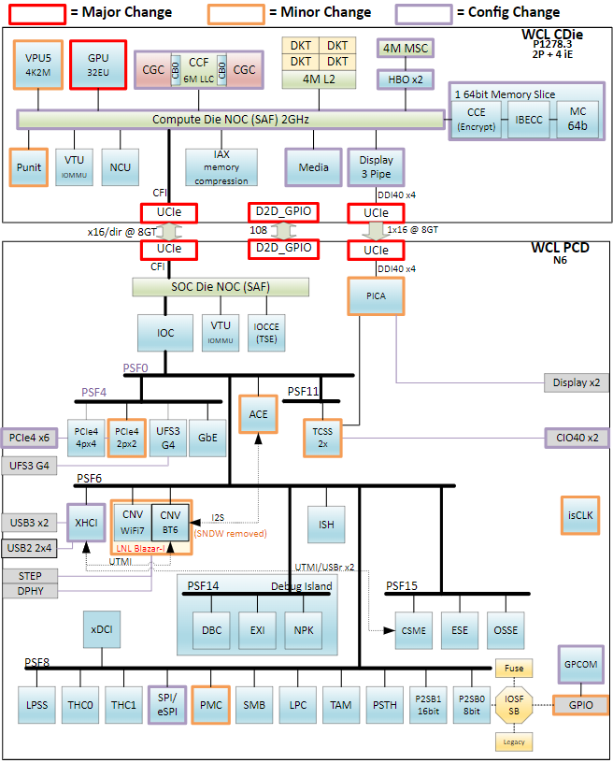

Figure 5 : WCL SoC Block Diagram

## WCL RVP Platform SoC/ Interface Support Overview

WCL RVP supports WCL socketed down on the board. All the CPUs will be supported by WCL RVP design.

Table 3 : WCL RVP Supported CPU TDP Characteristics

|  |  |  |
| --- | --- | --- |
| Die Package | Product | TDP |
| WCL | 2+4 | 15W |
| WCL | 1+4 | 15W |
| WCL | 0+4 | 15W |

The major platform interface supported on the WCL RVP apart from debug, sideband and GPIO are listed below.

Table 4: WCL SoC/ RVP platform interface support summary

|  |  |
| --- | --- |
| **Interface** | **WCL RVP’s** |
| Memory | DDR5/LP5x |
| eDP/ DDI | 1x4 eDP1.5b (HBR3) |
| HDMI | 1x HDMI2.1b (6Gbps TMDS) |
| Concurrent Dual eDP Display | N/A |
| USB Type C | 2 ports CIO40: USB4.0 + TBT4 + DP 2.1 (HBR3) |
| PCIe | X6 Gen4 (2 root port) |
| GbE (Muxed PCIe) | 1x 1GbE Port (muxed with PCIe Gen4 port) |
| USB3.2 Gen2x1 10G | 2 ports |
| UFS | 1x2 UFS 3.1 Gear 4 |
| USB2 | 8 ports USB 2.0 |
| CNV (WiFi / BT) | Blazar-I WiFi7R2, BT6.x |
| SPI Interface | 1 CSME SPI 2 THC SPI |
| Audio | 1 HD-A  3 I2S  4 SoundWire 2 DMIC Interfaces |
| eSPI | eSPI with 2 chip select signals |
| LPSS | 6 I2C Ports  2 I3C 2 GSPI/THC Ports 3 UART Ports |
| ISH | 3 I2C Ports 1 SPI Bus 2 UART Ports 12 GPIOs |
| Thermal DIODE | PCH Thermal Diode |
| MLINK | 1 Channel with CLK, DATA & RST |
| Integrated Clock Controller (ICC) | 6 SRC Clocks 6 SRC Clock Req |
| SMBUS / SMLINK | 2 SMLINK 1 SMBUS |

## 

## Form Factor

The WCL RVP will follow a 7.35inch x 11.1inch form factor with 12 Layer PCB. Please refer to the Mechanical chapter for more details.

Generic Implementation Notes

* GND vias are spread across the board on both top and bottom sides, with clear marking on silk screen will be provided.
* All the socket caps will be specified in the schematics and can be removed in the customer version of the schematics or board.
* RVP design will follow the PDG for routing of all traces.
* All the LED will be placed on the TOP side and will be visible.

Note: Text highlighted in yellow color will be updated in subsequent versions of this RVP HAS document

# Main Memory

## Memory Controller

The WCL memory subsystem supports DDR5/LPDDR5/LPDDR5x memory technologies. RVP SKU memory configuration support would be as follows.

Table 5 : Memory Support for various RVPs

|  |  |  |  |  |  |  |  |  |
| --- | --- | --- | --- | --- | --- | --- | --- | --- |
| **RVP SKU #** | **Config** | **Internal POR**  **Transfer Rate (MT/s)** | **External**  **POR**  **Transfer Rate (MT/s)** | **Memory Device** | **Routing Topology** | **Supported System Memory** | | **PCB Stack-Up / Routing Layer** |
| **Min** | **Max** |
| RVP1 T3 | DDR5 SODIMM | 2R 7200 | 2R 6400 | SODIMM | Point to Point | 8GB | 64GB | T3/6L  2 Layers |
| RVP2 T3 | LPDDR5/x  Memory Down  2x32 | 2R 8000 | 2R 6800 | 315 BGA | Point to Point | 4GB | 48GB | T3/6L  2 Layers |

## Memory Device BOM options

The following tables provide the Manufacturer Part number supported on WCL. The below table is based on initial HAS release. Contact MIO Team for the latest memory parts validated on the platform.

Refer to Platform BOM HSD Link for more details.

Table 6: Preferred Part List - Memory

|  |  |  |  |  |  |  |
| --- | --- | --- | --- | --- | --- | --- |
| **Memory Type** | **Package** | **Manufacturer Part Number**  **(Intel Part Number)** | **Speed**  **(MT/s)** | **Module/**  **DRAM density** | **Memory Config** | **Mfg** |
| DDR5 SODIMM | SODIMM | MTC8C1084S1VC64BD1 | 6400 | 16GB | 1R x8 | Micron |
| LPDDR5x | DDP 315b | ​H58G66CK8BX147 | 8500 | 8GB | 2R x16 | SK Hynix |

## Memory SPD

Memory SPD (Serial presence detect) is a standardized way to automatically access information about a [memory module](https://en.wikipedia.org/wiki/Memory_module) or device. Refer Link of SPD Repository [SPD_Files - BIOS Group BKMs - Intel Enterprise Wiki](https://intelpedia.intel.com/SPD_Files).

Table 7: Memory SPD info

|  |  |  |
| --- | --- | --- |
| **RVP SKU #** | **Config** | **SPD** |
| RVP1 T3 | DDR5 SODIMM 1DPC | On the module |
| RVP2 T3 | LPDDR5x Memory Down | BIOS Hard Coded/ SPD EEPROM ON RVP |

Example Schematics Snapshot for SPD EEPROM;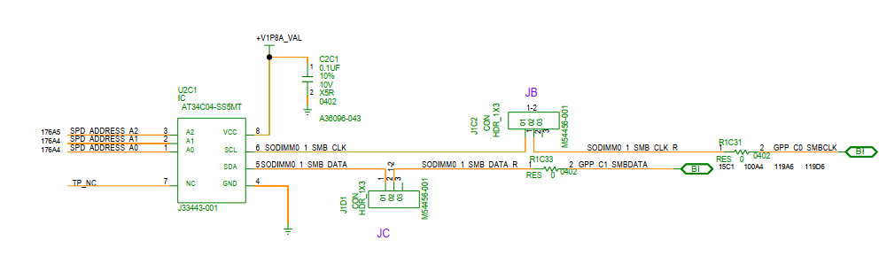

Figure 6 : LP5x Memory Down SPD EEPROM Schematic

Scheme for voltage level translation for SPD EEPROM.



Figure 7 : SPD EEPROM level translation option

SPD present signal will be given on DIP switch instead on jumper for customer’s convenience. The Level translator is optionally given in case VIL issue observed with SMBUS when interfacing with SPD EEPROM.

## Routing Topology

This section deals with the routing topology to be adopted for DRAM routing on WCL RVP boards.

### Topology for DDR5

DDR5 SODIMM routing on WCL will be point-to-point routing for all the DDR5 signals.



Figure 8 : DDR5 SODIMM Routing Topology for RVP1

**Bit/Byte Swapping Rule:**

* Bit swapping is allowed within each Byte for all memory technologies.
* DDR5: Byte Swapping is allowed within each x32 channel.
* ECC bits swap is allowed within ECC byte / nibble: DDR5 ECC[3..0]..

### Topology for LPDDR5x MB Down

The Address & command signals are routed with point-to-point topology with Data and Strobe signals in LP5x topology. This x32 device is common for T3 and T4 RVPs, illustrated in the figures below.



Figure 9 : LP5x Memory Down Routing Topology for RVP2

**Bit/Byte Swapping Rule:**

* Bit swapping is allowed within each Byte for all memory technologies.
* Byte swapping is allowed within a 16-bit channel.
* LPDDR5: x16 sub-channels can be swizzled within their x64 MC.
* When swapping channel DQ, the CA/CS signals must be swapped as well.

# Display

There are 2 types of Display PHYs on WCL which are C10 PHY and C20 PHY. C10 PHY support 2 display ports in WCL which are DDIA with eDP 1.5/HDMI 2.1b 6G TMDS and another dedicated DDIB port with HDMI2.1b 6G TMDS only whereas the C20 PHY support TCSS display with DP-Alt mode. WCL only supports 3 pipes display with a maximum 4Kp60 HDR output for both internal and external.

## Display Topology

There are two DDI ports on the CPU.

### WCL RVP Display Topology

Refer to below table and block diagrams for WCL RVP’s eDP/DDI display port configuration.

Table 8 : WCL RVP’s eDP/ DDI port display configuration

|  |  |  |
| --- | --- | --- |
| **Silicon Interface** | **RVP1: WCL DDR5 SODIMM RVP** | **RVP2: WCL LP5x MD RVP** |
| DDIA (Default) | eDP 1.5 Panel Conn | eDP 1.5 Panel Conn |
| DDIA (Rework) | HDMI 2.1b 6G TMDS compatible connector with ALS  (Non-POR, for NEX Only) | NA |
| DDIB (Default) | HDMI 2.1b 6G TMDS compatible connector with ALS | HDMI 2.1b 6G TMDS compatible connector with ALS |
| DDIB (Rework) | NA | HDMI 2.1b 6G with CRLS |



Figure 10 : WCL DDR5 SODIMM RVP1 display block diagram

Note: The DDIA rework option is only applicable for NEX team validation. All SW/ FW/ Validation/ Enablement activity to be owned by NEX.



Figure 11 : WCL LP5x MD RVP2 display block diagram

### OLED Panel Support

OLED panels are supported using OLED PMIC AIC to provide the required power changes. A cable from eDP 60-pin connector on RVP to be connected to OLED PMIC AIC. The output from that AIC will be connected to the OLED panel using another eDP 60-pin cable.



Figure 12 : OLED PMIC AIC support

## Display Topology from TCSS ports

Type-C PHY on WCL supports TBT displays but doesn’t support eDP muxing and native HDMI/DP. Type-C PHY can be used for DP alternate mode on a physical Type-C port but can’t be used as a dedicated DP or HDMI port with a DP or HDMI native connector. Refer to Type-C & Thunderbolt section for more details on the same.

Please refer to the Type-C section for the TCSS port mapping and block diagram for the various display topologies supported from TCSS ports.

## 3rd Party display re-driver support details.

Below table shows the 3rd party display re-driver device support list in WCL RVP’s.

Table 9 : Display 3rd party devices support list

|  |  |  |
| --- | --- | --- |
| **Device Name** | **MPN** | **IPN** |
| HDMI 2.1 Redriver (6G) | PI3HDX1204CZHEX | M47631-001 |
| TCSS Module - Analogix PPC and Redriver Integrated | ANX7495FN-AA-R | N44928-001 |
| TCSS Module - Texas Instrument (TI) – Redriver. | TUSB1044IRNQT | K67220-001 |

## DG Support

WCL RVP will **NOT** be supporting any third-party graphics card and DG MRB AIC.

# Type-C & Thunderbolt

WCL supports integrated Type-C ports, supporting DP2.1 (HBR3), USB3.2, TBT3, TBT4 and USB4 protocols. The following figure shows functional block diagram of the Type-C ports on the WCL SoC. The block diagram is a super set implementation of RVP SKUs.

## WCL RVP TCSS port configuration details

Refer to below table and block diagrams for the WCL RVP’s TCSS Type-C and display port configuration.

Table 10 : WCL RVP’s TCSS Type-C and display port configuration

|  |  |  |  |
| --- | --- | --- | --- |
| **Silicon Interface** | **Platform config requirement**  **(all inputs)** | **RVP1: WCL - T3 PCB - DDR5 SODIMM** | **RVP2: WCL - T3 PCB - LP5x MD** |
| TCP0 MB Short length | Type C USB4.0 / Thunderbolt Support Options- 1. TBT4 40G w/ single re-timer 2. USB4 20Gbps with single re-timer 3. USB4 20Gbps re-timer less (includes USB3/DP) 4. USB3/DP(HBR3) retimerless 5. TBT4 40G w/ Dual re-timer 6. TBT4 40G w/ cable topology 7. Discrete Barlow Ridge - Native DP2.1 UHBR20 retimerless FFC. 8. TypeC Port - USB/DP- 3rd Party 9. Type-A Con USB 3.2 Gen2 x1 10G without Redriver (form TCSS) | **Config 1:** M.2 Modular TCSS: USB-C Retimer Module.(Gothic Bridge Retimer) | **Config 1:** M.2 Modular TCSS: Third Party, Type C port - USB3/DP2.1 (HBR3) - Retimerless |
| **Config 2:** M.2 Modular TCSS: Type-A Con USB 3.2 Gen2 x1 10G without Redriver | **Config 2:** M.2 Modular TCSS - TBT 40G Single Re-Timer. (Single Retimer HBR ) |
| **Config 3**: M.2 Modular TCSS - TBT 40G Single Re-Timer. (Single Retimer HBR) | **Config 3:** M.2 Modular TCSS: TBT 40G Single Re-Timer. (Gothic Bridge Retimer) |
| TCP1 MB Long Length | **Motherboard Down** Type C port - TBT 40G Single Re-Timer. (Single Retimer GBR Motherboard down) | **Config 1:** M.2 Modular TCSS: Third Party Redriver - USB3/DP 2.1 (HBR3)(Third party - Texas instrument and Analogix) |
| **Config 2:** M.2 Modular TCSS - TBT 40G Single Re-Timer.(Single Retimer HBR) |
| **Config 3:** M.2 Modular TCSS: TBT 40G Single Re-Timer.(Gothic Bridge Retimer) |



Figure 13 : WCL DDR5 SODIMM T3 RVP TCSS and Display high level clock diagram



Figure 14 : WCL T3 LP5x RVP TCSS and display high level block diagram.

Note:

1. The port assignment & configuration may be changed as per layout feasibility.
2. The TCSS support only SPR on WCL, there is no EPR supported.
3. There will be no flash sharing supported between TCSS ports.
4. No PD AIC supported in WCL in both RVP SKUs.

## Modular TCSS AIC support

Type-C IO components are generally placed on the motherboard. For each variety of IO requirements based on the SKU, separate efforts in terms of electrical, mechanical and development and validation efforts are needed. RVP supporting these configuration needs to support nearly 20+ configuration as Type-C validation topologies. This results in multiple RVP construction and reworks for each configuration.

Modular approach tends to reduce these efforts significantly and reduce the number of RVP configurations needed. Modular TCSS AICs have been developed to validate different configurations of ports (Type-C / HDMI / DP / USB3 (Type A) / eDP) without the need for building dedicated RVPs to support these configs, thereby, reducing the number of RVPs required and save on integration and validation cost. One RVP can support all Type-C validation. Modular TCSS AIC is a new feature being intercepted from PTL and carry forwarded on WCL platforms.

To enable modularity on RVP, the TBT /USB4 lanes from the SoC needs to be used as the data link for the different IO port requirements (TBT / USB-C / Type-A / DP / HDMI). The IO ports can be incorporated into a separate module which come in a specific formfactor (such as 30x30 mm here). With different modules, the system feature set can be varied according to the segment requirements. Based on IO requirements, different modules can be ordered and validated.

On WCL RVP, following table lists down the POR modules for different WCL RVP SKUs.

Table 11 : Modular TCSS AICs support on WCL RVP SKUs

|  |  |  |
| --- | --- | --- |
| **TCP Ports** | **RVP SKUs** | |
| **RVP1: WCL - T3 PCB - DDR5 SODIMM** | **RVP2: WCL - T3 PCB - LP5x MD** |
| TCP0 | **Config 1:** M.2 Modular TCSS: USB-C Retimer Module.(Gothic Bridge Retimer) | **Config 1:** M.2 Modular TCSS: Third Party, Type C port - USB3/DP2.1 (HBR3) - Retimerless |
| **Config 2**: M.2 Modular TCSS: Type-A Con USB 3.2 Gen2 x1 10G w/o Redriver | **Config 2**: M.2 Modular TCSS - TBT 40G Single Re-Timer.  (Single Retimer HBR) |
| **Config 3**: M.2 Modular TCSS - TBT 40G Single Re-Timer. (Single Retimer HBR) | **Config 3:** M.2 Modular TCSS: TBT 40G Single Re-Timer. (Gothic Bridge Retimer) |
| TCP1 | **Motherboard Down** Type C port - TBT 40G Single Re-Timer. (Single Retimer GBR Motherboard down) | **Config 1:** M.2 Modular TCSS: Third Party Redriver - USB3/DP 2.1 (HBR3)(Third party - Texas instrument and Analogix) |
| **Config 2:** M.2 Modular TCSS - TBT 40G Single Re-Timer.(Single Retimer HBR) |
| **Config 3:** M.2 Modular TCSS: TBT 40G Single Re-Timer.(Gothic Bridge Retimer) |

**Note:**

1. Multiple configurations of modular TCSS AICs (such as TBT / USB Type-A/DP2.1(HBR3)) are available.
   1. All these modular TCSS AICs are interchangeable on TCP0 and TCP1 ports (except for TCP1 of RVP1 SKU).
   2. The above table lists the POR modules as per landing zone and does not restrict the usage of other modules.
   3. All modular TCSS AICs are ‘plug and play’.
2. The eDP modular AIC is not support over M.2 Modular Type C port of any RVP Sku’s.

For more details on modular TCSS AICs and user guide, please refer below link:

<https://goto/tcssmodule>

User Guide : [LINK](https://wiki.ith.intel.com/download/attachments/2901446996/Modular%20TCSS%20Add-In-Card%20Specification.docx?version=1&modificationDate=1683193228556&api=v2)

### List of POR TCSS Modules

The list below shows the POR TCSS modules planned on WCL RVP

Note: Please refer <https://goto/tcssmodule> for the updated information

Table 12 : POR TCSS modules on WCL RVPs

|  |  |  |  |
| --- | --- | --- | --- |
| **Module Name** | **Module Class** | **Module No.** | **TA No.** |
| TBT-40G HBR Retimer, TI-PD Module | 100 | 103 | N38727-XXX |
| Type-A Redriver less Module | 600 | 600 | N38705-XXX |
| TBT-40G Gothic Bridge Module | 700 | 702 | N45935-XXX |
| TI PD, Retimerless USB3/DP2.1(HBR3) Type C | 200 | 203 | N45940-XXX |
| ANX PD, Retimerless USB3/DP2.1(HBR3) Type C | 200 | 204 | N46063-XXX |
| TI Redriver, USB3/DP2.1(HBR3) Type C | 800 | 801 | N46067-XXX |
| ANX Redriver, USB3/DP2.1(HBR3) Type C | 800 | 802 | N46084-XXX |

## Discrete TBT Barlow Ridge support

WCL RVP1 and RVP2 does not support Discrete TBT Barlow Ridge.

## BSSB/I3C debug

### I3C debug impact

The debug mode is entered through debug Accessory mode and the Analog Mux switching is handled by the PD controller. I3C/BSSB closed chassis debug feature on Type-C will only be provided on TCP0 port.

## TBT Repeaters Support

* The SoC output is a muxed port that supports TBT4/DP2.1(HBR3)/USB3.2/USB4 protocols. PCIe is not supported as native or alternate mode.
* To support TBT protocol at 40Gbps, TBT retimer is implemented on the path. Each integrated TBT type-C port requires a retimer in WCL RVP. Aux/LSx signals are routed to the retimer where they are muxed internally.
* Hayden Bridge (HBR)/ Gothic Bridge(GBR) multiprotocol retimer is used on WCL RVP. Due to SI impact and high cost, retimer socket support is not provided on RVPs.
* SMBus would be connected to SML0 of SOC for vPRO support over TBT dock and shared with LPSS I2C (for one USBC port) for support programming of retimer in USB/DP only mode.

### Hayden Bridge Retimer (HBR)

Hayden Bridge is a Type-C multi-protocol retimer to be used in on-board applications.

Hayden Bridge offers the ability to latch protocol signals into on-chip memory before retransmitting

them onwards. It can be used to extend the physical length of the system without increasing high frequency jitter.

Hayden Bridge supports spec compliant retimer of following protocols:

* Display Port: four unidirectional DP lanes
* USB3.2 Gen1/2: two bi-directional USB lanes
* Thunderbolt/USB4: two bi-directional USB4 lanes
* Multifunction Display (MFD): two unidirectional lanes of DP and one bi-directional lane of USB3.2 Gen1/2

Few Features and limitations on HBR:

* Hayden Bridge device is not a symmetrical retimer. Its port B side should be always facing toward the Type-C device.
* Hayden Bridge cannot be used in multi-master applications
* Hayden Bridge doesn’t implement high speed lane crossing function
* The pin type is defined to be fail-safe when it is designed to sustain voltage without current flowing into it, when there is no external power provided to the re-timer.
* Flash (1.8V, at least 50MHz clk) can be updated either through LSx or SMBUS interface.
* When operating in Bypass mode, no cable orientation supported, so BSBU1 pin will be always connected to LSTX_SBU1 pin and BSBU2 pin will be always connected to LSRX_SBU1 pin.
* High Speed Interface Insertion Loss
  + SoC to re-timer channel: 17dB@10GHz
  + Re-timer to Type-C connector channel: 4.5dB@10GHz (+ 0.5dB@10GHz for the type-C receptacle).

#### Hayden Bridge I2C Addressing

Hayden Bridge supports standard I2C interface. It is used for communication between the internal link controller and PD controller on the M.2 Modular TCSS AIC.

The slave address of Hayden Bridge is configured through re-timer NVM. The selection between the address is done by POC_GPIO_7 and POC_GPIO_11 according to the below configuration:

M.2 Modular TCSS HBR AIC has the retimer address of **0x58** and address configuration is as below:

Table 13 : Hayden Bridge I2C addressing

|  |  |  |  |
| --- | --- | --- | --- |
| I2C Address | POC_GPIO_7 | POC_GPIO_11  (master / slave) | HBR# |
| 0x58 | 1 | 1 | HBR#1a |
| 0x58 | 1 | 1 | HBR#2a |

POC_GPIO_7 is I2C address select pin in HBR, while POC_GPIO_11 is a master / slave select strap pin in flash sharing mode.

Please refer below figure for more details on HBR numbering and I2C address correlation.



Figure 15 : I2C addressing scheme for Hayden Bridge re-timers

#### Gothic Bridge Retimer (GBR)

Gothic Bridge is a Type-C multi-protocol re-timer with an integrated PD controller to be used in onboard applications. Gothic Bridge device is not a symmetrical re-timer. Its port B side should be always facing toward the Type-C device. Gothic Bridge integrates PD/TCPC controller complaint to the PD3.1 version 1.5, Type-C rev2.1 version 1.3 and TCPCi rev2 version 1.3 to enable a single chip solution for the Type-C port.

In the re-timer application Gothic Bridge offers the ability to latch protocol signals into on-chip memory before retransmitting them onwards. It can be used to extend the physical length of the system without increasing high frequency jitter.

Gothic Bridge supports spec compliant retimer of following protocols:

1. Display Port: four unidirectional DP lanes
2. USB3.2 Gen1/2: two bi-directional USB lanes
3. Thunderbolt/USB4: two bi-directional USB4 lanes
4. Multifunction Display (MFD): two unidirectional lanes of DP and one bi-directional lane of USB3.2 Gen1/2

#### Gothic Bridge Retimer I2C addressing

Gothic Bridge supports standard I2C interface. It is used for communication between the internal link controller and integrated PD controller on the M.2 Modular TCSS AIC.

The slave address of Gothic Bridge is configured through re-timer NVM. The selection between TCPC or PD Mode is selected by ADDR pin based on Bit2 and Bit3 configuration.

The selection between the TCPC and PD address is done by ADDR and A2D pin according to the below configuration.

EC to PD address is configured based on A2D pin for the Gothic bridge controller is given below:

Note: I2C0 is a PD PMC communication I2C, I2C1 is an EC PD communication I2C, I2C2 is a PD Retimer communication I2C.

Table 14 : EC to PD Address based on A2D Pin for Gothic Bridge

|  |  |  |  |  |  |
| --- | --- | --- | --- | --- | --- |
| **GBR Pin** | **4bit ADC** | **Description** | **Rup** | **Rdown** | **I2C1 Address (EC-PD)** |
| A2D TCP0 | 0110 | PWR1, I2C1 ADDR2 | 100KΩ | 60.4KΩ | 0x56 |
| A2D TCP1 | 0111 | PWR1, I2C1 ADDR3 | 100KΩ | 76.8KΩ | 0x57 |

PD to PMC and PD to Gothic retimer address are configured in firmware and there is no HW strap:

Table 15 : PD to PMC and PD to Gothic Retimer Address

|  |  |  |
| --- | --- | --- |
| **Firmware configurable address** | **I2C0 Address (PMC-PD)** | **I2C2 Address (PD- Retimer)** |
| TCP port0 - 0x50 | 0x58 |
|  | TCP port1 - 0x51 | 0x58 |



Figure 16 : I2C addressing scheme for Gothic bridge re-timers

### Retimer Flash Sharing

**WCL RVP doesn’t have Flash sharing for any of the Retimer supported in WCL RVP1 and WCL RVP2 SKU’s**.

SF100-dediprog header shall be provided for shared Flash initial programming. Below are the details of Dediprog Header.

* 1.27mm pitch 2x3 header is provided on RVP.
* Need Universal Adapter board and cable for programming - <https://www.dediprog.com/product/ISP-ADP-127>
* Cable as 2x4 header and Last two pins are NC in it. Hence leave last two pins unconnected and connect just 6 pins as below.
* Flash to be programmed in **RVP powered OFF**, Dediprog will be Master and 1.8V from the Dediprog shall be used on RVP

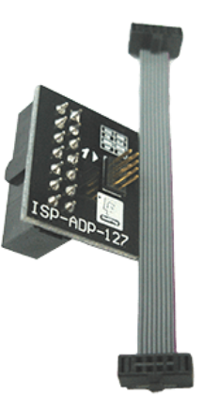

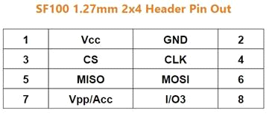

No Connect

This FW programming needed only when the TBT interface is not up (initial stages of bring-up). Once the TBT interface is up and working, programming through a host is possible.

Alternatively, unstuffed independent Flash footprint will be provided for the Slave retimer when flash is shared on the board.

### Legacy Display ports Support

* RVP doesn’t support native HDMI connector over modular TCSS HDMI AIC.
* Secondary eDP is not supported over TCSS.
* Native DP ports are not supported on WCL RVP.
  + Only DP alt / tunneling mode is supported on type-C ports.

## PD Controller Support

**There is no motherboard down Standalone PD controller on WCL SKUs**. WCL RVP1 support the Motherboard down config of Gothic Bridge Retimer which has the integrated PD Controller, and the second port supports M.2 Modular TCSS. WCL RVP2 Modular TCSS AICs are supported on both ports. The TBT modular TCSS AIC has on module PD controller. WCL RVP2 also supports the low cost third party TCSS solution from Analogix and Texas instruments.

There is no M.2 Modular TCPC Port controller supported on Chrome WCL RVP SKU. Refer to Chrome Requirements section for more details on Chrome TCSS requirement.

### On Board PD Controller

No RVP onboard PD controller supported on WCL. PD controller is only available on TCSS Module.

### Power Delivery Add-In-Card (PD AIC) Support

There is no PD AIC support on WCL RVP Sku’s. WCL RVP supports only motherboard down GBR Retimer and M.2 Modular TCSS AIC.

### SPR and EPR AIC support on WCL

On WCL platform, Type C ports TCP0 and TCP1 will support only SPR (20V) mode in both RVP1 and RVP2. There is no EPR (28V,48V) support in WCL platform.

### PD Controller Communication

* PD controller communication could be over I2C or through GPIOs as below:
  + PD (slave) to PMC through USBC SML Communication (I2C1).
  + PD (slave) to EC through I2C communication for UCSI communication (I2C2).
  + PD (master) to TBT retimer for configuration (I2C3).

### PD and Retimer Debug Support

The WCL RVP1 having Onboard Gothic Bridge Retimer supports the below debug header on motherboard. The M.2 Modular TCSS AIC has no Header option provided on AIC instead Test points are provided for below signal debug capabilities.

* Individual JTAG headers (HDR_2X3) supported only for GBR retimer flash – PRESENT ON RVP.
* TCSS Module retimer flash will have test point for firmware programming on Module.
* EC to PD I2C header (HDR_1X3)
* PMC (USBC SML) to PD I2C header (HDR_1X3)
* Soc (SMlink0) to Retimer (HDR_1X3) – PRESENT ON RVP



Figure 17 : PD/Retimer I2C debug headers

## Download & Execute (DnX) Support

This feature allows to download and execute the content from another system over USB2.

To enter in DnX mode, the DnX forceload GPIO should be asserted. In case of RVP, the DnX forceload is asserted by EC based on button press. On RVP, the LED is available to indicate the DnX progress.

This is supported on lowest USB2 port number in SoC. In WCL, USB2.0 port-1 is the lowest port number from the SoC.

The USB2.0 port mapping on the type-C ports should be in incremental order, to support the device mode. The violation of the incremental order port mapping may affect the device mode operation. Refer USB section of this document for WCL RVP port mapping.

Example for correct incremental order port mapping

Table 16 : Correct incremental order for USB2.0 and TCP port mapping

|  |  |  |
| --- | --- | --- |
| **TCP port number** | **USB 2 port number** | **Remarks** |
| TCP0 | USB2_1 | PHY Ports Usable with TCSS IO are 1,2,5,6 |
| TCP1 | USB2_2 | PHY Ports Usable with TCSS IO are 1,2,5,6 |

Example for incorrect incremental order port mapping

Table 17 : Incorrect incremental order for USB2.0 and TCP port mapping

|  |  |  |
| --- | --- | --- |
| **TCP port number** | **USB 2 port number** | **Remarks** |
| TCP0 | USB2_2 | Incorrect assignment; TCP0 is assigned with USB2_2; then USB2_1 should not be used in TCP1 |
| TCP1 | USB2_1 | Incorrect assignment; TCP1 is assigned with USB2_1; then USB2_2 should not be used in TCP0 |

## Feature list supported on WCL RVPs

The Table 18 provides the quick features list. The below table provides complete feature list supported on various WCL RVPs:

Table 18 : Various Type-C port Features in WCL RVPs

|  |  |  |  |  |
| --- | --- | --- | --- | --- |
| **SL No** | **Features** | **Mode** | **RVP1: WCL - T3PCB – DDR5** | **RVP2: WCL – T3PCB – LP5x MD** |
| 1 | Number of USBC ports |  | 2 | 2 |
| 2 | Power Profile - Consumer | 5V-20V @ 5A | Yes | Yes |
| 3 | EPR Power Profile - Consumer | 5V-48V @ 5A (WCL) | No | No |
| 4 | Power Profile – Provider  (On board type-C ports) | 5V @ 3A, 5V @ 1.5A. 1 port at 3A and other ports at 1.5A at a given time. | Yes | Yes |
| 5 | Power Profile – Provider  (Modular TCSS AIC based type-C ports) | 5V @ 3A, 5V @ 1.5A. 1 port at 3A and other ports at 1.5A at a given time. | Yes | Yes |
| 6 | POR PD controller | Modular TCSS AIC | Integrated GBR PD and  Modular TCSS AIC | Modular TCSS AIC |
| 7 | USBC Internal cable topology | [5V@3A power profile FFC cable](mailto:5V@3A%20power%20profileFFC%20cable) | No | No |
| 8 | BC1.2 support for Chrome | [5V@1.5A provider](mailto:5V@1.5A%20provider) | No | No |
| 9 | Non-TBT, USB/DP direct port | DP/USB/PCIE tunneling | No | Yes |
| 10 | Native DP2.0 with Repeater | HBR3 | Not POR | Not POR |
| 11 | USB3.2redriver | USB3.2 Gen2x2 | POR | POR |
| 12 | TBT - Single Retimer 40G | HB/GB retimer TBT/USB/DP | Yes | Yes |
| 13 | TBT - Retimer 20G | HB retimer TBT/USB/DP | No | No |
| 14 | Dual TBT retimer 40G | HB retimer TBT/USB/DP | No | No |
| 15 | USB4 Retimerless 20G | TBT/USB/DP | No | No |
| 16 | 3rd party redriver + TBT retimer | 3rd party Redriver + BB retimer TBT/DP/USB | No | No |
| 17 | dTBT Barlow Ridge support solder down | BR dTBT TBT/USB/DP | No | No |
| 18 | dTBT Maple Ridge + Burnside Bridge support | MR dTBT+BB TBT/USB/DP | No | No |
| 19 | DP-in (DP2.1 input) support for switchable graphics | Via dTBT Barlow Ridge Controller. | No | No |
| 20 | DP2.1 support over enhanced mini-DP connectors | DP2.1 output from SOC | No | No |
| 21 | DnX Support | DnX supported with external jumper or via EC | Yes. One port | Yes. One port |
| 22 | USBC debug support | USB3 DbC/ USB2 DbC/HTI Trace boxes (“Unitracer”, “PRI7” or “VPlus”) | Yes, 1 No's | Yes, 1 No's |
| 23 | USBC debug support | 2-wire DCI-OOB over I3C platform mux / Debug accessory mode | Yes, 1 No's | Yes, 1 No's |
| 24 | USBC switching AIC support - Cswitch 2.0**v** | Not supported on vertical ports. | Yes | Yes |
| 25 | USBC switching AIC support Cswitch Rev4.0**v** | 54mm spacing between Type-C (or other) Con | Yes | Yes |
| 26 | VPRO support | SML0 connection between retimer and PCH | Yes | Yes |
| 27 | Ardent connector |  | No | No |

## Chrome Connector Support

Chrome USB-C modular AIC based on PD interface shall be used for TCP0/1 ports. Refer to Chrome section for more details. WCL RVP doesn’t support TCPC AIC as there is no PD AIC option provided on RVP.

## Protection Circuit

Specific ESD protection diodes are provided for all the signals close to the Type C port connector. The Type-C connector has a higher pin density than legacy USB connectors. As a result, it is easier to accidentally short VBUS to adjacent pins. With the potential of having VBUS of up to 20 V, it is possible to have a short between the 20V and a 5V line (such as SBU, CC and so on). To protect against this potentially catastrophic event, VBUS short circuit protection is required. Short circuit protection on the SBU and CC lines are taken care in PD add-in card. No additional protector IC is provided on RVP board.

VBUS is also adjacent to the high differential lines, refer to the connector pinout in the Type C specification. These pins are protected using a series Resistor-Capacitor combination between the pins of the Type C connector and the chip. Refer to the Product Design Guide (PDG) document for more accurate details on the same.

# HSIO

WCL platform supports various HSIO interfaces like PCIe Gen4, USB 3.2 Gen2x1, Gbe LAN to connect different peripheral devices from PCD Die.

## WCL Platform HSIO support details

WCL PCD die supports:

1. 2x USB 3.2 Gen2x1(10G) lanes.
2. WCL PCD die supports 6 PCIe Gen4 lanes; 1 of the PCIe lane is muxed with Gbe LAN.

### PCIe device support on WCL RVP

WCL RVP supports the following PCIe Devices/ IO connectors:

1. M.2 Key-M SSD Gen4
2. M.2 Key-E WLAN
3. M.2 Key-B WWAN [Non-POR]
4. Integrated Gbe LAN
5. x4 PCIe DT Slot1 (Open ended) – for SD 7.0 AIC
6. x4 PCIe DT Slot2 (Open ended) – RVP2 only, enable for EV & FV team

### HSIO configurations in WCL RVP’s

Based on the platform LZ, POR & platform requirement initial HSIO Mapping has been done for WCL Platform. RVP ModPHY Mapping table will be used by the soft strap team & BIOS team to configure the individual lane as per RVP recommendation. RVP Implementation will support multiple configurations by sharing the same lanes for different functions, board rework andIFWIchanges will be required to enable the shared feature which has different functions.

Table 19 : HSIO support on WCL Platform

|  |  |  |  |  |  |  |  |
| --- | --- | --- | --- | --- | --- | --- | --- |
| **WCL HSIO ports** | | | | | | | |
| **Die** | **Port #** | **USB 3.2 10G** | **Gbe LAN** | **PCIe** | **PCIe Port Configs** | | |
| PCD Die | USB3.2 Ge2x1(10G) 1 | Yes |  |  |  |  |  |
| USB3.2 Ge2x1(10G) 2 | Yes |  |  |  |  |  |
| PCIe Gen4 0 |  |  | Yes | x4 | x2 | x1 |
| PCIe Gen4 1 |  |  | Yes | x1 |
| PCIe Gen4 2 |  |  | Yes | x2 | x1 |
| PCIe Gen4 3 |  |  | Yes | x1 |
| PCIe Gen4 4 |  |  | Yes |  | x2 | x1 |
| PCIe Gen4 5 / Gbe |  | Yes | Yes |  | x1 |

Table 20 : HSIO Mapping on WCL RVP's

|  |  |  |  |  |  |  |  |
| --- | --- | --- | --- | --- | --- | --- | --- |
| **WCL  HSIO ports** | | **RVP1: WCL - DDR5 SODIMM 1DPC T3** | | | **RVP2: WCL - LP5x Memory Down T3** | | |
| **Die** | **Port #** | **Topology1 (Default)** | **Topology2 (Rework)** | **Topology3 (Rework)** | **Topology1 (Default)** | **Topology2 (Rework)** | **Topology3 (Rework)** |
| PCD Die | USB3.2  Gen2x1 (10G) 1 | USB3.2 Gen2x1  Type-A Port1 | - | - | USB3.2 Gen2x1  Type-A Port1 with Re-driver | - |  |
| USB3.2  Gen2x1 (10G) 2 | USB3.2 Gen2x1  Type-A Port2 with Re-driver | - | - | USB3.2 Gen2x1  Type-A Port2 | - |  |
| PCIe4 0 | M.2 Key M Gen4 SSD Gen4 | - | - | M.2 Key M Gen4 SSD Gen4 | x4 PCIe DT Slot #2 |  |
| PCIe4 1 |
| PCIe4 2 |
| PCIe4 3 |
| PCIe4 4 | x4 PCIe Gen4 DT Slot #1 for SD Card – Lane 0 | M.2 Key E WLAN | - | x4 PCIe Gen3 DT Slot #1 - Lane 0 | M.2 Key E WLAN | x4 PCIe Gen3 DT Slot #1 - Lane 1 |
| PCIe4 5 / Gbe | Gbe LAN  Jacksonville | x4 PCIe Gen4 DT Slot #1 for SD Card – Lane 1 | M.2 Key B WWAN  (non-POR) | Gbe LAN  Jacksonville | x4 PCIe Gen3 DT Slot #1- Lane 1 | x4 PCIe Gen3 DT Slot #1 - Lane 0 |

## WCL RVP: HSIO Mapping



Figure 18 : RVP1 WCL DDR5 SODIMM T3 RVP HSIO Mappings



Figure 19 : RVP2 WCL LP5x Memory Down T3 RVP HSIO Mappings

# USB2.0

WCL PCD die supports 8 USB2.0 ports.

## WCL RVP: USB 2.0 Mapping

Table 21 : WCL RVP-1 & RVP-2 USB 2.0 port mapping

|  |  |  |  |  |  |
| --- | --- | --- | --- | --- | --- |
| **WCL  HSIO ports** | | **RVP1: WCL - DDR5 SODIMM 1DPC T3** | | **RVP2: WCL - LP5x Memory Down T3** | |
| **Die** | **Port #** | **Topology1 (Default)** | **Topology2 (Rework)** | **Topology1 (Default)** | **Topology2 (Rework)** |
| PCD Die | USB2_P1 | Type C port - various configurations – TCP0 | USB2 Vertical Type-A (Only for PPV) | Type C port - various configurations – TCP0 | USB2 Vertical Type-A (Only for PPV) |
| USB2_P2 | Type C port - various configurations – TCP1 | - | Type C port - various configurations – TCP1 | - |
| USB2_P3 | USB2 Type-A – TAP1 | - | USB2 Type-A – TAP1  with Re-driver | - |
| USB2_P4 | USB2 Type-A – TAP2 with Re-driver | - | USB2 Type-A – TAP2 | - |
| USB2_P5 | 2x5 USB2 HDR #1 (FP) | WWAN (non-POR) – Only RVP1 | 2x5 USB2 HDR #1 (FP) |  |
| USB2_P6 | Chicony  USB2 Camera | Chicony  USB2 Camera |
| USB2_P7 | FPS | 2x5 USB2 HDR #2 (FP)(Only for PPV) | FPS | 2x5 USB2 HDR #2 (FP)(Only for PPV) |
| USB2_P8 | M.2 WLAN Key E | M.2 WLAN Key E |



Figure 20 : WCL RVP1 & RVP2 USB2 Mappings

## USB Overcurrent (OC) Protection

WCL PCD die has implemented programmable USB OC signals. 2 OC pins are to be shared across the Type-C, USB2.0 & USB3.2 Gen2x1 Type-A ports. This allows the platform designer flexibility in routing of the OC pins & allows for unused pins to be configured as GPIOs. The current limits for the USB3.2 Gen2x1 Type-A ports is set to 900mA typical per port.

Table 22: OC Protection from the individual OC protection controllers in WCL RVP

|  |  |
| --- | --- |
| Pin Name | WCL Configuration |
| USB2_OCB_0 (default) /  USB2_OCB_1 (rework) | USB Type C Port 0 (for RVP2: Virtual OC only)  USB Type C Port 1 (Virtual OC only)  USB 3.2/2.0 Type A Port 1  USB 3.2/2.0 Type A Port 2  USB2.0 2x5 FP Header 1  USB2.0 2x5 FP Header 2  USB2.0 PPV Vertical Connector 1 |

## USB Signal Protection

WCL RVP shall have CMC and ESD diodes for Signal protection.

## USB Debug Support

Intel® DCI (Direct Connect Interface) is an Intel Technology that allows debug access by re-purposing a USB3.2 Gen 2x1 port. The advantage is debug functions & trace features can be connected using existing USB3 ports, rather than the usual additional connectors. It supports many debug functions & can be implemented “closed chassis”. The DCI connection supports run-control debug, validation, trace, DMA, OS Debug and scripting. DCI is implemented using 2 primary transport topologies:

* Intel® DCI.OOB (formerly BSSB)
* Intel® DCI.USB2/USB3 (formerly DbC)

Table 23: USB Debug Support on WCL RVP

|  |  |
| --- | --- |
| Connector Details | Supported Topologies |
| Connector1: Type-A Walk-Up USB Port  USB3.2 Gen 2x1_Port 1 & USB2_Port3 | USB.DbC |
| Connector2: Type-A Walk-Up USB Port  USB3.2 Gen 2x1_Port 2 & USB2_Port4 | USB.DbC |
| Type C Port0: USB2_Port1 | USB.DbC  DCI.OOB – 2 Wire |
| Type C Port 1: USB2_Port2 | USB.DbC  DCI.OOB – 2 Wire |

## USB2.0 Front Panel HDR Cable

WCL RVP have 2x5 HDR supported for the USB2.0 Port5 and Port6 as POR and USB2.0 Port 7 for PPV (rework option for other BOM SKU). Hence, a Front Panel cable will be supplied as part of bootkit. Alternatively, user may also get the same identical cable from other sources or open markets.

Below is the information of the 2x5 Front Panel cable:

|  |  |  |
| --- | --- | --- |
| IPN | Part Number | Manufacturer |
| K56424-001 | RUBAH-0329 | Amphenol |

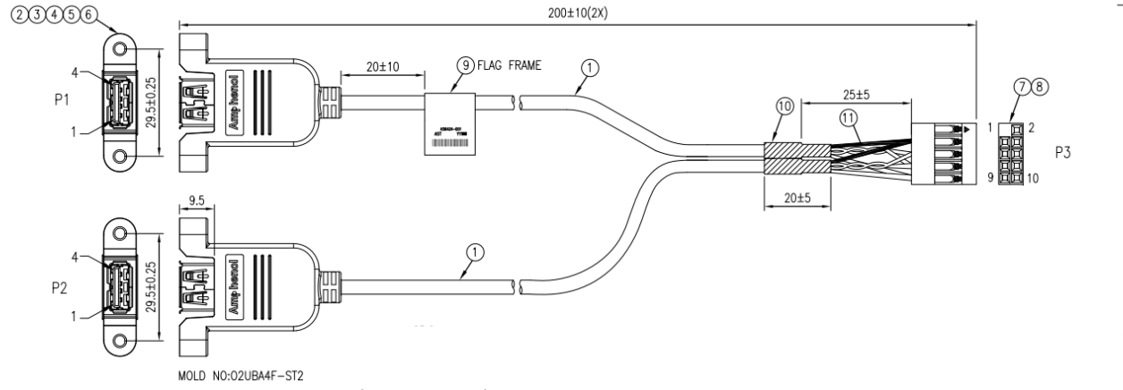

# Clocks

WCL SOC is the primary clock generator for all sub-systems on WCL RVP. The chipset has 2 major clock sources out of which all the sub-system clocks and external clock outputs are derived though internal PLLs. A high-level block diagram of the chipset clock interface is given below.

Table 24 : Clock Inputs on WCL

|  |  |
| --- | --- |
| Clock Name | Description |
| RTCX1/ RTCX2 | 32.768KHz crystal input for Real time clock |
| Single ended Crystal RTCX1 | Single-ended RTC crystal input by driving 32.768Khz CMOS clock on RTCX1 [Not used on RVP] |
| XTAL_IN/OUT | 38.4MHz crystal input for iSCLK (integrated System Clock) block |
| CRF_CLKREQ | To be sent to iSCLK & CRF Quasar to Synchronize CRF & Quasar |
| SRCCLKREQB [0:5] | SRCCLKREQB is used to support clock request protocol to enable or disable SRC clocks distribution to off-chip.  In addition, the SRCCLKREQB is also used for PCIe power management (L1.off, etc.). |
| OBS[1:0]MON_ISCLK | iSCLK monitoring pins for debug usage |
| SOC_REFRCOMP_ISCLK | Connected to an external precision resistor for Differential buffer, RCOMP between VSS and this pad. |

Table 25 : Output signals from Clock function on WCL

|  |  |  |
| --- | --- | --- |
| Signal Name | Frequency  & SSC Support | Description |
| GPP_V_7_SUSCLK | 32.768KHz  without SSC | Suspend clock that generated from the RTC crystal oscillator |
| CLKOUT_SOC_[0:5]_N/P | 100MHz – Gen4  Capable with SSC | 100MHz differential source clock for external PCIe Device |
| GPP_D_21_UFS_REFCLK | 38.4 MHz without SSC | 38.4MHz single-ended reference clock for external UFS device |

WCL SOC supports 6 SRC CLK’s & 6 CLKREQ signals. All SRC CLK’s from SOC are capable of Gen4.

By default, CLKREQ will be enabled as Native GPIO function. To use these pins as a CLKREQ it needs to be mapped in the BIOS.

The Gbe LAN PHY needs 25MHz input which will be fed from an external crystal input. The Embedded controller has the external 32.768kHz crystal input as the default option along with SUS_CLK option driven from SOC. Any other interface specific clocks required for third party devices will be derived out of the external crystals specific to the device requirements.

## WCL RVP : SRC Clock and CLK REQ Mapping



Figure 21 : RVP1 GEN4 SOC CLKOUT / SRCCLKREQ Mappings



Figure 22 : RVP2 GEN4 SOC CLKOUT / SRCCLKREQ Mappings

# Storage

WCL supports different storage options whose high level block diagram & details are as below.

Table 26 : Storage options supported on WCL

|  |  |  |
| --- | --- | --- |
| Sl. No | Interface | WCL RVP |
| 1 | PCIe NAND SSD | Share same M.2 Key M 2280 connector interfaced Modules |
| 2 | SD CARD over PCIe | Bay Hub PCIe to SD Card reader (Through PCIex4 slot) |
| 3 | UFS | Supported M.2 Key M UFS 3.1 G4 AIC |

## WCL RVP: Storage support Mapping



Figure 23 : RVP1 WCL DDR5 SODIMM T3 RVP Storage support



Figure 24 : RVP2 WCL LP5x Memory Down T3 RVP Storage support

## M.2 Key-M Connector

WCL RVP’s support M.2 SSD Key-M connectors following the PCI SIG M.2 spec. All the M.2 Key-M SSD ports will have RTD3 capability for PERST & WAKE signal coming from SOC.

### Dynamic M.2 Key-M SSD sideband GPIO voltage level switching (3.3V vs 1.8V)

WCL platform supports 1.8V IO level only. Platforms need level shifter to support legacy M.2 SSD modules with 3.3V sideband GPIO signaling. Upcoming M.2 modules are coming up with two configurations:

1. Support both 1.8V/3.3V sideband GPIO signal level
2. Support only 1.8V sideband GPIO signal level

For supporting both legacy & upcoming SSD modules, we need dynamic switching of sideband GPIO voltage level between 3.3V & 1.8V.

WCL RVP supports dynamic M.2 Key-M SSD sideband GPIO voltage level (3.3V vs 1.8V) switching.

* VIO_CFG is a signal indicates to the Platform that the Adapter supports an independent IO voltage domain for the sideband signals. It is output signal from M.2 Module. Sideband signaling is 3.3V when VIO_CFG signal is low and NC when sideband signaling is 1.8V.

### Power Loss Notification (PLN) Support

A sudden loss of power can cause an SSD to lose user data in its volatile write cache & the 3 primary causes for power loss are:

* User presses & holds power button for more than power button overrise time (4s/ 10s/ Custom)
* Battery disconnected in case of notebooks & AC power loss in case of DT systems without UPS.
* Battery runs down.

This proposal will address first cause, the user turning off the power without going through the Windows shut-down process. It is proposed to connect Power Button signal passing through an Open Drain Buffer to M.2 SSD connector Pin 8 & a GPIO from EC to the same open drain buffer. This implementation will be on all the SKUs of the WCL RVPs.



Figure 25 : Power Loss Notification circuit implementation

### BIOS recovery architecture

NVMe BIOS recovery feature supports on SSD which is connected to PCIe Gen4 lane [0:3].

#### SPI Descriptor Recovery

SPI Descriptor recovery in WCL is achieved by Descriptor verification (Detection) and recovery by the SPI controller in SOC. Since the Descriptor is required for any firmware to be loaded, it can’t be recovered by firmware component.

SPI Descriptor are used in SPI FLASH to access control of the SPI FLASH regions to different masters & specify various properties of these regions. If a SPI-Descriptor gets corrupted the platform will not be bootable. To recover from SPI-Description corruption, the SPI flash will now contain 3 descriptors and the SPI controller in SOC is modified to read the subsequent descriptor if it finds a corrupted descriptor. This will enable the system to boot even in the presence of 2 corrupted descriptor.

There are 2 straps used for SPI Descriptor recovery, mentioned below:

Table 27 : SPI Descriptor Recovery Strap details

|  |  |  |  |
| --- | --- | --- | --- |
| **GPIO Pin** | **Strap Details** | **Strap Functionality** | **Comment** |
| GPP_H1 | SPI FLASH Descriptor Recovery strap | 0= Recovery Disable (Default) 1= Recovery Enable. | Weak Internal 20K PD, Sampled at RSMRSTB. |
| GPP_H2 | SPI Flash Descriptor recovery source selection strap | 0=Flash descriptor recovery internal source (Default) 1= Flash descriptor recovery external source | Weak Internal 20K PD, Sampled at RSMRSTB. |

#### NVMe Recovery

If the BIOS/CSME partition in the Flash is corrupted, this feature enables the EC to use an out of band mechanism (I2C/SMBUS) with the NVMe drive & rewrite the BIOS/CSME partition into SPI flash. This enables the system to boot in the presence of a corrupted BIOS partition in SPI-NOR. To support this feature, the following are implemented in the design,

* The firmware issue detection & recovery occur in pre-boot stage. Hence, EC and primary M.2 SSD shall be powered up and running before CPU/PCH is enabled.
* When NOT using the recovery mode, the SSD shall be power gated (off) in Sx.
* EC can override the SSD power while in Sx for the recovery.
* EC shall access M.2 SSD secondary partition over I2C/SMBus signals during recovery mode. Level translator is used to convert EC driven 3.3V I2C/SMBus signals to M.2 SSD 1.8V levels.
* EC shall have recovery indication signal (GPIO).
* Flash descriptor override strap is sampled at RSMRST in WCL silicon to enable CSME recovery in MAF mode. EC firmware needs to wait for 100ms before trying to access the SPI flash after FDO strap is sampled high to prevent any conflicting case where SoC & EC both are trying to access SPI flash.
* EC Recovery indication GPIO should drive Flash descriptor override strap (Active high) of SOC as high to hold CSME communication with Flash Chip.

**Note: NVMe recovery in MAF mode is not POR for WCL RVP**

* + In MAF mode during BIOS/CSME recovery, platform power sequencing will be halted at SLP_S3. This is because in MAF mode, for EC to access the SPI flash the eSPI & SPI interface needs to be alive & for that we need RSMRST to be high. So, we can’t halt at RSMRST, so we halt at SLP_S3 signal.
  + In G3/SAF mode during BIOS/CSME recovery, platform power sequencing will be halted at RSMRST. This is because in G3/SAF mode, EC can directly access the flash so we can halt at RSMRST also.



Figure 26 : NIST193 Recovery Hardware implementation block diagram



Figure 27 : MAF Recommended Platform Flow



Figure 28 : SAF/G3 Mode recommended Platform Flow

## SD 7.0 card over PCIe

On the WCL RVP the PCIe to SD card interface is validated using the Bay Hub SD 7.0 PCIe to SD bridge IC based AIC & will be plugged on to x4 PCIe DT Slot.

## UFS3.1

The WCL RVP supports UFS 3.1 with a two-lane (x2) Gear 4 configuration across all its SKUs. On the WCL RVP1, the UFS lanes are multiplexed with PCIe Gen4 lanes 2 and 3 by a passive mux and share an M.2 Key M connector. This setup allows for a combination connector that accommodates both SSD and UFS interfaces. WCL RVP2 does not support this combined configuration; instead, it provides a dedicated M.2 Key M connector exclusively for UFS connections.

For the WCL RVP1, there is also a bypass option that enables UFS to connect to its own dedicated M.2 Key M connector, circumventing the shared arrangement. The M.2 Key M connector is utilized for connecting UFS 3.1 Gear 4 AICs. The power supply for UFS is functional in both the S0 (active) and S0ix (low-power idle) platform states, but there is no support for the RTD3 power-saving state for UFS power rails.

To meet EMC requirements, the two UFS lanes are equipped with a Common Mode Choke (CMC) as a placeholder, with a default option to bypass it. UFS devices are soldered onto M.2 UFS3.1 2230 form factor AICs, and UFS cards can be plugged into the M.2 Key M Gen4 connector available on the RVP. The 256GB UFS 3.1 Gear 4 AIC is available with two-part numbers: SK Hynix's N55514-300 and Samsung's N55546-300.



Figure 29 : WCL RVP1 UFS AIC CONN high level block diagram



Figure 30 : WCL RVP2 UFS AIC CONN high level block diagram

# Connectivity

The primary connectivity interface for the WCL RVP lies with the Chipset. The WCL chipset supports integrated connectivity CNVi core which eliminates the need for an external WiFi chip. The other connectivity options are GbE LAN and WWAN. Table 28 gives the list of Modules supported on WCL RVP SKUs as connectivity solutions.

Note: In WCL RVP there is no RTD3 support for both WLAN and WWAN and the corresponding load switches for enabling power is no longer supported.

Table 28: Connectivity Support on WCL RVP boards

|  |  |  |
| --- | --- | --- |
| Interface Name | Module Name | Remarks |
| Integrated CNVIo | Garfield Peak 2  Spider Peak 2  Whale Peak 2**  Filmorepeak 2** | M.2 Key E Socket 3 |
| Discrete WLAN+BT | Gale Peak 2 | M.2 Key E Socket 3 |
| WWAN(Non-POR) | Maple Spring | M.2 Key B Socket 2 |
| Gbe LAN | Jackson Ville Module | RJ-45 Jack |
| PCIe | Fox-Ville Add-In Card (Non-POR) | x1 PCIe AIC |

**NOTE: Whale Peak 2 and Filmore Peak 2 is reactive support only in WCL



Figure 31 : RVP1 WCL DDR5 SODIMM T3 RVP Connectivity Block Diagram



Figure 32 : RVP2 WCL LP5x Memory down T3 RVP Connectivity Block Diagram

## Connectivity Integration (CNVi)

The RVP supports a M.2 Hybrid Key E slot for Wireless connectivity solutions, it supports a Combo WiFi + BT M.2 module. The Wi-Fi interfaces are over integrated CNVi or x1 PCIe port while the Bluetooth connectivity is supported over CNVi, USB2 or UART+I2S interfaces based on modules is getting plugged in.

Connectivity integration (CNVi) is a general term referring to a family of connectivity solutions which are based on the hard macro(Blazar)) embedded within Intel Silicon. Besides the Blazar, the CNVi contains an external RF companion module (CRF) and RF antennas. This module will be implemented as a M.2 (2230) module solution on WCL RVP. The RF companion will be Garfield Peak 2, Spider peak 2 and Whale peak 2 based M.2 Key E module with provision for connecting the external RF antennas.

For Integrated WiFi and Bluetooth, CNVi DPHY TX/RX, STEP I/F/CNVio gen2 and RGI/BRI signals are used respectively. For discrete WiFi x1 PCIe is used and for discrete Bluetooth-USB2.0 and UART signals are used.

In the below diagram, all necessary signals from WCL to the M.2 Key E connector has been shown.



Figure 33 : WCL RVP M.2 Key E WLAN implementation high level block diagram

Table 29: Interface Details for WLAN Module

|  |  |  |
| --- | --- | --- |
| Description | Interface Name/ Signal Name | Support on  WCL RVP |
| WIFI | * CNVi DPhy & STEP * PCIe * CLINK(CSME) | Yes |
| BT DATA | * USB2.0 * BRI | Yes |
| WLAN M.2 Control | * RGI * RF_RESET# * WIFI_RFKILL# * BT_RFKILL# * WLAN_LED# * BT_LED# | Yes |
| BT AUDIO | * I2S | Yes |
| RF Coexistence | * UART_RX * UART_TX * UART supports Real-Time Coexistence | Yes |

### M.2-1A Key E Connector

Next generation WLAN modules need more power to meet performance and feature targets. M2 specification is restricting these features due to the limited current supply (2.5A) allowed in the connector specification.

The new M.2-1A connector will support 1A per pin, with 4pin it will support 4A. New mechanical key allowing current M.2 and New M.2-1A insertion but does not allow M.2-1A to work in old M.2 connectors.

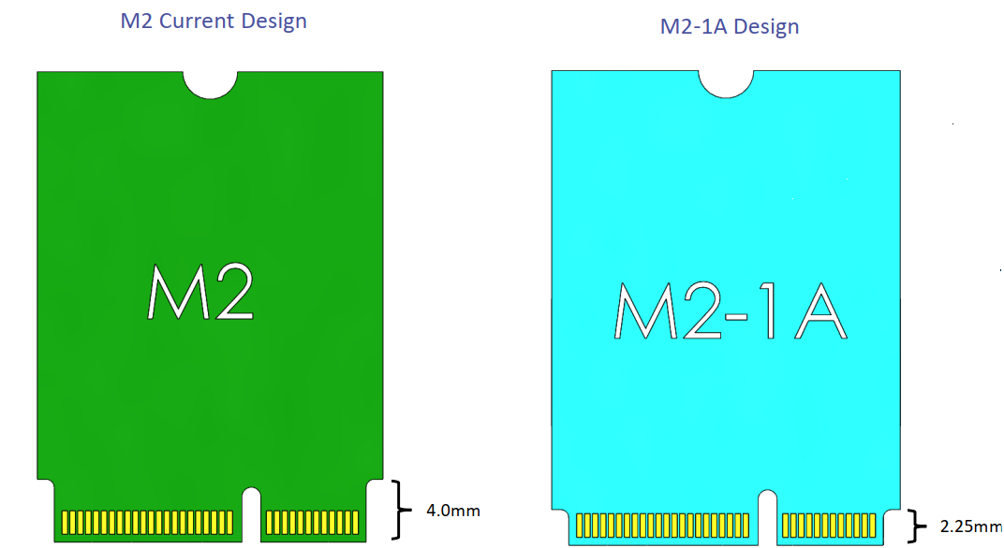

Figure 34 : New M.2-1A design

## WWAN M.2 Module (Non- POR)

WCL RVP supports M.2 7560 Socket 2 WWAN module. Single PCIe lane, x1 interface, and USB2.0 interface is routed to M.2 WWAN Key B connector. The USB 2.0 interface is used only during the production testing and debugging activities. Figure 35 below shows the interface connectivity of WWAN Module to WCL.

**Note: WWAN connectivity interface is not POR for WCL**. RVP will provide a x1 PCIE based M.2-1A connector on RVP1 DDR5 SODIMM T3 SKU to support the hardware needed for WWAN enablement. This is done to be ready for any future requirement for WWAN testing or any POR changes with respect to WWAN based on marketing/CCE feedback. This needs to be accompanied by CCB to enable SW/FW support for the same. WWAN sideband signals also routed to header on the board for chrome SKU for testing the WWAN over CEM slot .



Figure 35 : WCL RVP1 M.2 Key-B WWAN implementation high level block diagram

Further details on SIM Card Signals, Module WAKE and Reset etc. are listed in below table.

Table 30: Interface Details for Maple Spring

|  |  |  |
| --- | --- | --- |
| Description | Interface Name/ Signal Name | Support on WCL RVP |
| Inter-processor Communications | PCIe Gen3  USB 2.0 | Yes |
| USIM with Card Detect | SIM_CLK,  SIM_RESET,  SIM_IO,  SIM_PWR, SIM_DETECT | Yes |
| WWAN M.2 Control | FULL_CARD_POWER_OFF#  RESET#  PERST#  W_DISABLE#  LED#1  DPR (Body SAR) | Yes |
| Global Positioning (GPS/GLONASS) | TX_BLANKING,  FINE_TUNE_AIDING (FTA) | Yes |
| CSME | I2C | No |
| RF Coexistence | UART_RX  UART_TX  UART supports Real-Time Coexistence | No** |

**NOTE: Module does not support RF coexistence, but RVP has provision to test the Coexistence.

An LED is used to provide status indications to users via system provided indicators. LED#1 is an active low open drain output signal intended to drive system-mounted LED.

Table 31: LED Indicator description for WWAN

| State | Definition | WWAN State |
| --- | --- | --- |
| OFF | The LED is emitting no light | Not powered |
| ON | The LED is emitting light in a stable non-flashing state | Powered registered but not transmitting or receiving |
| BLINKING | State Blinking | TX / RX activity in progress |

### M.2-1A Key B Connector

Next generation WWAN modules need more power to meet performance and feature targets. M2 specification is restricting these features due to the limited current supply (2.5A) allowed in the connector specification.

The new M.2-1A connector will support 1A per pin (Total 5A). New mechanical key allowing current M.2 and New M.2-1A insertion but not allow M.2-1A to work in old M.2 connectors.



Figure 36 : New M.2-1A design

## GbE LAN

WCL RVP supports Wired Gigabit Ethernet interface through on-board Intel 1000Base-T PHY LAN Controller I219 (Jacksonville) that connects to PCH through an x1 PCIe interface. The LAN PHY operates in Gen1 PCIe mode.

2.5G Base-T MAC/PHY LAN Controller I225 (Foxville) based wired Ethernet will be validated through AIC. SMLink would be provided for the Foxville AIC. However, Foxville AIC is non-POR in WCL.

The LED indications for connectivity status of GbE LAN are listed in table below.

Table 32: LED definition for RJ45 Connector

|  |  |
| --- | --- |
| LED Function | State Description |
| Speed | OFF: 10Mbps  GREEN: 100Mbps  YELLOW: 1Gbps |
| Activity | GREEN: Link is up there no activity on the lines  GREEN BLINKING: Tx / Rx or both Activity on the lines |

RVP supports standard x4 PCI express desktop slots from SOC which can be used to plug-in a x1 or x4 Network Interface Cards for enabling the validation of third-party connectivity solutions.

### Jackson Ville Controller

The Ethernet Connect I219 is a single-port Gigabit Ethernet Physical Layer Transceiver. It connects to an integrated Media Access Controller (MAC) through a dedicated interconnect.

* I219 supports operation at 10/100/1000 Mb/s data rates.
* Provides IEEE 802.3 Ethernet interface for 10BASE-T, 100BASE-TX, and 1000BASE-T applications.
* Support for the Energy Efficient Ethernet (EEE) 802.az specification.
* IEEE 802.3u auto-negotiation conformance
* Supports carrier extension (half duplex)
* 802.1as/1588 conformance
* No support for Gb/s half-duplex operation
* Intel® vPro support with appropriate Intel chipset components.
* Ultra-Low Power at cable disconnect (<1 mW) enables platform support for connected standby.
* PCIe-based interface for active state operation (S0 state)
* SMBus-based interface for host and management traffic (Sx low power state)

### Foxville Controller (Non-POR)

The Intel® Ethernet Controller I225 (I225) is a single-port, compact, low power Gigabit Ethernet (GbE) controller. It is a fully integrated GbE Media Access Control (MAC) and Physical Layer (PHY) device, offering 10/100/1000/2500 Mb/s data rates. The interface-to-host system is a one lane PCI Express* (PCIe*) Gen 2 version 2.1

* 802.1q VLAN support
* 802.3az EEE support
* Support for AMT / Intel® vPro™ Technology
  + Host onboard & Dock
  + Intel Stable Image Platform Program (SIPP™) support
* Automatic polarity correction
* Network proxy/ARP Offload
* MDC/MDIO management interface
  + MDI Lane Swap design support
* Smart speed operation for automatic speed reduction on faulty cable plants
* Power Optimizer Support

On the WCL RVP the Foxville controller is validated by using the Foxville AIC plugged on to x1 PCIe DT Slot

### Connectivity (RVP/SiV) Test plan

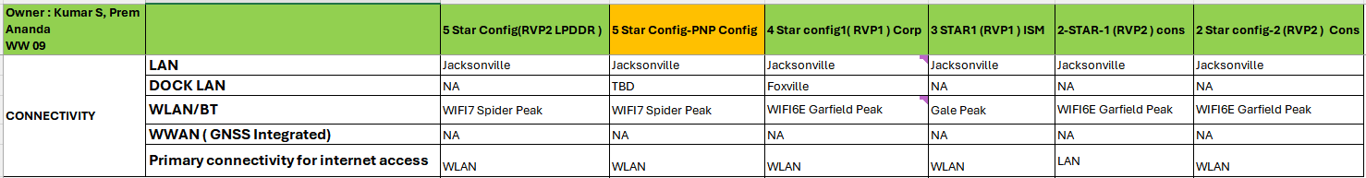

# Audio

WCL RVP supports ALC722 (SDCA V1.0) compliant Soundwire based codec down on the board through Sound wire. The codec drives on-board 3.5mm board jack along with DMIC and SPKR application via JS header through transducer AIC. The rest of the Audio features must be supported through add-in-cards through audio headers JA, JD, JE & JH. By default, SNDW will be connected to the onboard Codec. JH header is used to provide additional power options to the Audio AIC.

Onboard validation includes ALC722 Codec Jack, DMIC & SPKR through sound wire single lane/multilane configuration. Other validation will be performed on 6th Gen Realtek AIC and Cirrus/TI Audio AIC’s.

Table 33: WCL RVP Audio interface landing zone details

|  |  |  |
| --- | --- | --- |
| **RVP SKU’s** | **RVP Feature** | **Device Supported in RVP** |
| **RVP 1: WCL DDR5 SODIMM T3 PCB- Base SKU** | **Audio Options-**  1. Audio Jack Codec ALC722 Solder Down  2. Audio HDR - JA (HDA/I2S Codec Support)  3. Audio HDR - JD (DMIC support)  4. Audio HDR - JE (SNDW Codec support) 5. Power HDR -JH (RFU PWR support)  6. Audio HDR – JS (Codec DMIC & SPKR support)  7. I2S2 to M.2 Key-E for BT | **Soldered Down:** Realtek ALC722-CG (on-board RVP)  **AIC:** Realtek ALC712-VB (Gen6.x AIOC) Realtek ALC245 (Gen3.x AIOC) Cirrus CS42L43 (Cohen) AIOC V3 Realteak Gen41 Transducer (Speaker / DMIC) |
| **RVP 2: WCL LP5x Memory Down T3 PCB** |



Figure 37: WCL RVP Audio high level block diagram



## ALC722 SNDW on-board CODEC

The ALC722-CG is compliant to SDCA v1.0[MIPI04], where SDCA stands for SoundWire Device Class for Audio architecture that standardizes the interface for software to control the audio function through a SoundWire interface.

* The ALC722 integrates a headphone amplifier can drive 15-ohm headphone & supports legacy Universal Audio Jack.
* An integrated stereo Class-D amplifier directly drives the speakers. The Class-D amplifier is designed to drive speakers with as low as 4Ω impedance. Its maximum output power is 2.8W per channel at 5V power supply. The advantage of an integrated Class-D amplifier in the ALC722 is high efficiency with lower power consumption.
* The ALC722 has two stereo digital microphone inputs.

WCL RVP enables dedicated 12-pin header [JS] on RVP to connect Realtek Gen4.x transducer card for this on-board configuration using a Y-cable solution as shown below.

- SNDW3 multilane connects to ALC722 codec by default, SNDW1 single lane can be enabled with a rework option.

Realtek GEN4.x card (same as existing GEN 3.1 transducer card) supports 4xDMIC’s and 2x SPKR assembly.

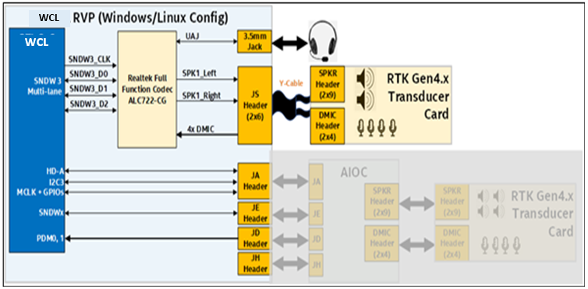

Figure 38: WCL RVP Audio ALC722 on-board configuration

## Audio AIC validation configurations

Refer below table for AIOC supported CODECs versus validation configuration details.

Table 34: WCL RVP Audio Windows build validation configuration table

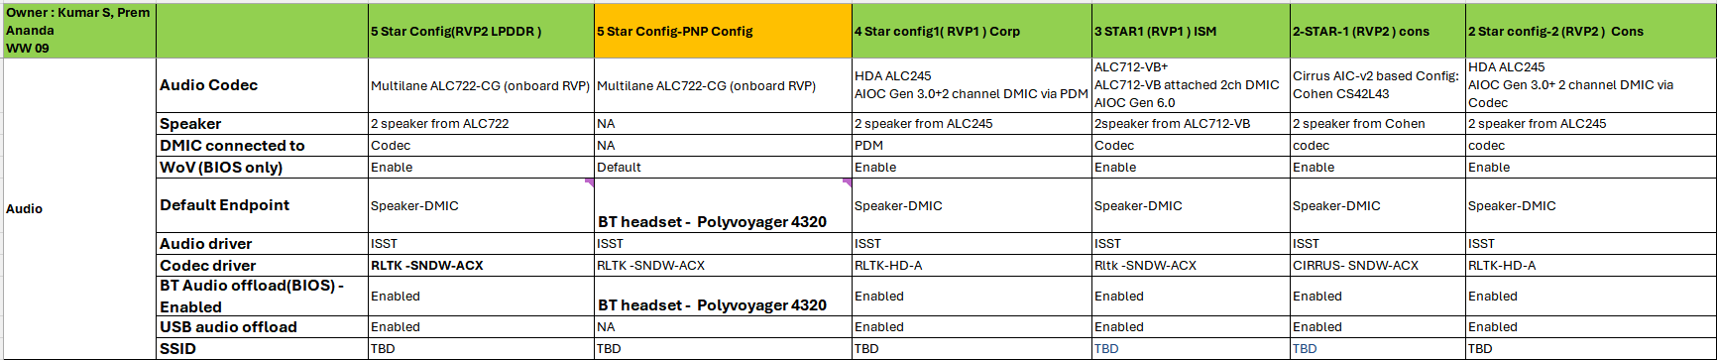

WCL RVP CHROME SKU supports following validation use-cases, without need for any resistor rework.

* + HDA config using Practon Audio Interposer (Chrome Audio AIC):
    - DMIC (JD – PDM0,1)
    - Dedicated GPIO for Codec_IRQ.
    - GPIO for PDB_CTRL.
  + SNDW3 multilane config using JE header
  + I2S can be configured through resistor stuff/ unstuff options

Table 35: WCL RVP Audio CHROME SoC pin configuration

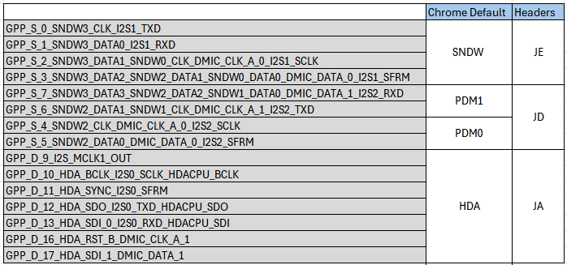

## Audio Headers

WCL silicon supports only 15 audio functionality pins. SoC muxing consideration is driven by CCG Platform team (comprising of Audio Domain Architects, as well as Platform EIO stakeholders) to balance between total GPIO pins needed/reserved for Audio while meeting primary requirements for the different segments (Windows, Chrome, IOT, etc). Pin muxing with reduced pin count for the WCL SoC is shown in the below table.

Table 36: WCL Audio pin muxing

|  |  |  |  |  |  |  |
| --- | --- | --- | --- | --- | --- | --- |
| **SoC Pin Name** | **SoundWire 3** | **SoundWire 2** | **SoundWire 0/1** | **DMIC** | **I2S / PCM** | **HD-A** |
| xxgpp_d_10_hda_bclk_i2s0_sclk_hdacpu_bclk |  |  |  |  | I2SSCLK[0] | HDA_BCLK |
| xxgpp_d_11_hda_sync_i2s0_sfrm |  |  |  |  | I2SSFRM[0] | HDA_SYNC |
| xxgpp_d_12_hda_sdo_i2s0_txd_hdacpu_sdo |  |  |  |  | I2STXD[0] | HDA_SDO |
| xxgpp_d_13_hda_sdi_0_i2s0_rxd_hdacpu_sdi |  |  |  |  | I2SRXD[0] | HDA_SDI0 |
| xxgpp_d_16_hda_rst_b_dmic_clk_a_1 |  |  |  | DMIC_CLKA[1] |  | HDA_RST# |
| xxgpp_d_17_hda_sdi_1_dmic_data_1 |  |  |  | DMIC_DATA[1] |  | HDA_SDI1 |
| xxgpp_d_9_i2s_mclk1_out |  |  |  |  | I2SMCLK[0] |  |
| xxgpp_s_0_sndw3_clk_i2s1_txd | SNDW_CLK |  |  |  | I2STXD[1] |  |
| xxgpp_s_1_sndw3_data0_i2s1_rxd | SNDW_DATA][0] |  |  |  | I2SRXD[1] |  |
| xxgpp_s_2_sndw3_data1_sndw0_clk_dmic_clk_a_0_i2s1_sclk | SNDW_DATA[1] |  | SNDW_CLK | DMIC_CLKA[0] | I2SCLK[1] |  |
| xxgpp_s_3_sndw3_data2_a_sndw2_data1_sndw0_data0_dmic_data_0_i2s1_sfrm | SNDW_DATA[2] | SNDW_DATA[1] | SNDW_DATA[0] | DMIC_DATA[0] | I2SFRM[1] |  |
| xxgpp_s_4_sndw2_clk_a_dmic_clk_a_0_i2s2_sclk |  | SNDW_CLK |  | DMIC_CLKA[0] | I2SCLK[2] |  |
| xxgpp_s_5_sndw2_data0_a_dmic_data_0_i2s2_sfrm |  | SNDW_DATA[0] |  | DMIC_DATA[0] | I2SFRM[2] |  |
| xxgpp_s_6_sndw2_data1_sndw1_clk_dmic_clk_a_1_i2s2_txd |  | SNDW_DATA[1] | SNDW_CLK[1] | DMIC_CLKA[1] | I2STXD[2] |  |
| xxgpp_s_7_sndw3_data3_sndw2_data2_sndw1_data0_dmic_data_1_i2s2_rxd | SNDW_DATA[3] | SNDW_DATA[2] | SNDW_DATA[1] | DMIC_DATA[1] | I2SRXD[2] |  |

WCL RVP supports different codec validation via AIC connected through JA, JD, JE & JH headers. Refer below section for each audio header pin details supported for Windows/Linux vs Chrome configuration when BT-audio is not enabled.

### JA Header[HDA/I2S header]

JA header is used to provide clock & data transmission in HDA mode & I2S mode. For HDA mode, Realtek GEN3 AIC (ALC245) will be used along with the transducer card. In SNDW mode, it will be used as power source for AIC. Refer below table for the header pinout vs silicon pin mapping details.

Table 37: Audio Header (JA) Connection

|  |  |  |
| --- | --- | --- |
| JA Header Pin Number | SoC Signal Name | Header Signal Definition |
| JA.1 | GPP_D_10_HDA_BCLK_I2S0_SCLK_HDACPU_BCLK | HDA_BCLK_I2S0_SCLK_HDR |
| JA.2 | NA | GND |
| JA.3 | xxgpp_d_16_hda_rst_b_dmic_clk_a_1 / GPP_D_9_I2S_MCLK1_OUT | HDA_RST_N_I2S_MCLK1_HDR |
| JA.4 | NA | +V1P8DX_AUDIO_JA |
| JA.5 | GPP_D_11_HDA_SYNC_I2S0_SFRM | HDA_SYNC_I2S0_SFRM_HDR |
| JA.6 | NA | GND |
| JA.7 | GPP_D_12_HDA_SDO_I2S0_TXD_HDACPU_SDO | HDA_SDO_I2S0_TXD_HDR |
| JA.8 | NA | +V3P3DX_AUDIO_JA |
| JA.9 | GPP_D_13_HDA_SDI_0_I2S0_RXD_HDACPU_SDI | HDA_SDI0_I2S0_RXD_HDR |
| JA.10 | NA | +VBATA_V5DX_AUDIO_JA |
| JA.11 | GPP_D_17_HDA_SDI_1_DMIC_DATA_1 / GPP_E_19_PMC_I2C_SDA | HDA_SDI1_GPIO_EN_HDR |
| JA.12 | NA | RESERVED(key) |
| JA.13 | GPP_H_7_I2C3_SCL_UART1_TXD_A_ISH_UART1_TXD | I2C3_SCL_AUDIO_HDR |
| JA.14 | GPP_H_6_I2C3_SDA_UART1_RXD_A_ISH_UART1_RXD | I2C3_SDA_AUDIO_HDR |
| JA.15 | GPP_F_17_THC1_SPI2_CS_B_A_ISH_SPI_CS_B_GSPI1_CS0_B | CODEC_IRQ_HDRX45 |
| JA.16 | NA | GND |

### JD Header

The JD header can be configured to drive 2-SPKR/4-SPKR using ALC1320 stereo amplifier codecs on Realtek GEN6 AIC or it can drive 6-SPKR using 6x Jamerson CS35L56 smart amplifiers on cirrus v3 AIC and it can be used to connect 4xDMIC’s directly (via Transducer card). Refer below table for the header pinout vs silicon pin mapping details.

Table 38: Audio Header (JD) Pinout

|  |  |  |
| --- | --- | --- |
| JD Header Pin Number | SoC Signal Name | Header Signal Definition |
| JD.1 | GPP_S_4_SNDW2_CLK_DMIC_CLK_A_0_I2S2_SCLK | DMIC0_CLK_SNDW2_CLK_HDR |
| JD.2 | GPP_S_5_SNDW2_DATA0_DMIC_DATA_0_I2S2_SFRM | DMIC0_DATA_SNDW2_DATA0_HDR |
| JD.3 | NA | GND |
| JD.4 | NA | V1P8DX_DMIC_JD |
| JD.5 | GPP_S_6_SNDW2_DATA1_SNDW1_CLK_DMIC_CLK_A_1_I2S2_TXD /GPP_D_16_HDA_RST_B_DMIC_CLK_A_1 | DMIC1_CLK_SNDW1_CLK_SNDW2_DATA1_HDR |
| JD.6 | GPP_S_7_SNDW3_DATA3_SNDW2_DATA2_SNDW1_DATA0_DMIC_DATA_1_I2S2_RXD/GPP_D_17_HDA_SDI_1_DMIC_DATA_1 | DMIC1_DATA_SNDW1_DATA0_SNDW2_DATA2_HDR |
| JD.7 | NA | GND |
| JD.8 | NA | RESERVED(key) |

### JE Header

The JE header can be used to drive ALC712-VB full function codec or ALC713-VB UAJ codec in multilane operation on Realtek GEN6 AIC. It can also drive Cohen CS42L43 jack codec in multilane operation on Cirrus v3 AIC. Refer below table for the header pinout vs silicon pin mapping details.

Table 39: Audio Header (JE) Pinout

|  |  |  |
| --- | --- | --- |
| JE Header Pin Number | SoC Signal Name | Header Signal Definition |
| JE.1 | GPP_S_2_SNDW3_DATA1_SNDW0_CLK_DMIC_CLK_A_0_I2S1_SCLK | SNDW0_CLK_SNDW3_DATA1_I2S1_CLK_HDR |
| JE.2 | GPP_S_3_SNDW3_DATA2_SNDW2_DATA1_SNDW0_DATA0_DMIC_DATA_0_I2S1_SFRM | SNDW0_DATA0_SNDW3_DATA2_I2S1_SFRM_HDR |
| JE.3 | NA | GND |
| JE.4 | NA | +V1P8DX_V5DX_AUDIO_JE |
| JE.5 | GPP_S_6_SNDW2_DATA1_SNDW1_CLK_DMIC_CLK_A_1_I2S2_TXD | SNDW1_CLK_HDR |
| JE.6 | GPP_S_7_SNDW3_DATA3_SNDW2_DATA2_SNDW1_DATA0_DMIC_DATA_1_I2S2_RXD | SNDW1_DATA0_HDR |
| JE.7 | NA | GND |
| JE.8 | NA | RESERVED(key) |
| JE.9 | GPP_S_0_SNDW3_CLK_I2S1_TXD | SNDW3_CLK_I2S1_TXD_HDR |
| JE.10 | GPP_S_1_SNDW3_DATA0_I2S1_RXD | SNDW3_DATA0_I2S1_RXD_HDR |

### JH Header

JH header will be used as additional power source in 4-SPKR/6-SPKR configuration. It also provides, SUS_CLK connection as always-on-clock for future use (Smart DMIC use-cases), PLT_RST_N is routed additionally so that when AIOC is powered from external supply and power recycle is done for RVP, PLT_RST_N can be used to ensure AIOC power recycle in such cases.

Table 40: Audio Header (JH) Pinout

|  |  |  |
| --- | --- | --- |
| JH Header Pin Number | SoC Signal Name | Header Signal Definition |
| JH.1 | NA | V5DX_AUDIO_JH |
| JH.2 | NA | V5DX_VBATA_AUDIO_JH |
| JH.3 | NA | RESERVED(key) |
| JH.4 | NA | GND |
| JH.5 | GPP_B_13_PLTRST_B/GPP_V_4_SLP_S3_B/PRIM_VR_BFR_OUT | PLT_RST_PWREN_HDR |
| JH.6 | GPP_D_9_I2S_MCLK1_OUT MIC_PRIVACY_HDR/GPP_V_7_SUSCLK | MIC_PRIVACY_I2S_MCLK_SUS_CLK_HDR |

### JS Header (On-board audio codec DMIC & SPKR Header)

New 12-pin header JS header is used to connect on-board ALC722 codec DMIC and SPKR load using Y-cable on transducer AIC. It can drive 4xDMIC & 2 SPKR’s.

Table 41: Audio Header (JS) Pinout

|  |  |  |
| --- | --- | --- |
| JS Header Pin Number | Codec Pin Name | Header Signal Definition |
| JS.1 | DMIC_CLK | CODEC_DMIC_CLK_HDR |
| JS.2 | DMIC_DATA12 | CODEC_DMIC_DATA12_HDR |
| JS.3 | NA | GND |
| JS.4 | NA | +V1P8DX_DMIC_JS_HDR |
| JS.5 | NA | GND |
| JS.6 | DMIC_DATA34 | CODEC_DMIC_DATA34_HDR |
| JS.7 | NA | GND |
| JS.8 | NA | RESERVED(key) |
| JS.9 | SPK_OUT_L+ | CODEC_SPKR_OUT_L_P_HDR |
| JS.10 | SPK_OUT_L- | CODEC_SPKR_OUT_L_M_HDR |
| JS.11 | SPK_OUT_R+ | CODEC_SPKR_OUT_R_P_HDR |
| JS.12 | SPK_OUT_R- | CODEC_SPKR_OUT_R_M_HDR |

## Privacy Microphone Protection Feature

Privacy microphone protection feature is POR in WCL RVP.

The ACE (Audio Context Engine) IP offers a microphone privacy protection scheme through a HW DMA (Dynamic Memory Access) data zeroing mechanism if parameter (Microphone Privacy Enable) MICPVCE = 1.

The HW will take in a privacy signaling input from the GPIO pin (which typically connects to a mic disable switch), indicating the current user privacy mode setting on the system.

If the mic disable switch is turned on, and the DfMICPVCP.DDZE policy register indicates privacy mode is enabled, the HW will interrupt DSP FW (if link management is offloaded) / host SW (if link management is not offloaded) indicate the mic disable entry (allow DSP FW / host SW to gracefully [ the audio capture stream without any audible glitches), and then mask the data from the microphone to zeros after a time-out period programming in DfMICPVCP.DDZWT register. It also turns on a privacy indicator output through the GPIO pin (which typically connects to a privacy LED).

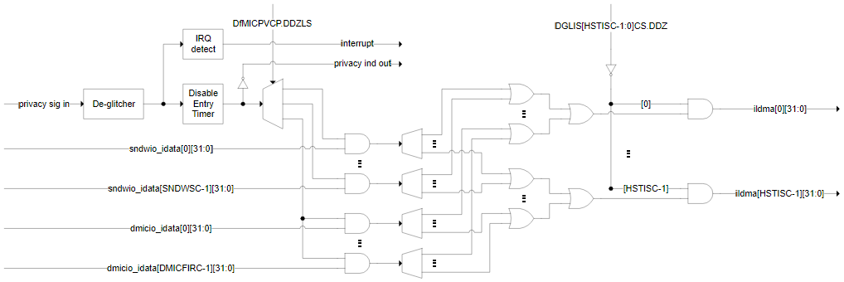When the mic disable switch is turned off later, the HW will unmask the data from the microphone (immediately) and interrupt DSP FW indicating the mic re-enabling (allow DSP FW / host SW to gracefully unmute), as well as turning off the privacy LED indication through the GPIO pin.

Figure 39: Privacy microphone protection conceptual diagram

**Reference:**

[https://docs.intel.com/documents/iparch/ace/ACE%20IP/3.x/Integration%20Specs/WCLSM/WCLSM_ACE3.x_Integration_HAS.html#privacy-microphone-protection](https://docs.intel.com/documents/iparch/ace/ACE%20IP/3.x/Integration%20Specs/PTLSM/PTLSM_ACE3.x_Integration_HAS.html#privacy-microphone-protection)

Below table represents the **privacy sig in** & **privacy ind out** signal description.

Table 42: Privacy microphone protection signal description

|  |  |  |
| --- | --- | --- |
| **SIGNAL NAMES** | **TYPE** | **DESCRIPTION** |
| PVC_SIG_IN | I | **Privacy Signaling Input:**  Privacy microphone disable signaling input, typically for connection to a switch. Asserted high to indicate the microphone disabled state (HW will ensure the data output from the microphone is masked to zero). |
| PVC_IND_OUT | O | **Privacy Indicator Output:**  Privacy microphone disable indication output, typically for connection to an LED. Asserted high to indicate the microphone disabled state (after HW has masked the data output from the microphone to zero). |

**Note:** These pins are typically associated with DMIC interface, but also usable by microphone connected over SoundWire interfaces.

WCL RVP uses SoC pins MIC_MUTE and MIC_MUTE_LED to support microphone privacy protection. The diagram below represents RVP implementation.



Figure 40: WCL RVP audio MIC privacy support block diagram

The following table represents MIC privacy operation through SoC pins using jumper control as supported in WCL RVP.

Table 43: WCL RVP MIC privacy feature SoC signal description

|  |  |
| --- | --- |
| **SIGNAL NAME** | **DESCRIPTION** |
| GPP_H_3_MIC_MUTE | Mic mute - Indicate the user privacy mode setting on the system (ON : gate the clock to the mic, OFF : ungate the clock to the mic) |
| GPP_H_17_MIC_MUTE_LED | Mic mute led- Led to Indicate the user privacy mode setting on the system. (ON : gate the clock to the mic, OFF : ungate the clock to the mic) |

Refer below table for MIC mute operation using jumper settings

Table 44: WCL MIC Mute Operation using jumper setting

|  |  |  |
| --- | --- | --- |
| **MODE** | **Jumper POSITION** | **LED INDICATION** |
| MIC mute OFF - Default | 2-3 | OFF |
| MIC mute ON | 1-2 | ON (Green) |

# Serial Interfaces- SPI, eSPI, SMBus, SM Link, MLink/CLink

This chapter discusses the various serial interfaces namely SPI, eSPI, THC-SPI, SMBus, SMLink, MLink. The SPI, eSPI and THC-SPI are functionally similar IPs. The mapping of all serial ports is as shown below. The mapping is subjected to change based on the inputs from design or validation teams.

***Notes:***

1. For probing these signals, test points will be provided by opening the via masks on the SOC side. For the device side, series resistors or pull ups close to the device will be used for probing. If there are no components available near the end device for probing, then the test points will be provided closest to the device. However, if the test points are adding additional vias and violate the SI guidelines, then test points will not be provided.
2. For all the serial interfaces, for only one of the ports, A dummy test structure consisting on VCC pull up resistor (empty), load capacitor to ground(empty) and 0-ohm series resistor(populated) sharing pads as close as possible to SOC side and device side will be implemented.
3. The following options are not provided on RVP for any of the LPSS / ISH / Serial interfaces:  
   TLA footprint, midbus probes, Beagle headers, Aardwark support.
4. The mapping of ports and GPIOs will be same for all the RVP SKUs to ease software effort. Deviations will be mentioned in the specific sections.

## SPI & THC SPI Ports

The WCL SOC provides Serial Peripheral Interfaces (SPI) for connecting BIOS Flash, TTK3 and TPM. Which is 1.8V IO voltage only with maximum speed of 50MHz.

The SPI0 (CSME SPI) interface consists of 3 chip-select signals. It is allowing up to two flash memory devices (SPI0_CS0# and SPI0_CS1#) and one TPM device or TTK3 device (SPI0_CS2#) to be connected to the SOC working in quad-mode. The SPI0 interfaces support 1.8V only.

A rework option would be provided for the 64MB SPI flash part working at 100MHz, 1 Load only on the SPI0 bus.

Legacy touch can be supported from GSPI. But since THC is POR for WCL, only THC based touch connections will be provided on RVP. GSPI based touch support is not provided.

The GSPI0 interface is multiplexed with THC0, implementing one Chip Select signal (SPI0_CS#) and is intended for integrated touch implementation, also working in quad-mode. GSPI0 supports 1.8V only. THC/I2C/GSPI signals are all muxed internally in the PCH as a HID device port (there are 2 HID ports on WCL) and will be programmable through the BIOS GPIO Configuration (as alternate functions). This requirement is no board reworks needed to switch among bus selection within the same HID port, HID port definition was introduced in ADP-LP.

Refer to the BIOS Flash Interface (SPI) section for detailed explanation on the Flash sharing mechanisms.



Figure 41: WCL RVP SPI & THC SPI Interface support

## eSPI Port

The PCH eSPI (Enhanced SPI) controller supports the following features:

* Support for 20MHz, 25MHz, 33Mhz and 50MHz bus operation.
* 1.8V support only
* Up to quad mode support with 2 Chip Select signals.
* In-band messages for communication between the SOC and slave device to eliminate side-band signals
* Real time SPI flash sharing, allowing real time operational access by the SOC and slave device.
* MAF & SAF modes
* PECI over eSPI

On WCL RVP, eSPI interface is for communication between EC and SOC. This port can run at max 50MHz and IO voltage is 1.8V. The eSPI pins will be routed to ESPI Bus Header with appropriate reworks.

eSPI also has an option, as illustrated in the figure below to be connected to the MECC connector for other EC support and eSPI bus header.



Figure 42: WCL RVP eSPI Interface support

## SMBus & SMLink

SMBus Controller IP is SMBus 2.0 compliant and provides a mechanism for the SOC to initiate communications with the SMBus peripherals (slaves) or allows external attached peripherals to write or read to the SoC. SMBus controller supports 100 kHz, 400 kHz, 1 MHz operation.

On WCL RVP, the SMBus is interfaced to PCIe Slot, Memory SPD (SODIMM), PSS EEPROM, FRU EEPROM, ESPI Bus Header, SOC MIPI60 Connector, PM Side Band Header using a SMBUS Bus expander. Figure 43 gives the list of devices on the SMBUS and their read/write addresses.

SOC implements 2 SMLink controllers for the 3 SMLink interfaces, SMLink0, SMLink0B and SMLink1. The interfaces are intended for system management and are controlled by the Intel® ME. And they can run at frequencies up to 1MHz.

On WCL SMLink0 is mainly used for integrated LAN. When an Intel LAN PHY is connected to SMLink0, a soft strap must be set to indicate that the PHY is connected to SMLink0. The interface will be running at the frequency of up to 1 MHz depending on different factors such as board routing or bus loading when the Fast Mode is enabled using a soft strap.

SMLink0 is routed to Jacksonville, x4 PCIe Slot, USB-C Connector and. SMLink0B is routed to TBT Retimer, USB-C Connector, MECC and EC on WCL RVP. SMLink1 is routed to PM Sideband Header, MECC and PD A



Figure 43: WCL RVP SMBus & SMLink support

## MLink / CLink

M-Link interface is the management communication link between the SOC and Intel Wireless cards. It enables Manageability to support low power interface of Intel WiFi network interfaces. Supported in S0 and Sx power states. Single Clink controller to connect to external C-link device or as a internal C-link connection with CNVi.

Note: Clink has also been called Manageability link (MLink) in some documentation

The M.2 WLAN card Link Status can be monitored with help of C-Link signals from the M.2 Module. The signal routing option is provided through a tri-pad, to the WLAN module, 2x4 Header and SOC.

Table 45: CLink Interface Signals

|  |  |  |
| --- | --- | --- |
| Signal Name | Type | Description |
| CL_RST# | O | Wi-Fi* CLINK host bus reset for standard CNV with CLINK support (Intel® vPro™).  Optional to connect to a Wi-Fi* CLINK reset pin on the Intel® vPro™ Wi-Fi* module. |
| CL_DATA | I/O | Wi-Fi* CLINK host bus data for standard CNV with CLINK support (Intel® vPro™).  Optional to connect to a Wi-Fi* CLINK data pin on the Intel® vPro™ Wi-Fi* module. |
| CL_CLK | O | Wi-Fi* CLINK host bus clock for standard CNV with CLINK support (Intel® vPro™).  Optional to connect to a Wi-Fi* CLINK clock pin on the Intel® vPro™ Wi-Fi* module. |

**Note: MLINK HDR will not be stuffed in RVP**

# Embedded Controller

WCL RVP will support MEC1723 Microchip Embedded Controller (EC) onboard. MEC1723 supports ESPI mode of operation. LPC mode will not be supported in WCL. EC controls the preliminary platform power sequencing and does system and power management. EC is the platform thermal controller that monitors and throttles CPU or controls CPU Fan. The key functionalities of EC on the platform are illustrated in below figure.

**Note:** EC part (144-pin WFBGA package) used in WCL design **is MEC1723NB0-I/SZ**



Figure 44: Embedded Controller Block Diagram

The EC subsystem consists of:

* Thermal Management functions like CPU Fan control, Chassis Fan control, PECI, DIMM temperature etc.
* Platform Power management like Power sequencing, Sx and Deep Sx entry/exits.
* Any CEC specific Modern Standby requirements to be implemented inside EC
* Handles the Board-ID, Fab-ID, BOM SKU-ID, messages to the BIOS.
* RVP design will support all three i.e., SAF, MAF, G3 Flash configuration, default will be MAF.
* 2x14 pin eSPI header will also be supported.
* Switching between MAF / SAF / G3 will be through resistors only. No jumper can be provided as it impacts SI and leads to Signal Integrity issues.
* Separate PMR resistors will be added for 1.8V and 3.3V rails going to EC.
* EC GPIO mapping yet to be updated and shared with EC team.
* MECC connector will be supported for validating the EC from different vendors only on the RVP2 of WCL. In all other sku’s this connector will be unstuffed.

In WCL we are following PTL-UH RVP implementation and there are few changes/ optimizations as compared to previous RVP platforms in the EC and MECC sections to ease out the routings, reduce BOM cost, add extra features etc. The details are mentioned below.

* Only one PS2 header is supported over the WCL RVP which is default configured as PS2 KB from EC. EC has only one PS2 IP which can be configured as PS2 KB/ PS2 mouse at any given point of time.
* The LDO to generate the VREF ADC rail has been removed from WCL RVP. So, this is generated from 3.3VA KBC EC rail in current design (same as VTR_PLL rail, as recommended in EC datasheet).
* We have additional 3 thermistors in WCL RVP getting mapped to the EC for energy telemetry application.
* EC EEPROM is removed from WCL RVP as deep Sx state is not supported in none of the SKUs.
* Few signals are removed from the on-board EC due to lack of functionality to ease out the routing (EC SMI signal, HB NVDC SEL, EC SLP S0 CS, INT from board ID IO expander, Aux adapter detect, EC SML CLK/ DATA).

There has been changes done to latest MECC specifications as per platform requirements after discussion in EC WG, kindly refer to MECC section for more details.

The RVP supports LED for CAPSLOCK, NUMLOCK and SCROLL LOCK. The EC error code table with on-board LED status is given below.

Table 46: EC error code indication

|  |  |  |  |  |
| --- | --- | --- | --- | --- |
| Error type | Error code | Caps Lock LED | Scroll Lock LED | Num Lock LED |
| No Error | 0 | Off | Off | Off |
| RSMRST#_PWRGD | 1 | Off | Off | Flash |
| PM_SLP_S5# | 2 | Off | Flash | Off |
| PM_SLP_S4# | 3 | Off | Flash | Flash |
| PM_SLP_S3# | 4 | Flash | Off | Off |
| PM_SLP_A# | 5 | Flash | Off | Flash |
| ALL_SYS_PW_RGD | 6 | Flash | Flash | Off |
| PLTRST# | 7 | Flash | Flash | Flash |

It is to be noted that,

* KSC Thermal Shutdown is indicated by flashing of Num_Lock and Caps_Lock LEDs alternatively.
* The above errors are displayed by EC on Port80 as EC 01 to EC 07. These errors are not EC errors, and these errors represent the platform status.

## MECC AIC Support

MECC AIC connector(200-pin) is supported for windows RVP for validating the external EC over AIC. Chrome BoM SKU is supported through onboard Chrome AVL EC MEC1727N-B0-I/SZ-CHR0 part.

Chrome SKU uses H1 & Servo AIC same as MTL-P for Chrome SKU to support the MECC AIC option.

**Note:** MECC connector is supported only on RVP2(LP5x T3 MECC RVP2) SKU. It is not supported on all other RVP SKUs.

Table 47: MECC Connector

|  |  |  |
| --- | --- | --- |
| MFG | Mfg. Part Number | IPN Number |
| Amphenol | 84535-191LF | N15428-001 |

MECC connector pinout details are shared over [Link](https://intel-my.sharepoint.com/personal/ccgmtlclientsystempdt/ArchLZPRD/MTL_M_P_RVP_Architecture_HAS/GPIO_Mappin_SoC_EC/2021_MECC_Pin_Mapping.xlsx?d=w135724d44d1a4c0d9465ca91899415e9)

## Flash Sharing

WCL RVP supports both MAF, SAF and G3 flashing configuration. There is no dedicated Flash to EC. SOC GPIO is used for flash selection strap pin refer Pin strap section for more details.

EC shared flash (SOC SPI NOR).

* Shared SPI Flash: Currently a Composite image. Update is done by BIOS. Top swap allows recovery.
* Slave Attached EC Flash. Lot of security features in EC. (Apple uses EC as a root of trust, Google uses BIOS based root of trust)).

## EC – I2C IO Expander

I2C based IO expanders are provided to handle Board-ID, Fab-ID, BOM SKU-ID and some IO requirement. EC I2C mapping is provided in the below table.



Figure 45: EC- I2C Block Diagram

## EC – Headers

Below sections includes connector and pinout details of the connectors used in EC section.

### eSPI Sideband Header

Table 48: eSPI Sideband Header and Pinout

|  |  |  |
| --- | --- | --- |
| **MFG** | **Mfg. Part Number** | **IPN Number** |
| Samtec | ASP-175166-01 | H46981-001 |

|  |  |  |  |
| --- | --- | --- | --- |
| Signal Name | Pin # | Pin # | Signal Name |
| ESPI_CLK_HDR | 1 | 2 | GND |
| ESPI_CS0_HDR_N | 3 | 4 | NO PIN |
| SHM_TRIG_PLT_RST_R | 5 | 6 | +V5A_VAL |
| ESPI_IO3_HDR | 7 | 8 | ESPI_IO2_HDR |
| +V3P3A_VAL | 9 | 10 | ESPI_IO1_HDR |
| ESPI_IO0_HDR | 11 | 12 | GND |
| SMB_CLK_S3 | 13 | 14 | SMB_DATA_S3 |
| +V3.3A_1.8A_R1_TPM | 15 | 16 | ESPI_CS1_HDR_N |
| GND | 17 | 18 | NC |
| ESPI_RST_HDR_N | 19 | 20 | ESPI_ALERT0_HDR_N |
| NO PIN | 21 | 22 | NO PIN |
| ESPI_ALERT1_HDR_N | 23 | 24 | NC |
| TP_GPP_A8_CLKRUN_R_N | 25 | 26 | NC |
| +V5A_VAL | 27 | 28 | NC |

### PS2 KB HEADER

There is no PS2 mouse header on WCL RVP. We have only one PS2 header which is configured as PS2 KB from EC.

Table 49: PS2 KB and Pinout

|  |  |  |
| --- | --- | --- |
| **MFG** | **Mfg. Part Number** | **IPN Number** |
| SAMTEC | TSM-105-01-G-SV-P-TR | K88184-001 |

|  |  |
| --- | --- |
| **Pin #** | **Signal Name** |
| 1 | PS2_KB_CLK_FB |
| 2 | +V5_PS2 |
| 3 | GND |
| 4 | GND |
| 5 | PS2_KB_DATA_FB |

### Scan Matrix Keyboard Header

Table 50: Scan Matrix Header and Pinout

|  |  |  |
| --- | --- | --- |
| **MFG** | **Mfg. Part Number** | **IPN Number** |
| Ipex | 20542-028E-01 | H24635-001 |

|  |  |  |
| --- | --- | --- |
| Pin # | Signal Name | |
| 1 | KBC_SCANIN<6> |
| 2 | KBC_SCANIN<0> |
| 3 | KBC_SCANIN<1> |
| 4 | KBC_SCANOUT<6> |
| 5 | KBC_SCANIN<3> |
| 6 | KBC_SCANIN<2> |
| 7 | KBC_SCANOUT<15> |
| 8 | KBC_SCANIN<5> |
| 9 | KBC_SCANIN<4> |
| 10 | KBC_SCANOUT<10> |
| 11 | KBC_SCANOUT<14> |
| 12 | KBC_SCANIN<7> |
| 13 | KBC_SCANOUT<13> |
| 14 | KBC_SCANOUT<11> |
| 15 | KBC_SCANOUT<8> |
| 16 | KBC_SCANOUT<7> |
| 17 | KBC_SCANOUT<9> |
| 18 | KBC_SCANOUT<12> |
| 19 | KBC_SCANOUT<3> |
| 20 | KBC_SCANOUT<2> |
| 21 | KBC_SCANOUT<1> |
| 22 | KBC_SCANOUT<4> |
| 23 | KBC_SCANOUT<5> |
| 24 | KBC_SCANOUT<0> |
| 25 | LED_NUMLOCK |
| 26 | LED_CAPSLOCK |
| 27 | +V3.3A_KBC |
| 28 | NC |

### Keyboard Backlight Header

Table 51: KB Backlight Header and Pinout

|  |  |  |
| --- | --- | --- |
| **MFG** | **Mfg. Part Number** | **IPN Number** |
| Ipex | 20542-006E-01 | H24575-001 |

|  |  |  |
| --- | --- | --- |
| **Pin #** | **Signal Name** | |
| 1 | +V5S_KBD_BKLT |
| 2 | +V5S_KBD_BKLT |
| 3 | NC |
| 4 | NC |
| 5 | KBD_BKLT_CTRL_FET |
| 6 | KBD_BKLT_CTRL_FET |

### Fan Header

Table 52: Fan Header and Pinout

|  |  |  |
| --- | --- | --- |
| **MFG** | Mfg. Part Number | IPN Number |
| Molex | 51021-0400 | A36295-009 |

|  |  |
| --- | --- |
| **Pin #** | Signal Name |
| 1 | FAN_CONN_PWM_IN |
| 2 | CPU_TACHO_R_FAN |
| 3 | GND |
| 4 | +V5_FAN_SUPPLY |

## Front Panel Header

Table 53: Front Panel Header and Pinout

|  |  |  |
| --- | --- | --- |
| **MFG** | Mfg. Part Number | IPN Number |
| WIESON TECHNOLOGIES CO., LTD | AC2100-0009-042-HH | K96810-001 |

|  |  |  |  |  |  |
| --- | --- | --- | --- | --- | --- |
| **Signal Name** | | Pin # | Pin # | Signal Name | |
| FRONT1(Pull up to 5V) | 1 | | 2 | FRONT2 (Pull up to 5V) |
| TP _SATA_LED_N | 3 | | 4 | GND |
| GND | 5 | | 6 | PWR_CONN_D |
| RST_PUSH_N_D | 7 | | 8 | GND |
| +V5A_VAL | 9 | | 10 | Key |
| NC | 11 | | 12 | GND |
| GND | 13 | | 14 | Key |
| BC_ACOK_DSW | 15 | | 16 | +V5A_VAL |

## PM Sideband Header

Table 54: PM Sideband Header

|  |  |  |
| --- | --- | --- |
| **MFG** | **Mfg. Part Number** | **IPN Number** |
| Molex | 87832-4020 | C12536-002 |

|  |  |  |  |
| --- | --- | --- | --- |
| **Signal Name** | **Pin#** | **Pin #** | **Signal Name** |
| PM_PWRBTN_N | 1 | 2 | ALL_SYS_PWRGD |
| PM_RSMRST_N | 3 | 4 | SMB_BS_DATA_PORT80_R |
| PM_SLP_S5_N | 5 | 6 | SMB_BS_CLK_PORT80_R |
| PM_BATLOW_N | 7 | 8 |  |
| PM_SLP_S3_N | 9 | 10 | SIDEBAND_TIME_SYNC_0 |
| PM_SLP_S4_N | 11 | 12 | SML1_DATA_R |
| +V3P3A | 13 | 14 | SML1_CLK_R |
| EDM_PCD_PM_HDR | 15 | 16 | GND |
| RTC_RST_N | 17 | 18 | M.2_WLAN_PE_WAKE_N |
| SMC_WAKE_SCI_N | 19 | 20 | SMC_LID |
|  | 21 | 22 | BC_ACOK_EC_IN |
| PS_ON_SW_N | 23 | 24 | PM_SLP_A_N |
| M2_SSD_EC_I2C05_CLK | 25 | 26 | PM_PCH_PWROK |
| M2_SSD_EC_I2C05_DATA | 27 | 28 | SRTC_RST_N |
| RECVRY_INDICATOR_N | 29 | 30 | RSMRST_PWRGD_N |
| PM_SYSRST_N | 31 | 32 | PM_SLP_S0_N |
| +V1P8A | 33 | 34 | BUF_PLT_RST_N |
| SMB_DATA_S3_J | 35 | 36 | SYS_PWROK |
| SMB_CLK_S3_J | 37 | 38 | EDM_CPU_PM_HDR |
| NC | 39 | 40 | NC |

# BIOS Flash Interface (SPI)

WCL RVP supports native SPI interfaces SPI0. The SPI0 is for used for flash and TPM while THC SPI1 and THC SPI2 are used for Touch interface.

WCL RVP supports 1.8V 64MB flash on SPI0 interface. Windows RVP will use 1x 64MB part MX77U51250FZ4I42 from Macronix default and Chrome RVP will use 32MB W25Q256JWEIM default.

TPM AIC should be plugged into the same header used for BIOS flashing on SPI0.

WCL RVP will support 1.8V compatible SPI devices for MAF/SAF and G3 mode. RPMC for 1.8V devices will be default supported on WCL RVP. SPI devices will support 100MHz clock rates. No 3.3V SPI support from WCL SOC.

Default Device supported on RVP will be 64MB 1.8V with RPMC. Jumper for Flash Descriptor Override will be supported. Also, RVP allows to boot the platform while Dediprog SF600/SF100 programmer is connected to the platform.

WCL RVP1 has placeholder for second flash on SPI0 to support dual flash topology which is not POR.

WCL RVP2 has placeholder for second flash to enable 24 SPINOR for chrome SKU which not POR, which is tripaded with flash 0.

The SPI0 interface of SOC is shown in below diagram.



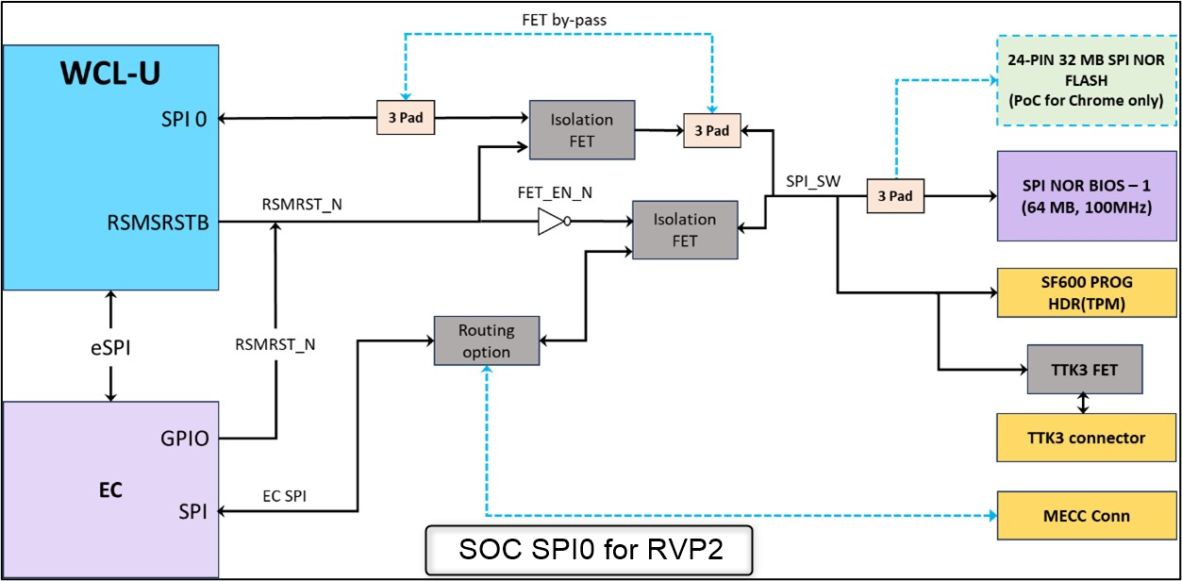

Figure 46: BIOS Flash interface (SOC-SPI0) for RVP1 and RVP2

**NOTE:** WCL SPI0 buffer type is Fail Safe Buffer, hence no isolation FET is needed from SoC to Flash especially in SAF and G3 Flash Sharing configuration. However, due to concerns on the voltage level during FW flashing, RVP have provided the isolation FET with bypass in RVP and isolation FET path will be the default.

## EC Flash Topology

EC FW image is stored in either external SPINOR or embedded flash. The embedded flash should have enough space to store the entire FW and any Non-Volatile data. ECs without embedded flash requires an external SPI flash, either dedicated or shared with SOC. Three types of flash sharing mechanisms shall be supported on WCL RVP designs.

* G3 flash sharing
* MAF - Master attached flash sharing
* SAF - Slave attached flash sharing.

WCL RVPs shall support all the flash sharing mechanisms. Reworks change into SAF or G3 from MAF will be minimized comparing to previous RVPs.

### G3 Flash Sharing

In this mechanism, the SPI lines from flash part are connected to both SOC and EC either directly or switch. Due to security concerns and flash access limitation, this is the least recommended option in all the flash sharing mechanisms.

* The RSMRST# from EC is used for controlling the flash access and switched only once during G3 exit.
* EC accesses the SPINOR only when RSMRST# is asserted and tri-states the SPI lines on de-assertion.
* On G3 exit (with RSMRST# asserted) EC loads the entire image in its internal SRAM and releases RSMRST# for SOC to access the flash. This doesn’t require eSPI to be operational.
* Some isolation FETs required if SOC doesn’t tristate the lines when RSMRST# is asserted.



Figure 47 : G3 Flash Sharing high level block diagram

#### Flash update

* Requires host to update the EC region in shared SPINOR without EC involvement.
* Update is like any other OEM regions like BIOS.
* Host can support Full image update or EC region update.
* UEFI Capsule update is the minimum requirement with BIOS signature verification.
* FW recovery
  + Intel SOC is not responsible for EC FW recovery.
  + OEMs may support through alternate options
    - Use other interface that is active in S5 (typically used in service center)
    - Implement non updatable block (ROM) in EC that brings up the system to S0 for flash update.

#### Master Attached Flash Sharing (MAF)

MAF is one of the Flash sharing mechanisms where SOC is the master which access flash over SOC SPI0 Controller and EC sharing the same flash will access over eSPI. MAF will be default the configuration for the WCL.

Here the SPI flash is connected to SOC and EC accesses the flash over eSPI.

* Requires eSPI interface to be up and initialized by both SOC and EC.
* On G3 exit, EC de-asserts RSMRST#(GPIO055), initializes eSPI, reads its image from SPINOR over eSPI, loads into its internal SRAM and notifies PCH. This is handled by the ROM in EC chip before giving control to the downloaded FW image.
* The downloaded flash image continues the power sequencing until SOC is out of reset and BIOS starts executing.
* This flash sharing mechanism also allows access during runtime which is handled by the downloaded EC FW image.
* Soft strap in descriptor to restrict EC to access EC FW region only.
* EC image Offset 1000H.



Figure 48 : MAF high level block diagram

#### Slave Attached Flash Sharing (SAF)

SAF is one of the Flash sharing Mechanism where EC is the master which access flash over its SPI Controller and PCH sharing the same flash will access over eSPI. MEC1723 Microchip Embedded Controller can support SAF mode flashing. Rework is required on RVP to support SAF.

WCL SOC is allocated dedicated regions (for each of the supported masters) within the eSPI slave-attached flash devices. SOC has read, write, and erase access to these regions, as well as any other regions that maybe permitted by the region protections set in the Flash Descriptor. The Slave will optionally perform additional checking on SOC provided address. In case of an error due to incorrect address or any other issues it will synthesize an unsuccessful completion back to the eSPI Master.

The SAF supports Flash Read, Write and Erase operations. It also supports the RPMC, Read SFDP and Read JEDEC ID commands.

In this topology, the SPI flash is connected to EC and SOC accesses the flash over eSPI.

* On G3 exit, EC loads its entire image into its internal SRAM, verifies the image (if supported as root of trust), and then de-asserts RSMRST# for PCH/SOC to access flash over eSPI.
* EC must meet the timing requirements for the SAF to avoid FW access latencies to avoid any impact to responsiveness or boot time.
* EC should enable the access to regions based on soft straps in the descriptor.



Figure 49 : SAF high level block diagram

# Low Power Sub Systems (LPSS)

Initial allocation of each port is given in the block diagram of the respective sub-sections.

***Notes:***

1. For probing these signals, test points will be provided by opening the via masks on the SOC side. For the device side, series resistors or pull ups close to the device will be used for probing. If there are no components available near the end device for probing, then the test points will be provided closest to the device. However, if the test points are adding additional vias and violate the SI guidelines, then test points will not be provided.
2. For all the serial interfaces, for only one of the ports, A dummy test structure consisting of VCC pull up resistor (empty), load capacitor to ground(empty) and 0- ohm series resistor(populated) sharing pads as close as possible to SOC side and device side will be implemented.
3. Following options are not provided on RVP for any of the LPSS / ISH / Serial interfaces:  
   TLA footprint, midbus probes, Beagle headers, Aardwark support.
4. The mapping of ports and GPIOs will be same for all the RVP SKUs to ease software effort. Deviations will be mentioned in the specific sections.

## I2C/I3C

The SOC implements 6 I2C controllers for 6 I2C interfaces (I2C0-I2C5), capable of maximum bit rate of 3.4 Mbps (High-speed mode). Each interface is a two-wire serial interface consisting of a serial data line (SDA) and a serial clock (SCL). The following are the constraints considered for I2C mapping:

1. Camera sensors and touch screen / touch pad cannot be on the same I2C bus.

2. Each camera connector needs a separate I2C bus to avoid address conflict since all the camera sensors have same I2C address. In older platforms the address conflict is resolved by doing a rework and a software work around. But on WCL this needs to be fixed. Hence allocating one I2C per camera connector in WCL RVP.

Each I2C interface can support the following Speed & power options:

* Standard mode (up to 100 kbps)
* Fast mode (up to 400 kbps)
* Fast mode plus (up to 1 Mbps)
* High speed mode (up to 3.4 Mbps)
* 1.8V support only

WCL supports 3- I3C interfaces and I3C interface.

* Support backward compatibility for Fast Mode and Fast Mode Plus. Slave device clock
* stretching is not supported.
* Single Data Rate (SDR) 12.5 Mbps, Dual Data Rate (DDR) 25 Mbps
* Support In-band Interrupt (IBI)
* Support Hammock Harbor time synchronization

Table 55: I2C/I3C device mapping

|  |  |
| --- | --- |
| **Bus** | **Device Mapping** |
| I3C (Debug BPK I3C) | Modular TCSS TCP0 I3C Debug, I3C 1X4 HDR |
| I2C 0/ I3C 0 | 1X4 HDR, MECC AIC, SPD as I3C0  TTK3 for chrome rework as I2C0 |
| I2C 1/ I3C 1 | SV DIPSW HDR /MECC AIC as I2C1 |
| I2C 2/ MFUART 2 | M.2 WLAN MFUART 2 |
| I2C 3/ UART1/ ISH UART1A | Track PAD/ Audio/ PSS/ Power meter/TTK3/EDP |
| I3C 3A/ Display Sideband | Display sideband GPIO |
| I2C 4/ THC0_SPI1/THC_I2C0 | Touch Panel Con 1 (THC_I2C0 & THC0_SPI1 mode) |
| I2C 4A/ ISH I2C 2/ MFUART0 | M.2 WLAN MFUART 0 / ISH HDR as ISH I2C2 |
| I2C 5/ THC1_SPI2/THC_I2C1 | Touch Panel Con 2 and Touch PAD (THC_I2C1 & THC1_SPI2 mode) |
| I2C 5A/ MFUART 0/ ISH GP | ISH GPIO's |



Figure 50: LPSS I2C/I3C high level Block Diagram

### I2C Device Details

The table below provides the devices connected to the LPSS I2C/I3C subsystem.

Table 56: I2C/I3C device details

|  |  |  |  |  |
| --- | --- | --- | --- | --- |
| Device | Speed | 7 Bit address Set | 7 Bit Address Options | I2C IO Voltage |
| Touch Pad | 400KHz | 0x2C | 0x2C | 3.3V |
| Touch Panel-1 | 400KHz/ 1MHz | 0x5C (General Study) | 0x5C | 1.8V |
| Touch Panel-2 | 400KHz/ 1MHz | 0x5C (General Study) | 0x5C | 1.8V |
| PSS | 400KHz | 0x6E | 0X68 or 0x6A or 0X6C or 0X6E | 1.8V |
| Power meter Chip#1 | 100KHz/ 400KHz/ 1MHz ( FM+) | 0x18 | Configurable through resistor | 1.8V |
| Power meter Chip#2 | 100KHz/ 400KHz/ 1MHz ( FM+) | 0x1E | Configurable through resistor | 1.8V |
| Power meter Chip#3 | 100KHz/ 400KHz/ 1MHz ( FM+) | 0x11 | Configurable through resistor | 1.8V |
| Power meter Chip#4 | 100KHz/ 400KHz/1MHz ( FM+) | 0x15 | Configurable through resistor | 1.8V |
| Power meter Chip#5 | 100KHz/ 400KHz/1MHz ( FM+) | 0x19 | Configurable through resistor | 1.8V |
| Power meter Chip#6 | 100KHz/ 400KHz/1MHz ( FM+) | 0x14 | Configurable through resistor | 1.8V |
| Power meter Chip#7 | 100KHz/ 400KHz/1MHz ( FM+) | 0x17 | Configurable through resistor | 1.8V |
| Power meter Chip#8 | 100KHz/ 400KHz/1MHz ( FM+) | 0x16 | Configurable through resistor | 1.8V |
| Power meter Chip#9 in RVP2 | 100KHz/ 400KHz/1MHz ( FM+) | 0x13 | Configurable through resistor | 1.8V |
| Power meter Chip#10 in RVP2 | 100KHz/ 400KHz/1MHz ( FM+) | 0x1B | Configurable through resistor | 1.8V |
| High accuracy Power meter Chip#1 | 100KHz/ 400KHz/1MHz ( FM+) | 0x12 | Configurable through resistor | 1.8V |
| High accuracy Power meter Chip#2 | 100KHz/ 400KHz/1MHz ( FM+) | 0x1D | Configurable through resistor | 1.8V |
| High accuracy Power meter Chip#3 | 100KHz/ 400KHz/1MHz ( FM+) | 0X1A | Configurable through resistor | 1.8V |
| CONNECTIVITY - GBIT LAN - JACKSONVILLE LAN PHY CHIP |  | 0xC8 (Read) , 0xC7 (Write) |  | 3.3V |
| FRU EEPROM | 100KHz/400KHz | 0xAD(Read), 0xAC (Write) | Configurable through resistor | 3.3V |

## UART

The LPSS Subsystem includes 3 UART ports. The UART ports communicate with serial data port devices compatible with the RS-232 interface protocol. The device map for the LPSS-UART interfaces on WCL are as shown below.

Table 57: UART Device details

|  |  |
| --- | --- |
| Bus | Device Mapping |
| UART 0 | Serial Debug Port /TTK3 |
| UART 1/ ISH UART 1A/ I2C 3 | Track PAD/ Audio/PSS/ Power meter/TTK3/EDP |
| UART 2/ CNVi | M.2 BT module CNIVi and non CNVi |



Figure 51: LPSS UART Block Diagram

## GSPI

The SOC implements 2 GSPI interfaces to support devices that uses serial protocol for transferring data. Each interface consists of a clock (CLK), 2 chip selects (CS) and 2 data lines (MOSI and MISO). The device map for the LPSS-GSPI interfaces on WCL are as shown below.



Figure 52: LPSS GSPI High level Block Diagram

# Integrated Sensor Hub (ISH)

## ISH Sensors

Following sensors are selected for validation on WCL and will be hosted on the MoSAIC Gen 2 card. The details of ISH and MoSAIC Gen 2 card are discussed in subsequent sections.

Note: BOM1 BOM2 Sensors are not finalized for WCL. The 3PE teams need to provide the data.

Table 58: List of Sensors on WCL RVP

|  |  |  |
| --- | --- | --- |
| **Generation** | **ISH 5.8** | |
| **Platforms** | **BOM1** | **BOM2** |
| 3-axis Accelerometer | *Bosch BMI323* | STMicro LSM6DSV16 |
| 3-axis Magnetometer | Memsic MMC5603NJ | AKM AK9919C |
| 3-axis Gyroscope | *Bosch BMI323* | STMicro LSM6DSV16 |
| Barometer/Altimeter |  | STMicro LPS22DF |
| ALS | Vishay VCNL4030 | ST VD6283 |
| RGB/XYZ |  | ST VD6283 |
| SAR - Proximity | Semtech SX9331 | Semtech SX9331 |
| IR |  | ST VD6283 |
| UV |  |  |
| 2nd Accelerometer | Bosch BMA422 | STMicro LIS2DW12 |
| Humidity |  |  |
| Shock |  | ST LSM6DSV32 |
| Temperature |  | STMicro HTS221 |
| HAL switch | Rohm BU52072GWZ | Rohm BU52072GWZ |
| Heart rate/Sp02 |  |  |
| ECG |  |  |
| Human Presence | ST VL53L7 | *Infineon BGT60TR13C* |
| User temperature |  |  |

**Note:**

* Samtec Cable: HQCD-030-12.00-TBL-SBR-1
* Extender Cable: 10-pin 2x5 Socket-Socket 1.27mm IDC (SWD) Cable (<https://www.adafruit.com/product/1675>)
* Uses same sensor BOM as LNL and PTL
* Supported by 3rd party vendor.

## Integrated Sensor Hub

The Integrated Sensor Hub (ISH) is a Soft IP that serves primarily as the connection point for the sensors on a platform. ISH is designed for the “Always-On, Always-Sensing” goal. WCL supports Integrated Sensor Hub (ISH 5.8). It contains the following interface to the sensors namely: I2C, I3C, SPI, UART, GPIO. It provides the following functions to support this goal.

* Acquisition / sampling of sensor data in all platform states including Sx and S0.
* Ability to combine data from individual sensors to create a more complex Virtual sensor that can be directly used by the firmware/OS/Applications.
* Low power operation through clock and power gating of the ISH blocks, including SRAMs, together with the ability to manage the power state of the external sensors.
* The ability to operate independently when the host platform is in a low power state.
* Compatibility with various operating systems,
* Ability to provide sensor-related data to other subsystems within the SOC, such as the CSME, Camera subsystem, Audio subsystem, etc.

ISH contains the following interface to the sensors namely: I2C, I3C,SPI, UART, GPIO.

* **ISH I2C:** ISH contains up to 3 I2C Ports capable of High-Speed Mode up to 3.4 Mbps.
* **ISH I3C:** ISH contains up to 2 I3C Ports with 10Mbps.
* **ISH SPI:** ISH contains 2 SPI port supporting speed up to 25 Mbps.
* **ISH UART:** ISH supports 2 UART ports capable of supporting operating speeds up to 6 Mbps.
* **ISH GPIOs**: ISH GPIOs are typically used for enabling the power to the sensor, detecting the interrupts from sensors etc. External pull ups will be provided for ISH GPIOs.



Figure 53: ISH Sensor Header high level block diagram

### ISH I2C/I3C

The ISH supports three I2C controllers capable of operating at speeds up to 3.4 Mbps each. The I2C controllers are completely independent of each other: they do not share any pins, memory or interrupts.

The ISH’s I2C host controllers also share the same general I2C port specifications:

* Master Mode Only (all peripherals must be slave devices)
* Support for the following operating speeds:
  + Standard mode: 100kbps
  + Fast Mode: 400kbps
  + Fast Mode Plus: 1Mbps
  + High speed mode:3.4Mbps
* Support 7-bit addressing formats on the I2C bus
* FIFO of 64 bytes with programmable watermarks/thresholds

ISH I3C signal is muxed with ISH I2C.

Table 59: ISH I2C device mapping

|  |  |
| --- | --- |
| Bus | Device Mapping |
| ISH_I2C 0/ ISH_I3C0 | Sensor HDR as ISH I2C 0 (Default)/ I3C0 (Rework)  ISH I2C0 to TTK3 (Default) |
| ISH_I2C 1/ISH I3C1/ ISH UART 1/ UART 1A | Sensor HDR as ISH I2C 1 (Default)/ SV HDR as ISH I2C1 (Rework) |
| ISH_I2C 2/ I2C 4A/ MFUART0 | SNSR HDR as ISH I2C2 (Default)/SV HDR as ISH I2C2 (Rework) |

### ISH UART

ISH supports 2 UART ports capable of supporting operating speeds up to 4 Mbps. ISH UARTs is used to generally connect the sensors related to GNSS (Global Navigation Satellite Systems) Ex: GPS. All the signals are routed to the sensor header.

Table 60: ISH UART device mapping

|  |  |
| --- | --- |
| Bus | Device Mapping |
| ISH_UART 0/ ISH SPI/ SML 0B | Sensor HDR (Default)/MECC as ISH UART0 (Rework) |
| ISH_UART 1/ ISH I2C 1/ ISH I3C1 UART 1A | Sensor HDR as ISH I3C1 (Default) /SV HDR as ISH I3C1 (Rework) |
| ISH_UART 1A/ UART1/ I2C3 | Power meter/Audio/ PSS as I2C3 (default) / THC PAD/MIPI60 as I2C3 (Rework) |

### ISH SPI

The ISH supports one SPI controller comprises of four-wired interface connecting the ISH to external sensor devices and port is routed to sensor header.

The SPI controller includes:

* Master Mode Only
* Single Chip Select
* Full Duplex Operation only
* Programmable SPI clock frequency range with maximum rate of 25 Mbps
* FIFO of 64 bytes with programmable threshold.

Table 61: ISH SPI device mapping

|  |  |
| --- | --- |
| Bus | Device Mapping |
| ISH_SPI/ ISH UART0/ SML 0B | Sensor HDR as ISH SPI (Default) / Sensor HDR as ISH UART0 (Rework) |

### ISH GPIOs

ISH GPIO’s are typically used for enabling the power to the sensor, detecting the interrupts from sensors etc. External pull ups will be provided for ISH GPIOs. Up to 11 dedicated GPIOs can be used from ISH.

### ISH Header

WCL will use the MoSAIC Gen2 board. Modular Sensor Add-In-Card (MoSAIC) Gen 2 is an add-in card to enabling connecting different sensors to sensor-enabled platforms. Its main purpose is to connect sensors to ISH (Integrated Sensor Hub aka ISS, Intel Sensors Solution), but it can be used with other sensor solutions as well. MoSAIC Gen2 is a carrier card which means that no sensors are installed on MoSAIC itself. Instead, the MoSAIC Gen 2 card provides 15 DIP sockets, into each a 1-sensor card with one or more sensors can be plugged. Several switches soldered on the MoSAIC Gen2 board are used to route the sensor signals (I2C/SPI/UART/GPIO) to relevant platform (ISH) pins.

**Please note that, the pullup voltage provided by the WCL RVP on pin 1 and 3 is 1.8V only. There is no support for 3.3V on these pins.**

Table 62: ISH Header Connector Pinout

|  |  |  |  |
| --- | --- | --- | --- |
| Pin name | Pin No | Pin No | Pin name |
| V1.8S_1.8A_SNSR_HDR | 1 | 2 | V3.3A_SNSR_HDR |
| V1.8S_1.8A_SNSR_HDR | 3 | 4 | V3.3A_SNSR_HDR |
| GND | 5 | 6 | V3.3A_SNSR_HDR |
| GSPI2_CS1_N_SNSR_HDR | 7 | 8 | GND |
| ISH_GP_7_SNSR_HDR | 9 | 10 | ISH_I2C1_SDA_SNSR_HDR |
| NC | 11 | 12 | ISH_I2C1_SCL_SNSR_HDR |
| GND | 13 | 14 | GND |
| NC | 15 | 16 | ISH_GP_1_SNSR_HDR |
| NC | 17 | 18 | ISH_GP_0_SNSR_HDR |
| GND | 19 | 20 | ISH_GP_6_SNSR_HDR |
| ISH_GP_3_SNSR_HDR | 21 | 22 | NC |
| ISH_I2C2_SCL_SNSR_HDR | 23 | 24 | NC |
| ISH_I2C2_SDA_SNSR_HDR | 25 | 26 | GND |
| GND | 27 | 28 | GND |
| GND | 29 | 30 | GND |
| NC | 31 | 32 | NC |
| NC | 33 | 34 | SAR_NIRQ_R |
| NC | 35 | 36 | ISH_GP_5_SNSR_HDR |
| V3.3A_WWAN_SAR | 37 | 38 | ISH_SPI_CS_N_SNSR_HDR |
| GND | 39 | 40 | NC |
| ISH_SPI_MOSI | 41 | 42 | ISH_GP_4_SNSR_HDR |
| ISH_SPI_MISO | 43 | 44 | ISH_SPI_CLK_SNSR_HDR |
| GND | 45 | 46 | HDD_PROT |
| NC | 47 | 48 | NC |
| GND | 49 | 50 | NC |
| NC | 51 | 52 | NC |
| NC | 53 | 54 | ISH_UART0_RTS_N |
| ISH_I2C0_SCL_SNSR_HDR | 55 | 56 | ISH_UART0_CTS_N |
| ISH_I2C0_SDA_SNSR_HDR | 57 | 58 | ISH_UART0_TXD |
| ISH_GP_2_SNSR_HDR | 59 | 60 | ISH_UART0_RXD |

# Touchscreen & Touchpad

## Touchscreen

WCL RVP will support 2 touch panels (1 per port) to support two 1x20 Headers on board that are not backward compatible with ADL RVP. These panels will support dual screens as you can connect two screens to one RVP and have touch and pen work for both panels.

WCL RVP shall support 2 I2C based touch screen by default Touch Panel Connector - 0 and Touch Panel Connector – 1 and if customers need SPI interface means it needs rework. The configuration above is the desire BKC Default, which shall be configured in BIOS. Starting in MTL/ARL, there will be an internal Muxing of the PCH to switch between I2C/GSPI/THC on the HID Port. Therefore, the ability to switch these ports shall be supported in BIOS and configuration can be changed by user preference.

**NOTE**: Maximum on-board THC-SPI trace length < 10"

The default power gating option is not provided for the POR touch panel as idle power requirement is on the low.



Figure 54 : Touch Panel high level block diagram

### Touchscreen SPI / I2C header

The Pinout Details for the Touchscreen Header are provided below. The touch panel connector is different from ADL-P RVP Touch Panel connector but same as MTL/PTL connector.

Table 63: Touch Screen Header Pin-Out Details

|  |  |  |
| --- | --- | --- |
| **Pin No** | **Functionality** | **Pin Descripton** |
| 1 | THC SPI IO0 | SPI MOSI (SPI Signals) |
| 2 | I2C SCL | I2C based touch panel - I2C clock |
| 3 | THC SPI IO1 | SPI MISO (SPI Signals) |
| 4 | I2C SDA | I2C based touch panel - I2C data |
| 5 | THC SPI INT_N/I2C INT | Interrupt |
| 6 | THC SPI RST_N/I2C RST | Reset |
| 7 | GND |  |
| 8 | THC SPI CLK | SPI Signals |
| 9 | THC SPI CS | SPI Signals |
| 10 | THC SPI IO2 | SPI Signals |
| 11 | THC SPI IO3 | SPI Signals |
| 12 | THC VDD PWR EN GPIO in | Loop back for RVP usage. Other usage is VISA |
| 13 | THC VDD PWR EN GPIO out |  |
| 14 | VDD_3.3V | VDD - Power input to Touch controller |
| 15 | GND |  |
| 16 | VDDSPI_1.8V | VDDSPI - SPI Power input to Touch Controller |
| 17 | Touch Pause Scan | Input to Touch panel to pause the scan |
| 18 | RESERVE |  |
| 19 | I2C SPI MODE SEL | I2C/SPI Selection pin |
| 20 | HOOK[0] (CLTAP_PWRGOOD) | RSMRSTB |

Note: Touch panel power header (1x4) will be removed from the RVP. This is because, 1.8V pins are allocated in the touch panel connector itself. So, switching between 3.3V and 1.8V power is no longer required.

### Touchscreen Interrupt & Reset Mapping

For POR the default interface is 1.8V SPI interface and following signals from SOC/PCH are used as reset and interrupt.

Table 64: Pin map for Reset & Interrupt for Integrated Touch Panel

|  |  |  |  |
| --- | --- | --- | --- |
| PCH GPIO | Function | Description | Voltage |
| TCH_PNL_RESET | Reset | HIGH: Out of Reset  LOW: In Reset | PCH I/O voltage  (No board level shifting) |
| TCH_PNL_INT | Interrupt | HIGH: No interrupt  LOW: Interrupt | PCH I/O voltage  (No board level shifting) |

## TouchPad

WCL RVP provides a 1x12 pin header to interface the THAT based click pad**.** The Touchpad is interfaced to LPSS I2C-1 at 3.3V through the level shifter on board.



Figure 55: Touchpad high level block diagram

### Touchpad I2C Header

Table 65: 1x12 Header Pinout for Touchpad Interface

|  |  |
| --- | --- |
| Pin No | Signal Name |
| 1 | +3.3V |
| 2 | +3.3V |
| 3 | +1.8V |
| 4 | I2C_SDA |
| 5 | TABLET_MODE_CTRL |
| 6 | I2C_SCL |
| 7 | GND |
| 8 | TP |
| 9 | TP |
| 10 | GND |
| 11 | GND |
| 12 | INT_N |

Note : The 5V will be removed from Touchpad connector. This is no longer used in latest touch pad. So pin 8 and 9 will NC in WCL

# Security

Trusted Platform Module (TPM) is a Trusted Computing Group (TCG) low-cost security solution to increase confidence on system security. The TPM is a device that resides on the motherboard and is connected to SOC/PCH using Serial Peripheral Interface (SPI) bus to communicate with the rest of the platform.

The objective of the TPM is to establish a baseline of platform integrity and enhance system security. TPM's are available from several integrated circuit vendors in the form of a silicon component and accompanying software. When integrated into the PC, a TPM provides protected storage of platform data allowing for platform-level authentication toward the goal of making data files, transactions, and communication more trustworthy.

The WCL RVP supports only SPI based TPM AIC. It doesn’t support eSPI based TPM as no such device exists. LPC based TPM as LPC interface is no longer supported.

## SPI based TPM

The WCL RVP supports the discrete SPI TPM AIC over the primary SPI0 interface that connects the SOC/PCH and the BIOS flash memory.

The SPI based TPM AIC should be plugged into the traditional 20pin BIOS flash header. The IPN of the 2x10 header is G25403-002 with pin definition given in below table.

Table 66: Pinout Details for SPI based TPM

|  |  |  |  |
| --- | --- | --- | --- |
| Signal Name | Pin No | Pin No | Signal Name |
| KEYING | 1 | 2 | CHIP_SELECT_ 0 |
| RSMRST | 3 | 4 | CHIP_SELECT_ 1 |
| GND | 5 | 6 | +3.3A OR +1.8A |
| SPI_CLK | 7 | 8 | DQ2 |
| DQ3 | 9 | 10 | SPI_MISO |
| HOLD | 11 | 12 | SPI_MOSI |
| CHIP_SELECT_ 2 | 13 | 14 | GND |
| WRITE_PROTECT | 15 | 16 | TP_SERIAL_IRQ |
| SPI_TPM_INT_N | 17 | 18 | +3.3A OR +1.8A |
| PLTRST | 19 | 20 | RSVD |

SPI TPM AIC hosts the SLB9670Tx chip from Infineon. It supports an SPI interface with a transfer rate of up to 43MHz. Its power management is handled internally; no explicit power-down or standby mode is required. The device automatically enters a low-power state after each successful command/response transaction. If a transaction is started on the SPI bus from the host platform, the device will wake immediately and will return to the low-power mode after the transaction has been finished.

# PSS

PSS is Processor Secured Storage interface that is primarily intended for tracking the platform specific information in a factory like environment. The PSS interface enables platform specific information to be stored on the On-board memory (EEPROM) and access the stored information by either I2C or RFID reader. The information can be uploaded to a Central Database which will then be accessible by internal labs for the purpose of tracking and proactively reviewing current hardware and software status. Information like reworks implemented on the specific platform can be stored in the PSS EEPROM chip.

PSS interface design is a standard implementation on all Intel RVP boards and WCL RVP shall follow the same circuit and design as its predecessors.

The PSS chip should be able to be read by an external reader at a distance greater than 1 meter from the Platform that contains the PSS chip in an open environment.

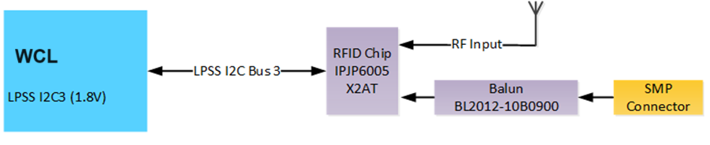

Figure 56: PSS Circuit high level block diagram

The WCL RVP supports 8K memory size RFID chip with options for I2C connection from SOC.

The RVP supports both on board PCB Dipole antenna as well as the external Antenna options. The external antenna path will have the on board BL2012 series Balun chip from ACX. The PSS shall have the properties mentioned in the table below.

Table 67: PSS Properties on WCL RVP

|  |  |
| --- | --- |
| Description | Value |
| Memory Size | 8kbit |
| Memory Configuration | 12 x 128 NVM / OTP |
| I2C Interface | Device Driver-OS |
| Reader Communication | Gen2 RFID Commands |
| Antenna Bandwidth | 900MHz |
| Antenna Type | Dipole, Monopole |

# GPIOs

The SOC General Purpose Input/output (GPIO) signals are grouped into multiple groups (such as GPP_A, GPP_B, and so on) and are powered by the SOC/PCH Primary well. Many GPIO signals are multiplexed with other native functions.

The high-level features of GPIO:

* **Support 1.8V GPIO only**
* GPIO Serial Expansion (GSX) bus mux on existing GPIO pins
* All GP Input are capable of generating an IRQ interrupt based on software configured level or edge-triggered event.
* All GP Input are capable of generating SCI.
* All GP Input are capable of generating wake event.
* Selective GP Input are capable of generating NMI or SMI#.
* GPIO supports glitch free during power sequencing, and when switching mode of operation (see GPIO spreadsheet for pins with exception).
* Supports software configured GP Input polarity.
* Supports GPIO mode input sensing (Rx) disable.
* Supports GPIO mode internal weak pull configured for pullup, pulldown or none.
* Support RCOMP for all GPIO pins (LP).
* Support Virtual GPIO for internal on-die connection between CNVi and LPSS, ACE, PCIe CLKREQ, and OC Virtual wire support.

Table 68: GPIO Power group mapping

|  |  |  |
| --- | --- | --- |
| Power Group | Number of Pins | Remarks |
| GPP_A | 16 | A0-A17 |
| GPP_B | 24 | B0-B25 |
| GPP_C | 22 | C0-C23 |
| GPP_D | 16 | D0-D25 |
| GPP_E | 21 | E0-E22 |
| GPP_F | 21 | F0-F23 |
| GPP_H | 23 | H0-H24 |
| GPP_S | 8 | S0-S7 |
| GPP_V | 18 | V0-V17 |

The GPIO allocation can be checked in below link.

[WCL RVP Platform Mapping Document](https://intel.sharepoint.com/:f:/r/sites/ccg_cpe_cps_wclsystempdt/Shared%20Documents/RVP%20Engineering%20Docs/WCL-Platform%20Mapping%20documents?csf=1&web=1&e=R3roNd)

All the SOC/PCH GPIO pins will be routed though resistor which will help in debugging.

## RCOMPs

RCOMP’s in WCL platform are listed below.

Table 69: RCOMP Resistor Values

|  |  |  |
| --- | --- | --- |
| Pin Name | Description | Termination |
| DDI_RCOMP | eDP PHY RCOMP, analog connection point for an external bias resistor to ground | 200 ohms 1% |
| SOC_REFRCOMP_ISCLK | Connected to an external precision resistor for XCLK bias voltage generation | 180 ohms 1% |
| TCP_RCOMP |  | 200 ohms 1% |
| PCIE4A_RCOMP | analog connection point for an external bias resistor to ground | 200 ohms 1% |
| PCIE4B_RCOMP | analog connection point for an external bias resistor to ground | 200 ohms 1% |
| USB3_RCOMP | USB3 MPHY RCOMP, analog connection point for an external bias resistor to ground | 200 ohms 1% |
| USB2A_RCOMP | USB Resistor Bias, analog connection points for an external resistor to ground. | 200 ohms 1% |
| USB2B_RCOMP | USB Resistor Bias, analog connection points for an external resistor to ground. | 200 ohms 1% |
| CNV_RCOMP | WiFi DPHY RCOMP, analog connection point for an external bias resistor to ground | 200 ohms 1% |
| SNDW_RCOMP | SoundWire buffer RCOMP, analog connection point for an external bias resistor to ground | 200 ohms 1% |
| UFS_RCOMP | UFS MPHY RCOMP, analog connection point for an external bias resistor to ground | 200 ohms 1% |
| DDR_RCOMP |  | 100 ohms 1% |

# On board Hardware Straps

The WCL RVP takes care of the default hardware strap configuration for both CPU and PCH to ensure normal functionality. WCL RVP will provide on-board Pull-up/Pull-down resistor stuffing options for each strap. The strap configuration options along with default setting is given in below tables.

## SOC Hardware Straps

SOC straps are mentioned in the table below.

Table 70: PCH Hardware Strap Options

|  |  |  |  |  |  |
| --- | --- | --- | --- | --- | --- |
| **GPIO #** | **When Sampled** | **Termination** | **HVM Strap** | **Pin Strap Usage** | **Polarity** |
| **xxgpp_b_4** | RSMRSTB | 20K PD | No | Flash descriptor security override  (commonly referred to as FDO strap) | Security measures defined in the Flash Descriptor is overridden if sampled high |
| **xxgpp_b_14** | PCH_PWROK | 20K PD | No | Top swap override | Top Swap is enabled if sampled high |
| **xxgpp_b_23** | RSMRSTB | 20K PD | No | “RTC” PLL (POR) or XTAL | Default RTC PLL distribution source 1 = 38.4MHz XTAL (Survivability usage only) 0 = “RTC” PLL @76.8MHz. This is the POR, and the default. *This pin strap is for survivability usage only, and expected to be further qualified with the “Personality Strap’ aka “A0 only Strap” outside of GPIO prior to being used by iSClk. |
| **xxgpp_c_2** | RSMRSTB | 20K PD | No | TLS Confidentiality Enable | TLS conf enabled if sampled high |
| **xxgpp_c_5** | RSMRSTB | 20K PD | No | eSPI Disabled (previously called "EC-less Platform") | ESPI is disabled if sampled high |
| **xxgpp_c_15** | RSMRSTB | 20K PD | No | XTAL Input Mode**[0]** | XTAL input mode 0: XTAL attached **- default** 1: Single-ended crystal input HVM/BI testing to pull-up this strap to select Single-Ended |
| **xxgpp_d_12** | PCH_PWROK | 20K PD | No | No Reboot | No reboot if sampled high |
| **xxgpp_e_6** | RSMRSTB | 20K PU | No | JTAG ODT Disable | JTAG ODT is disabled if sampled low |
| **xxgpp_e_9** | RSMRSTB | None | **Yes** | RTCPLL Pre Divider Enable (HVM use only) | RTCPLL Pre Divider Enable 0 – Bypass pre-divider (functional; 32.768KHz input) 1 – Enable /125 pre-divider (HVM; 4MHz input) *This strap is qualified by DFXTESTMODE |
| **xxgpp_e_10** | RSMRSTB | None | **Yes** | XTAL Input Frequency *HVM/BI mode only | Single-ended reference clock divider select  0 – Divider Bypass (functional) - **default** 1 – Divide by 4 (100MHz HVM mode) *This strap is qualified by DFXTESTMODE |
| **xxgpp_f_2** | RSMRSTB | 20K PU | No | M.2 CNV modes / Integrated CNV Enable/Disable | M.2 CNV modes 0 = Integrated CNV enable  1 = Integrated CNV disable |
| **xxgpp_f_19** | RSMRSTB | 20K PD | No | Skip RTC Clock Stabilization Delay (IOTG Boot Time Reduction) | Skip RTC Clock Stabilization Delay (IOTG Boot Time Reduction) 0 = No bypass (default) 1= Bypass/Skip 95ms RTC clock stabilization delay |
| **xxgpp_h_0** | RSMRSTB | 20K PD | No | eSPI Flash Sharing Mode | Master attached flash sharing (MAFS) if sampled low, else slave attached flash sharing (SAFS) |
| **xxgpp_h_1** | RSMRSTB | 20K PD | No | Enable/Disable SPI Flash Descriptor Recovery | Flash Descriptor Recovery for NIST SP800-193 0 - Flash descriptor recovery disable - **default** 1 - Flash descriptor recovery enable |
| **xxgpp_h_2** | RSMRSTB | 20K PD | No | SPI Flash Descriptor Recovery Source - Internal/External | Flash Descriptor Recovery Source for NIST SP800-193 0 - Flash descriptor recovery internal source - **default** 1 - Flash descriptor recovery external source |
| **xxspi0_io_2** | RSMRSTB | 20K PU | No | Consent Strap | Consent strap is enabled if sampled low |
| **xxspi0_io_3** | RSMRSTB | 20K PU | No | Personality Strap (A0 only, disabled by RevID) | Personality strap is enabled if sampled low |
| **xxdbg_pmode** | RSMRSTB | 20K PU | No | DFXTESTMODE active | Assert DFXTESTMODE to enable other straps to take effect if sampled low |

## CPU Hardware Straps

No NOA signals from WCL SOC.

# Debug and Validation Hooks

A system could be debugged either via one of below methods:

* Open Chassis debug – this includes XDP, MIPI60 (LTB) with only one MIPI60 header on WCL RVP
* Closed chassis debug – USB debug (USB2/USB3/OOB/I3C)

This section of RVP HAS shall cover the overview of SoC debug architecture followed by debug interfaces of SoC that are supported in the RVP. It shall also list down various SoC validation hooks and cover all the validation interfaces that are supported in this WCL RVP for users to debug the Silicon.

## SoC Debug architecture - Introduction

WCL SoC Architecture overview here.

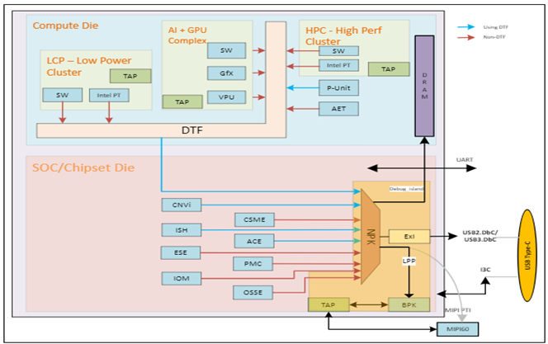

Figure 57: WCL Architectural overview

WCL has one High performance CPU, an Atom core cluster for efficient computing and an AI-GPU complex on the compute die. The VPU has been moved to the AI & GPU cluster.

The SoC/Chipset Die consists of NorthPeak (NPK) debug island and supports multiple debug interfaces like the USB/MIPI60/JTAG etc.

Debug Trace Fabric (DTF) is considered default bus to carry traces to NorthPeak (NPK). However, not all the trace sources support writing to DTF and their connection to NPK is shown in different colors.

## Debug interfaces supported by SoC

Table 71 : SOC VISA MIPI60 Connector

|  |  |  |  |  |  |  |  |  |  |  |  |  |  |  |  |  |  |  |  |
| --- | --- | --- | --- | --- | --- | --- | --- | --- | --- | --- | --- | --- | --- | --- | --- | --- | --- | --- | --- |
| |  |  |  | | --- | --- | --- | | **Type** | **Interface Name** | **Supported in WCL RVP** | | Open Chassis | JTAG (over MIPI60) | Yes | | MIPI-PTI (over MIPI60) | Yes | | Closed Chassis | USB2 DbC (over Type C) | Yes | | USB2 DbC (over USB2 port) | Yes | | OOB 2 wire (over Type C) | No | | I3C Debug (over Type C) | Yes | | USB3 DbC (over Type C/Std-A) | Yes (Type-A & Type-C) | |
|  |

### SMP Mapping of Validation Hooks

Validation signals on single SMP connector List:

Only one signal at a time can be connected to SMP connector after resistor stuffing rework.

Table 72 : Validation Hooks on SMP

|  |  |
| --- | --- |
| **SMP - 1** | **SMP - 2** |
| CPU_VIEWPWR_1 | OBS0MON_ISCLK |
|  | VTARGET_0 |
|  |  |
|  | |
| **SMP - 3** | **SMP - 4** |
| CPU_VIEWPWR_0 | OBS1MON_ISCLK |
|  | VTARGET_1 |
|  | USB2_ID |
|  | |
| **SMP - 5** | **SMP - 6** |
| XTAL_IN | DDR_VIEW [0] |
| XTAL_OUT | PCD_MBPB_0 |
|  |  |
|  | |
| **SMP - 7** | **SMP - 8** |
| DDR_VIEW [1] | DDR_ANA_VIEW |
| PCD_MBPB_1 | CPU_HVM_BCLK |
|  | DLVR_PDMON0 |
|  | |
| **SMP - 9** | **SMP - 10** |
| CPU_VIEWCLK_0 | CPU_VIEWCLK_1 |
|  |  |
|  | |
| **SMP - 11** |  |
| DLVR_PDMON1 |  |
|  |  |

## Generic RVP debug features

### Open Chassis Debug

Debug used for interfaces that are not placed inside a closed system is referred to as Open Chassis Debug.

Types of Open Chassis:

* MIPI PTI
* JTAG

The MIPI PTI & JTAG signals are over the MIPI 60 Connector.

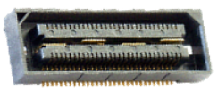

Figure 58: MIPI60 Debug Port (Samtec QSH-030-01 series)

The MIPI 60 Debug Port Interface enables communication between the Target System and Debug Tools. The MIPI 60 connector has power pins, JTAG, UART, I2C clock & data signals and different active low signals like POWER_BUTTON_N, CPU_EARLY_BREAK_N, PLATFORM_BOOT_STALL_N, Single RESET_N, RESET_BUTTON_N to initiate a target system cold boot, to stall the CPU boot sequence at the earliest CPU stall point to perform pre-boot configurations to Intel CPU’s, to stall the platform boot sequence at the earliest stall point to perform pre-boot configurations to Intel PCH’s and SoC’s, to determine various Reset and Power states on the Target System, to initiate a Target System warm-reset without cycling power cycles respectively.

#### MIPI60 Debug Connector

WCL supports 4 channel VISA debug capability. Channel 3 & 4 VISA signals will be routed to MIPI 60 connector. Whereas Channel 1 & 2 VISA signals are muxed with Touch signals & will be routed to new Touch connector.

WCL RVP will support a single MIPI 60 connector for debug. WCL does not have NOA signals.

The WCL RVPs will have support for MIPI 60 debug port with optional SOC/PCH –VISA only signals routed to a MIPI 60 connector & Touch connector.

Note- SOC/PCH JTAG will be routed to MIPI-60 Debug connector.



Figure 59: WCL RVP VISA connections

Table 73: SoC VISA MIPI60 Connector Pinout

|  |  |  |  |  |  |  |  |
| --- | --- | --- | --- | --- | --- | --- | --- |
| **PIN** | **Intel MIPI60**  **Signal Name** | **Target System Signal Name** | **Device** | **PIN** | **Intel MIPI60**  **Signal Name** | **Target System Signal Name** | **Device** |
| 1 | VREF_DEBUG | No Connect | NA | 2 | TMS | No Connect | NA |
| 3 | TCK0 | No Connect | NA | 4 | TDO | No Connect | NA |
| 5 | TDI | No Connect | NA | 6 | HOOK[7]/nReset | No Connect | NA |
| 7 | Hook[6] | No Connect | NA | 8 | TRST_PD | 10KΩ to GND | NA |
| 9 | TRST_N | No Connect | NA | 10 | PREQ_N | No Connect | NA |
| 11 | PRDY_N | No Connect | NA | 12 | VREF_TRACE | VREF_TRACE | System |
| 13 | PTI_0_CLK | PTI/VISA_0_CLK | CPU | 14 | PTI_1_CLK | GND | NA |
| 15 | POD_PRESENT1_N | GND | GND | 16 | GND | GND | NA |
| 17 | POD_PRESENT2_N | GND | GND | 18 | PTI_1_DATA[0] | No Connect | NA |
| 19 | PTI_0_DATA[0] | PTI/VISA0_DATA[0] | PCH | 20 | PTI_1_DATA[1] | No Connect | NA |
| 21 | PTI_0_DATA[1] | PTI/VISA0_DATA[1] | PCH | 22 | PTI_1_DATA[2] | No Connect | NA |
| 23 | PTI_0_DATA[2] | PTI/VISA0_DATA[2] | PCH | 24 | PTI_1_DATA[3] | No Connect | NA |
| 25 | PTI_0_DATA[3] | PTI/VISA0_DATA[3] | PCH | 26 | PTI_1_DATA[4]/  PTI_2_DATA[0] | No Connect | NA |
| 27 | PTI_0_DATA[4] | PTI/VISA0_DATA[4] | PCH | 28 | PTI_1_DATA[5]/  PTI_2_DATA[1] | No Connect | NA |
| 29 | PTI_0_DATA[5] | PTI/VISA0_DATA[5] | PCH | 30 | PTI_1_DATA[6]/  PTI_2_DATA[2] | No Connect | NA |
| 31 | PTI_0_DATA[6] | PTI/VISA0_DATA[6] | PCH | 32 | PTI_1_DATA[7]/  PTI_2_DATA[3] | No Connect | NA |
| 33 | PTI_0_DATA[7] | PTI/VISA0_DATA[7] | PCH | 34 | RSVD1 | No Connect | NA |
| 35 | PTI_0_DATA[8]/  PTI_3_DATA[0] | PTI0_DATA[8]/  PTI/VISA1_DATA[0] | PCH | 36 | HOOK[3] | No Connect | NA |
| 37 | PTI_0_DATA[9]/  PTI_3_DATA[1] | PTI0_DATA[9]/  PTI/VISA1_DATA[1] | PCH | 38 | HOOK[2] | No Connect | NA |
| 39 | PTI_0_DATA[10]/  PTI_3_DATA[2] | PTI0_DATA[10]/  PTI/VISA1_DATA[2] | PCH | 40 | HOOK[1] | No Connect | NA |
| 41 | PTI_0_DATA[11]/  PTI_3_DATA[3] | PTI0_DATA[11]/  PTI/VISA1_DATA[3] | PCH | 42 | HOOK[0] | VREF_TRACE_  PWRGOOD | System |
| 43 | PTI_0_DATA[12]/  PTI_3_DATA[4] | PTI0_DATA[12]/  PTI/VISA1_DATA[4] | PCH | 44 | RSVD2 | No Connect | NA |
| 45 | PTI_0_DATA[13]/  PTI_3_DATA[5] | PTI0_DATA[13]/  PTI/VISA1_DATA[5] | PCH | 46 | RSVD3 | No Connect | NA |
| 47 | PTI_0_DATA[14]/  PTI_3_DATA[6] | PTI0_DATA[14]/  PTI/VISA1_DATA[6] | PCH | 48 | I2C_SCL | No Connect | NA |
| 49 | PTI_0_DATA[15]/  PTI_3_DATA[7] | PTI0_DATA[15]/  PTI/VISA1_DATA[7] | PCH | 50 | I2C_SDA | No Connect | NA |
| 51 | TCK1 | No Connect | NA | 52 | RSVD4 | No Connect | NA |
| 53 | HOOK[9] | No Connect | NA | 54 | DBG_UART_TX | No Connect | NA |
| 55 | HOOK[8] | No Connect | NA | 56 | DBG_UART_RX | No Connect | NA |
| 57 | GND | GND | NA | 58 | GND | GND | NA |
| 59 | PTI_3_CLK | PTI_VISA1_CLK | PCH | 60 | PTI_2_CLK | GND | NA |

### Closed Chassis Debug

Debug using functional connections available in the complete, closed, form-factor system is referred to as Closed Chassis Debug.

Types of Closed Chassis:

* Debug over USB 2.0
* Debug over USB 3.0
* Intel 2W DCI
* Debug for I3C

#### Debug over USB 2.0

The Debug Class over USB 2.0 is supported on all USB 2.0 ports and uses the native USB protocol to transmit. USB2.0 debug class does require the use of the TS functional xHCI controller.

USB2 DBC Port 1 has enhanced capabilities beyond other USB2 ports and should be connected to an easily accessible USB Type-C port so these new features can be utilized. These features are enabled because USB2 DBC Port 1 is in “Debug Island”. The features include:

Able to connect very early in the boot sequence to support Connect First/Authorized Debug unlocks.

Able to remain connected and active during low power events (Sx and S0iX).

Connection does not affect device going to low power.

Since the Intel Trace Hub is also instantiated in Debug Island, traces can seamlessly transition overpower cycling events.

Supports all other traditional connection and debug capability.

For the Debug Class over USB 2.0 to operate, the TS must have debug enabled and the TS USB port used must be in the UFP role. The Type C is configured to UFP role when the PD controller detects Debug Accessory Mode. DTS is in the DFP role and TS is in the UFP role. The Std-A port must have the USB2 port manually configured to the UFP role in the FW straps using the mFIT tool and can’t be used as functional port when it’s configured for debug.

#### Debug over USB 3.0

The Debug Class over USB 3 is supported on all of the USB 3 ports from the PCH and CPU and uses the native USB protocol to transmit. USB 3 Debug Class does require the use of the functional controller. The Debug Class over USB 3 works over both Type A and Type C. However, DFx is not supported on USB3 connection to the CPU. Only USB3.1 connection to the SOC supports DFx.

The Debug Class over USB 3 is only available during the S0 power state. Debug Class over USB 3.1 is first available after the platform reset de-assertion and when the CPU is running. The Debug Class over USB 3 does not survive through Sx power state transitions and across warm and cold resets. When the Debug Class over USB 3.1 is connected, the system will not be able to exit the S0 power state into lower states.

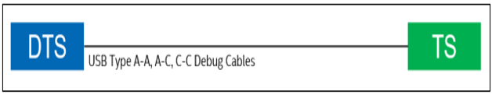

Figure 60: Illustrates the most basic connection between DTS and TS using just a USB Debug cable

#### Intel 2W DCI – (not supported in WCL)

Intel® DCI 2W DCI OOB uses the CCA adaptor combined with the “2W DCI OOB UART Adaptor” to convert USB signaling from the DTS to UART signaling to the TS. The Intel® 2W DCI OOB port is instantiated in the “Debug Island” power well which enables operation during early boot and through low power state transitions. 2W Intel® DCI OOB functions at low bandwidth, which supports Intel® JTAG Probe Mode like commands, Platform Boot Stall and run control but is too low for typical trace bandwidth. Intel® DCI 2W DCI OOB is a mature technology which is being replaced by the new platform debug connection called “Debug for I3C.

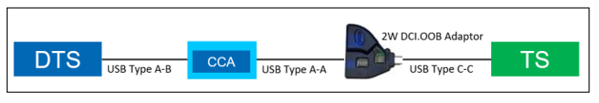

Figure 61: 2W DCI OOB Connection

Figure 61 illustrates the connection between the DTS and TS using 2W DCI.OOB. The DTS connects with the CCA device which converts the USB transport signaling into proprietary OOB (out of band) signaling. The CCA device passes these proprietary signals through the 2W DCI.OOB UART Adaptor which level shifts them and multiplexes them onto the SBU pins for presenting to the Target System.

#### Debug for I3C

I3C is a new open standard protocol being used for inter-device communication. It extends traditional I2C by adding multi-mastering, higher speeds, and security protections. The MIPI I3C Debug Standard allows the I3C transport to send debug commands and have them intercepted and used to drive debug functionality. The primary use case is using a single I3C bus to interconnect all platform components to this debug transport. This allows a single connection to debug Intel’s SOC, Intel’s Discrete Graphic solution, and other compatible third-party devices. Since the MIPI I3C Debug Standard is public and scalable, third-party tool and device providers can freely use it to support platform debug.

A big advantage of using “Debug for I3C” is Hot Connect. The “Debug for I3C” port can reliably connect upon fail and extract some triage information. If DAM is preset, then the system can be unlocked by Intel and more extensive debug performed.

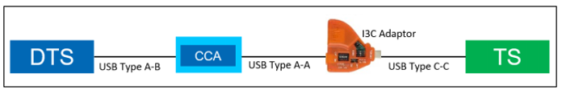

Figure 62: “Debug for I3C” Connection

Figure 62 illustrates the connection between the DTS and TS using the “Debug for I3C” transport. The DTS connects with the CCA device which converts the USB transport signaling into proprietary OOB (out of band) signaling. The CCA device passes these proprietary signals through the I3C Adaptor which converts them and multiplexes them onto the SBU pins for presenting to the Target System.

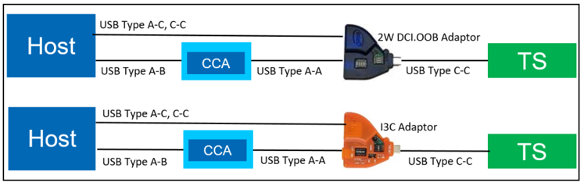

Figure 63: Extending 2W DCI.OOB and Debug for I3C with USB DbC

It is possible to multiplex USB3 DBC and USB2 DBC transports with either the 2W DCI.OOB or the “Debug for I3C” debug connections by routing a second USB port through the convertor. Figure 63 illustrates adding the additional connection. Caution, the TS USB port is set to Debug Accessory Mode, so the USB2 port is changed to an Upper Facing Port (UFP).

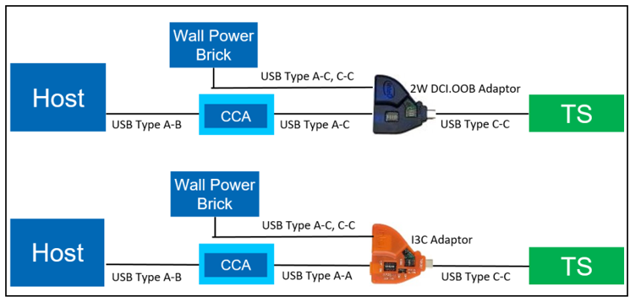

Figure 64: Charging the TS while Debugging using 2W DCI OOB or Debug for I3C

It is possible to power the USB port used for debug by plugging in a USB charging brick to the second port of the adaptors. Figure 64 shows some possible configurations.

### Debug features supported in RVP

Table 74: Table depicting different debug interface supported in WCL

|  |  |
| --- | --- |
| **Debug Feature** | **Description** |
| SINAI2 | SINAI2 is used for voltage & current sensing, current pump channels and GPIO manipulations. |
| InTEC | InTEC is Integrated Thermal Environment Controller used for PECI and thermal monitoring of CPU and PCH thru the external InTEC AIC. |
| PM sideband header | Most of the power sequencing related signals are terminated on this header, which can be used for debugging purpose. This header now being used by the RVP DAC AIC card which helps to enable remote debugging. |
| Port80 Display Output | The WCL RVP supports the 4 digit 7-Segment LED display for Port80 debug messages |
| Serial Debug Console | Serial debug console over a micro-AB USB 2.0 receptacle port |
| LED | LED indications for system states/status/errors. |
| RVP Health DAC | A novel way to access remote hardware & accelerate debug |
| UCP-SQUID | Low cost, Multi-Protocol and Remote programming solution |
| RVP NEST | RVP NEST is a remote access farm hosted and maintained by RVP Team |
| Box Stress Test | BST is an AIO integrated solution used for Voltage measurements, Voltage drive/margining, GPIO's manipulations, I2C master controller and Thermal Diodes measurements capabilities |

#### SINAI2/NEVO

SINAI2 is used for voltage & current sensing, current pump channels and GPIO manipulations. SINAI (believed to be the name of mountain where the Ten Commandments were given to Moses by God) is just an internal project name and does not have an acronym. The primary platform interface for SINAI2 is a 2x50, 100pin connector (IPN: D10221-001) for voltage margining and current sensing.

Sinai2 connectors has following types of pins:

1. GPIO: General purpose IOs. Can be configured as input or output and be configured as Open drain or CMOS.
2. GPIO-Fixed: IOs which should be routed to specific signals on the platform or stayed unconnected (if the feature is not needed). These have special topology which matches the relevant functionality.
3. DC3V3IO: General purpose IOs. Can be used to drive 3.3V signals. Good for stable signals (DC) like mux controls & straps. Currently only work as outputs.
4. ISNS [P/N]: Differential pair for sensing current through shunt resistors. Supports up to

160mV.

1. VSNS [P/N]: Differential pair for sensing voltage. Supports up to 3.2V in normal mode and 6.4V in extended mode.
2. IDRV: Current pumps output for voltage margining. Can drive/sink up to 14mA.
3. SPCL: Special purpose pins, which are used for power/GND or other maintenance functions in Sinai2. They must be connected as stated in the pin map.

SINAI2 special pins:

1. GND – should be connected to reference GND of the platform.

2. VCCST – should be connected to VCCST plane (normally 1.05V) for reference of SVID bus)

3. VCCIO – should be connected to VCCIO plane (normally 0.95V) for reference of MBP and all other GPIOs.

4. Setup done (pin 100 in sideband) – indicates that Sinai2 configuration is done and that the GPIOs are in programmed state. A good practice would be to connect this indication to the power sequence of the platform to prevent race between Sinai2 and other devices. Normally this signal is asserted ~900mS before CPU_POWERGOOD (if powered from the same power supply)

The actual utilization of the Vsense, Isense, Idrive & GPIO channels of Sinai2 is platform dependent. The pinout and channel allocation of SINAI2 interface will be finalized after reviewing the requirements from VFT representative. Multiple options would be supported using optional resistors. Resistor based stuff/unstuff option must be included in any GPIO and Isense path to Nevo connector.

##### Current Sensing Signals

Sinai2 senses current for measurement through the Sideband connector. Like in voltage sensing, the accuracy required from Sinai2 is very high. Moreover, in current sensing, Sinai2 is actually sensing low voltage levels (0-160mV) on a shunt resistor and errors and bWCLy routed traces will result in wrong current reading. Max bus voltage is 3.2V (common mode voltage). P/N traces to be taken from phase sense resistor (P/N) similarto PnP HDR routing.

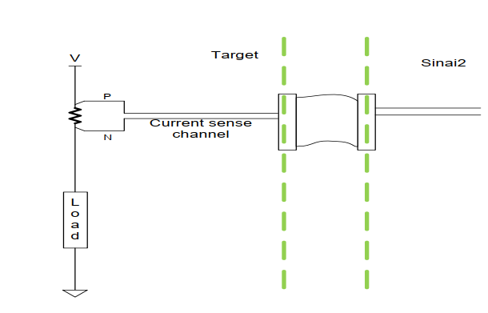

Figure 65: Current Sense Implementation

##### Sense resistor selection

It is important to note that the sense resistor selected for this circuitry should enable Sinai2 to measure the entire (or the desired) range of current to the load. For that, the voltage on that resistor in maximum current condition should not exceed 160mV. For example, if the maximum current expected from a plane is 15A, then a good practice would be to select a 10mΩ sense resistor (Vishay WSK2512-0.010-1%-R86E3 can be used for this purpose). A larger resistor will cause a cutoff in the range of sampling while a smaller resistor will cause degradation of the granularity and accuracy of the sampling.

##### Routing Guidelines for Sense Signals

Sinai2 senses voltage rails for measurement through AVMC connector. The accuracy required from Sinai2 sensing is very high (less than 1mV), thus, the routing of the sense traces should get special attention. The Routing of AVMC sense signals will follow below guidelines:

• The Voltage sense traces should be routed as differential pair on the platform from the sensing point to the AVMC connector.

• The traces differential impedance should be 80-100 Ω.

• If the negative trace (the *_N trace) is to be connected to GND, then it should be connected to the GND plane as close as possible to the sensing point (e.g. the CPU) and routed differential with the positive trace (*_P).

• It is preferred that the traces will be routed directly to the connector, but if there is a need to place series resistors on the voltage sense traces, the resistance of these resistors should not be bigger than 100 Ω.

• The traces should be routed in internal layers as far as possible from noisy parts (coils, oscillators, high frequency signals etc.)

##### SVID Signals to SINAI

SVID to SINAI2 connections are not part in any RVP SKUs of WCL since no team using SVID VR margining or validation over SINAI2 connector.

Table 75: SINAI2 Connector pinout

|  |  |  |  |  |  |
| --- | --- | --- | --- | --- | --- |
| **Pin #** | **Pin Name  (Option1 / Option2)** | **Type** | **Pin #** | **Pin Name  (Option1 / Option2)** | **Type** |
|
|
| 1 | VSENSE_P<0> | VSNSP | 51 | GPIO3 | GPIO |
| 2 | VSENSE_P<1> | VSNSP | 52 | BCLKP | GPIO - FIXED |
| 3 | VSENSE_N<0> | VSNSN | 53 | GND | SPCL |
| 4 | VSENSE_N<1> | VSNSN | 54 | GND | SPCL |
| 5 | VSENSE_P<2> | VSNSP | 55 | ISense5N | ISNSN |
| 6 | VSENSE_P<3> | VSNSP | 56 | VSENSE_P<11> / I2C_Slave_SCL | VSNSP/GPIOFIXED |
| 7 | VSENSE_N<2> | VSNSN | 57 | ISense5P | ISNSP |
| 8 | VSENSE_N<3> | VSNSN | 58 | VSENSE_N<11> / I2C_Slave_SDA | VSNSN/ GPIO - FIXED |
| 9 | VSENSE_P<4> | VSNSP | 59 | ISense6N | ISNSN |
| 10 | VSENSE_P<5> | VSNSP | 60 | VSENSE_P<12> | VSNSP |
| 11 | VSENSE_N<4> | VSNSN | 61 | ISense6P | ISNSP |
| 12 | VSENSE_N<5> | VSNSN | 62 | VSENSE_N<12> | VSNSN |
| 13 | GPIO0 | GPIO | 63 | I2C_Master_SCL | GPIO - FIXED |
| 14 | GPIO1 | GPIO | 64 | I2C_Master_SDA | GPIO - FIXED |
| 15 | GND | SPCL | 65 | GND | SPCL |
| 16 | GND | SPCL | 66 | GND | SPCL |
| 17 | VSENSE_P<6> / SPI-MISO | VSNSP/ GPIO - FIXED | 67 | ISense7N | ISNSN |
| 18 | VSENSE_P<7> / SPI-MOSI | VSNSP/ GPIO - FIXED | 68 | ISense8N | ISNSN |
| 19 | VSENSE_N<6> / SPI-CLK | VSNSN/ GPIO - FIXED | 69 | ISense7P | ISNSP |
| 20 | VSENSE_N<7> / SPI-CS | VSNSN/ GPIO - FIXED | 70 | ISense8P | ISNSP |
| 21 | VSENSE_P<8> | VSNSP | 71 | GPIO4 | GPIO |
| 22 | ISense0N | ISNSN | 72 | GPIO5 / PECI_MUX_CTRL | GPIO - FIXED |
| 23 | VSENSE_N<8> | VSNSN | 73 | CPU_PWRGD | GPIO - FIXED |
| 24 | ISense0P | ISNSP | 74 | PLT_RESETN | GPIO - FIXED |
| 25 | VSENSE_P<9> | VSNSP | 75 | GPIO6 | GPIO |
| 26 | ISense1N | ISNSN | 76 | PLT_RESTARTN | GPIO - FIXED |
| 27 | VSENSE_N<9> | VSNSN | 77 | GND | SPCL |
| 28 | ISense1P | ISNSP | 78 | GND | SPCL |
| 29 | VSENSE_P<10> / PMSYNC | VSNSP/ GPIO - FIXED | 79 | ISense9N | ISNSN |
| 30 | CPU_SVID_OUT | GPIO - FIXED | 80 | ISense10N | ISNSN |
| 31 | VSENSE_N<10> / PECI_MON | VSNSN/ GPIO - FIXED | 81 | ISense9P | ISNSP |
| 32 | CPU_SVID_CLK | GPIO - FIXED | 82 | ISense10P | ISNSP |
| 33 | GND | SPCL | 83 | PROCHOT(Drive) | GPIO - FIXED |
| 34 | GND | SPCL | 84 | VSENSE_P<13> | VSNSP |
| 35 | CATERR | GPIO - FIXED | 85 | VSENSE_N<13> | VSNSN |
| 36 | CPU_SVID_ALRT | GPIO - FIXED | 86 | VSENSE_P<14> | VSNSP |
| 37 | PROCHOT | GPIO - FIXED | 87 | VSENSE_N<14> | VSNSN |
| 38 | THERMTRIP | GPIO - FIXED | 88 | GPIO7 | GPIO |
| 39 | ISense2N | ISNSN | 89 | VCCST | SPCL |
| 40 | VRM_SVID_OUT | GPIO - FIXED | 90 | VCCST | SPCL |
| 41 | ISense2P | ISNSP | 91 | GPIO8 / IDRIVE9 | GPIO/IDRV |
| 42 | VRM_SVID_CLK | GPIO - FIXED | 92 | IDRIVE0 | IDRV |
| 43 | ISense3N | ISNSN | 93 | IDRIVE1 | IDRV |
| 44 | GND | SPCL | 94 | IDRIVE2 | IDRV |
| 45 | ISense3P | ISNSP | 95 | IDRIVE3 | IDRV |
| 46 | VRM_SVID_ALRT | GPIO - FIXED | 96 | IDRIVE4 | IDRV |
| 47 | ISense4N | ISNSN | 97 | IDRIVE5 | IDRV |
| 48 | PECI | GPIO - FIXED | 98 | IDRIVE6 | IDRV |
| 49 | ISense4P | ISNSP | 99 | IDRIVE7 | IDRV |
| 50 | BCLKN | GPIO - FIXED | 100 | IDRIVE8 / PLT_SETUP_DONE | IDRV/SPCL |

#### INTEC Header

InTEC is Integrated Thermal Environment Controller used for PECI and thermal monitoring of CPU and PCH thru the external InTEC AIC. The platforms signals that enable the thermal control and monitoring are thermal DIODE signals and PECI signals from CPU and PCH. The platform connector part details are given in below table. Test points will be provided for PECI, FORCEPR# & THERMTRIP#, and CATERR# signals.

Table 76: INTEC Connector PN

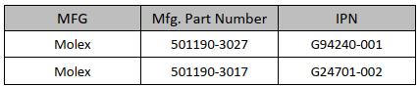

The RVP supports G94240-001 part by default. The design details are given below.

Table 77: Platform Design Recommendations for InTEC signals

|  |  |  |  |
| --- | --- | --- | --- |
| **pin#** | **InTEC signal name** | **RVP Signal Connection** | **Comments** |
| 1 | THERMDA0_Sense | VAL_THERMDA0_S | Compute Die Thermal Diode 1 |
| 2 | THERMDC0_Sense | VAL_THERMDC0_S |
| 3 | THERMDC0_Force | VAL_THERMDC0_F |
| 4 | THERMDA0_Force | VAL_THERMDA0_F |
| 5 | PROCHOT0 | PROCHOT_MON0_INTEC_N | PROCHOT Copy (LVTTL) |
| 6 | GND | GND |  |
| 7 | THERMDA1_Sense | VAL_GCD_THERM_DA_S | GCD Die Thermal Diode 2 |
| 8 | THERMDC1_Sense | VAL_GCD_THERM_DC_S |
| 9 | THERMDC1_Force | VAL_GCD_THERM_DC_F |
| 10 | THERMDA1_Force | VAL_GCD_THERM_DA_F |
| 11 | PROCHOT1_PECI Trigger | NC |  |
| 12 | GND | GND |  |
| 13 | THERMDA2_Sense | VAL_SOC_THERM_DA_S | SOC Die Thermal Diode |
| 14 | THERMDC2_Sense | VAL_SOC_THERM_DC_S |
| 15 | THERMDC2_Force | VAL_SOC_THERM_DC_F |
| 16 | THERMDA2_Force | VAL_SOC_THERM_DA_F |
| 17 | PROCHOT2 | NC |  |
| 18 | GND | GND |  |
| 19 | THERMDA3_Sense | VAL_THERMDA1_S | Compute Die Thermal Diode 2 |
| 20 | THERMDC3_Sense | VAL_THERMDC1_S |
| 21 | THERMDC3_Force | VAL_THERMDC1_F |
| 22 | THERMDA3_Force | VAL_THERMDA1_F |
| 23 | PROCHOT3 | NC |  |
| 24 | GND | GND |  |
| 25 | PECI0 | CPU_PECI | PECI Interface |
| 26 | GND | GND |
| 27 | VTT0 | +VCCIO_TERM_V1P25_INTEC |
| 28 | PECI0_Mux_Ctrl | *PECI Mux Ctrl |
| 29 | PECI_Copy | **PECI PROBING |
| 30 | GND | GND |  |

*PECI Mux Ctrl Logic:

• PECI_MUX_CTRL = 0 - InTEC connected to H_PECI (CPU), EC/PCH disconnected from H_PECI (CPU)

• PECI_MUX_CTRL = 1 - InTEC disconnected from H_PECI (CPU), EC/PCH connected to H_PECI (CPU) **PECI Probing (Copy/Monitor):

• 3.3V copy of PECI signal

• Buffered output, for monitoring only (w/o option to drive from PECI connector side)

##### PECI Signal

PECI is an Intel proprietary interface that provides a communication channel between Intel processors and external components such as Super IO (SIO) and Embedded Controllers (EC) to provide processor temperature, Turbo, Assured Power (cTDP), and Memory Throttling Control mechanisms and many other services. PECI is used for platform thermal management and real-time control and configuration of processor features and performance. PECI support eSPI is POR for WCL.

#### PORT80 Display Output

The WCL RVP supports the 4 digit 7-Segment LED display for Port80 debug messages like all other previous generation RVPs. The Port80 LED driver will be SMBus based connected to the Embedded Controller (EC) on-board. The EC gets the port80 messages from PCH over the eSPI interface depending on the platform configuration.



Figure 66: Port80 Functional Diagram

A 2x8 16-pin header 2.54mm pitch provided on the RVP design to bring the Port80 LED signals to front panel for validation purpose.

Table 78: SAS Header and Pinout

|  |  |  |
| --- | --- | --- |
| **MFG** | **Mfg. Part Number** | **IPN Number** |
| WIESON TECHNOLOGIES CO., LTD | AC2100-0009-005-HH | K92628-001 |

|  |  |  |  |
| --- | --- | --- | --- |
| **Signal Name** | **Pin #** | **Pin #** | **Signal Name** |
| +V3.3A_3.3DSW_VAL | 1 | 2 | LED_SEG8 |
| GND | 3 | 4 | LED_SEG7 |
| NO PIN | 5 | 6 | LED_SEG6 |
| NC | 7 | 8 | LED_SEG5 |
| NC | 9 | 10 | LED_SEG4 |
| NC | 11 | 12 | LED_SEG3 |
| RSVD_LED_SEG9 | 13 | 14 | LED_SEG2 |
| LED_SEG0 | 15 | 16 | LED_SEG1 |

#### Serial Debug Console

The WCL RVP supports Serial debug console over a micro-AB USB 2.0 receptacle port. The RVP uses CP2105 Dual USB UART / FIFO IC for UART to USB2.0 conversion. The RVP will have option for EC and SOC/PCH connectivity for TX and RX signals while the CTS and RTS signals would be available from the SOC/PCH.

Debug UART signals from EC shall be connected to mECC AIC connector and TTK3 connector as option in the design.



Figure 67: Serial debug console high level block diagram

Table 79: Micro USB connector and Pinout

|  |  |  |
| --- | --- | --- |
| **MFG** | **Mfg. Part Number** | **IPN Number** |
| Hirose | ZX62RD-AB-5P8(30) | E10610-003 |

|  |  |
| --- | --- |
| **Pin #** | **Signal Name** |
| 1 | +V_VCC_USB_UART |
| 2 | USB_C_DEBUG_DM |
| 3 | USB_C_DEBUG_DP |
| 4 | NC |
| 5 | GND |

#### LEDs

The WCL RVPs supports the following list of LEDs with their description given in below table.

Table 80: RVP LEDs & Function

|  |  |  |
| --- | --- | --- |
| **LED Name** | **Functional Description** | **LED Color** |
| CAPSLOCK | Driven by EC to indicate the CAPSLOCK condition | GREEN |
| NUMLOCK | Driven by EC to indicate the NUMLOCK condition | GREEN |
| S0_LED_DRV | Indicates system entering state - S0 | GREEN |
| S3_LED_DRV | Indicates system entering state – S3 | GREEN |
| S4_LED_DRV | Indicates system entering state – S4 | GREEN |
| S5_LED_DRV | Indicates system entering state – S5 | GREEN |
| SUS_LED_DRV | Indicates system sleep state | GREEN |
| ME_LED_DRV | When asserted, INTEL ME is off | GREEN |
| CATERR | On board LED to indicate catastrophic event driven by CPU. | RED |
| M.2_WLAN_LED1 | Indicates WLAN Module availability | GREEN |
| M.2_WWAN_LED | Indicates WWAN Module availability | GREEN |
| M.2_BT_LED2 | Indicates BT Module availability | GREEN |
| M2_SSD_DEVSLP_LED | Indicates Device sleep signal asserted connected on M.2 | GREEN |
| SATA_DIRECT_DEVSLP_LED | Indicates SATA direct connect device sleep signal asserted | GREEN |
| PCH_SATA_LED | Indicates activating SATA | GREEN |
| PM_PWRBTN_LED | Driven by EC | GREEN |
| CHGR_LED_GATE_LED2 | Driven By EC – Charging status | YELLOW |
| HGR_LED_GATE_LED1 | Driven By EC – Charging status | GREEN |
| CS_INDICATE_LED | Indicates whether system is in Connected Standby(CS) | GREEN |
| C10_GATE_LED | Indicated C10 | GREEN |
| PCIE_LINK_DOWN | Indicates PCIe link down and will be routed to LED and to header | AMBER |

Table 81: WCL RVPs support following press buttons on board

|  |  |
| --- | --- |
| **Button** | **Function** |
| Volume UP | Volume increase input to EC (Provided over header) |
| Volume DOWN | Volume decrease input to EC (Provided over header) |
| Power | External Power button input to the PCH and EC |
| Reset | External Reset button input to the PCH |

Power and Reset signals will be routed to Front Panel Header and PM Side band header.

In general, for debug connectors, Refdes and pin numbering will be provided. Silkscreen for signal names can’t be supported. Also, default power on from G3 state (i.e., no need to press power button) will be supported.

Table 82: Table depicting different debug features supported in WCL

|  |  |
| --- | --- |
| **Debug Features** | **Supported in WCL** |
| SINAI2 | Yes |
| InTEC | Yes |
| Port80 Display Output | Yes |
| Serial Debug Console | Yes |
| LED | Yes |
| Box Stress Test | Yes |

## Programming capabilities:

Devices programmable in RVP

* BIOS SPI Flash
* EEPROMs
* PD AIC
* Retimer Flash
* TTK3
* EC Flash
* Dediprog

## Details of debug tools

Below table shows a list of probes, their associated cables and adapters dependencies. For more information refer to wiki link.

Table 83: List of Probes, Associated Cable and Adapter

|  |  |  |
| --- | --- | --- |
| **Tool** | **Description** | **Wiki Link** |
| XDP - Extensible Debug Port | The XDP, also known as XDP3, XDP3b, XDP3br, Pod, ITP Blue Box is a JTAG debug adapter | [XDP - Extensible Debug Port - Debug Tools Support - Intel Enterprise Wiki](https://wiki.ith.intel.com/display/ITPII/XDP+-+Extensible+Debug+Port) |
| CCA - Closed Chassis Adapter | CCA (Closed-Chassis Adapter) is one of the two ways of connecting the host and the target in the DCI (Direct Connect Interface) topology. | [CCA - Closed Chassis Adapter - Debug Tools Support - Intel Enterprise Wiki](https://wiki.ith.intel.com/display/ITPII/CCA+-+Closed+Chassis+Adapter) |
| DbC - Debug Cable | DbC (Debug Cable) is one of the two ways of connecting the host and the target in the DCI (Direct Connect Interface) topology | [DbC - Debug Cable - Debug Tools Support - Intel Enterprise Wiki](https://wiki.ith.intel.com/display/ITPII/DbC+-+Debug+Cable) |
| LCP - Low Cost Probe | The LCP - Low Cost Probe, is a probe manufactured by Lauterbach for Intel. It is similar in function to the Combi-Probe, but it has functional limitations built in which make it suitable for automation only, and not usable for regular debug. | [LCP - Low Cost Probe - Debug Tools Support - Intel Enterprise Wiki](https://wiki.ith.intel.com/display/ITPII/LCP+-+Low+Cost+Probe) |
| LTB - Lauterbach Combiprobe | The Combiprobe is a third-party developed JTAG probe built by Lauterbach (LTB) that can be used with Intel or Lauterbach's proprietary software; Trace32 and Powertrace. It connects to a MIPI60 JTAG connector or to a USB DCI connection via an adapter. | [LTB - Lauterbach Combiprobe - Debug Tools Support - Intel Enterprise Wiki](https://wiki.ith.intel.com/display/ITPII/LTB+-+Lauterbach+Combiprobe) |
| UTAG - USB JTAG Probe | The UTAG4, is a JTAG debug adapter that works with PVT/OpenIPC. In simple terms, it acts as a bridge between a host system and a target platform. It is a very low-cost alternative to most of the other JTAG probes but does have some limited capability. | [UTAG - USB JTAG Probe - Debug Tools Support - Intel Enterprise Wiki](https://wiki.ith.intel.com/display/ITPII/UTAG+-+USB+JTAG+Probe) |

### Box Stress Tool

BST is an AIO integrated solution used for Voltage measurements, Voltage drive/margining, GPIO's manipulations, I2C master controller and Thermal Diodes measurements capabilities.

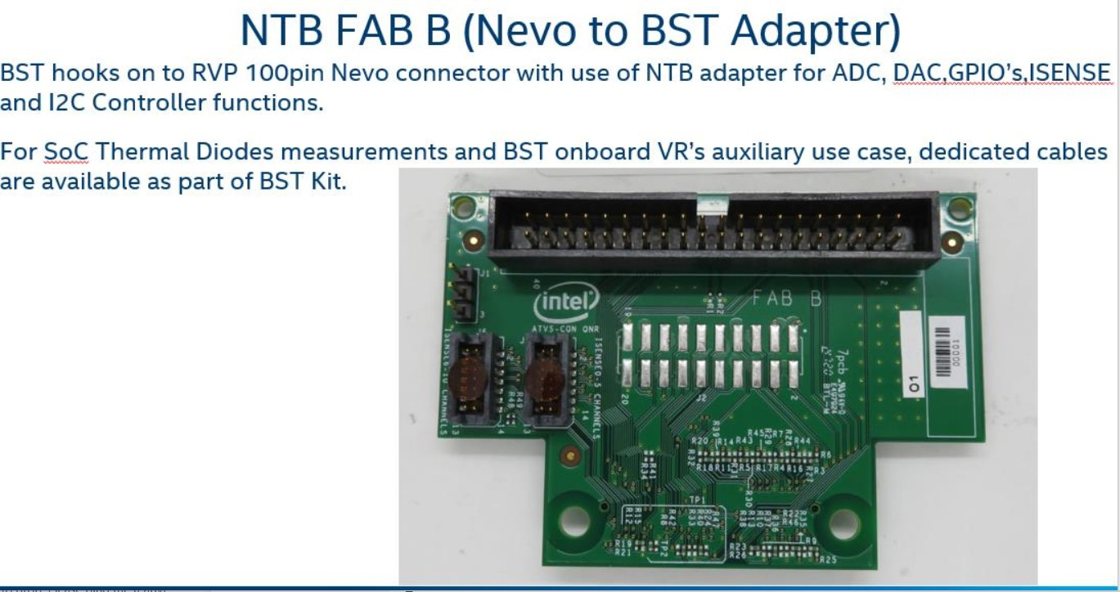

Figure 68: Nevo to BST Adapter

Note: Users who want to use Nevo will need an Adapter card and extension cable.

Cable and extension adapter are part of Nevo demand call catalog which open every Quarter, kindly look at info below.

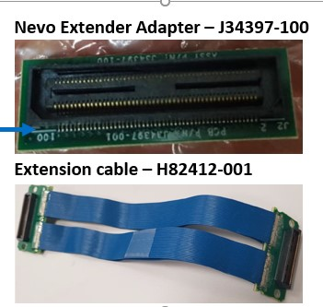

Figure 69: Nevo Extension Cable

##### Interface

BST hooks on to RVP 100pin Nevo connector with use of NTB adapter for ADC, DAC, GPIO’s and I2C Master functions.

For SoC Thermal Diodes measurements and BST onboard VR’s auxiliary use case, dedicated cables will be available as part of BST Kit.

##### Power Supply

For standard operation of ADC, DAC, GPIO’s, I2C Master and Thermal diodes measurements the BST is powered from an USB Type-A to mUSB (5V from Host PC to BST).

For BST auxiliary use case a standard ATX with 12V/5V connector is required.

## SINAI to CPU sideband optimization

PECI circuit in WCL has similar implementation with PTL-UH which contains optimization as feature below:

* Retain the 3pin 100mil header & remove the PECI MUX circuit completely.
* Default SoC PECI connection should be pull-down, InTEC users must remove the jumper while validating using InTEC tool.
* Unstuff the PECI copy/probing circuit as this is not used currently per INTEC users.
* Retain EC connection to 3 pin header using resistor STUFF option to support any use-case.
* PECI probing circuit is currently UNSTUFF in WCL and it can be removed from next program onwards, if no use-case is identified from any of the users.
* SINAI connector will have 3V3 level of SoC FORCEPR and THERMTRIP signal.

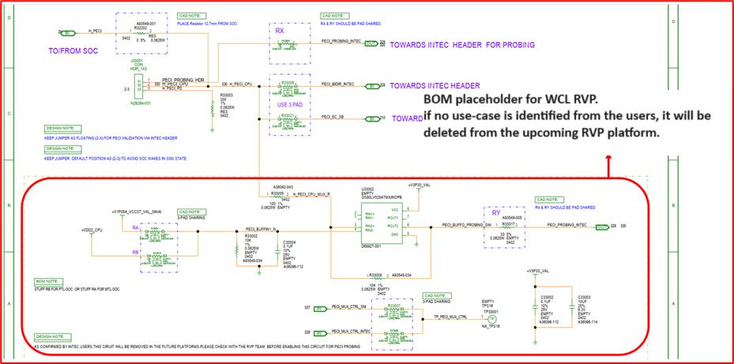

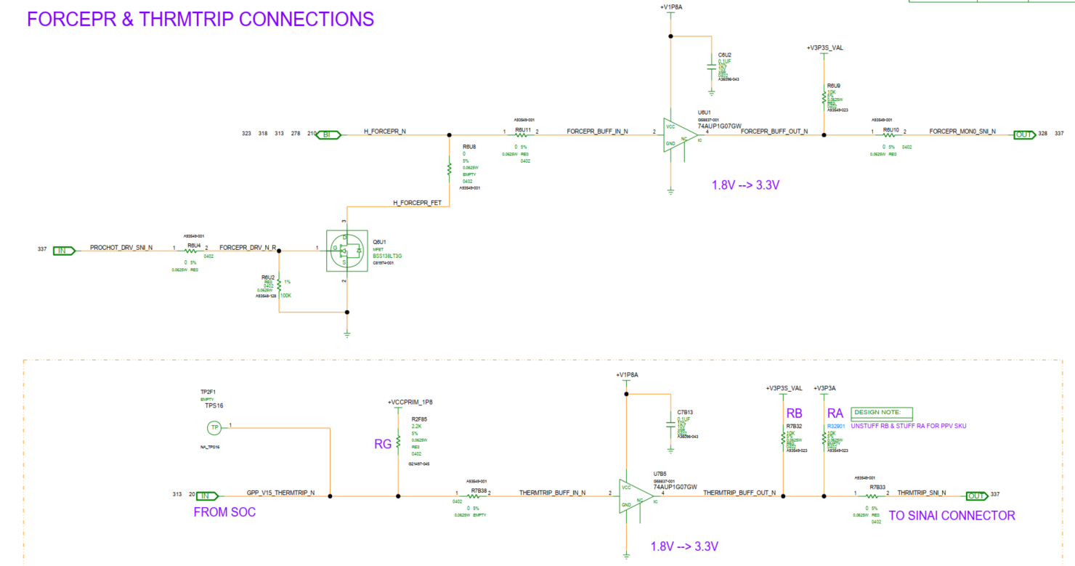

Figure 70: SINAI to CPU sideband optimization schematic in WCL

# Power Delivery & Sequencing

In this section, all the WCL power delivery implementation details (with respect to energy management, rest of the platform power delivery, IMVP9.3, power sequencing, power measurement, voltage margining, power accumulator and PnP requirement) would be covered. High level SoC Power scheme for WCL is shown below, Figure 71 shows the pin map for 15W silicons sku, this 15W sku can be validated on RVP board.

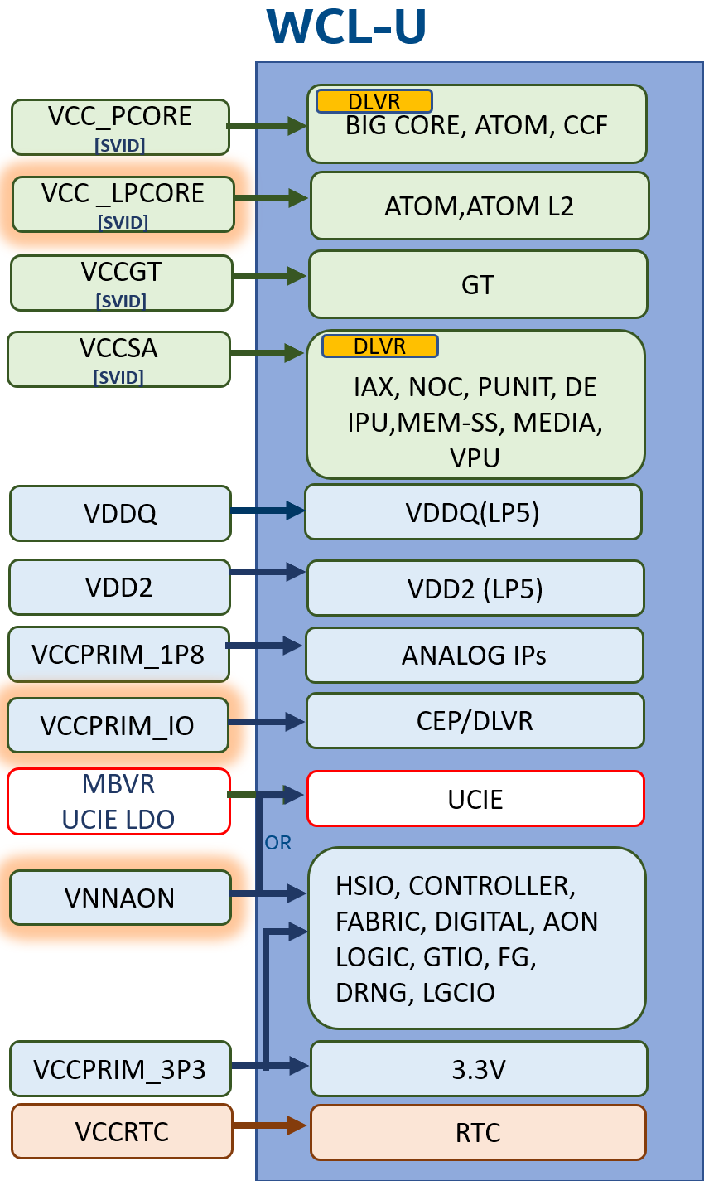

Figure 71: WCL High Level SoC Power Scheme

## Power Sources

WCL can be powered through a standard AC adapter, a Type C power Adapter, or a Battery pack.

Note: PPV does not support battery, or a Type C power supply. Only powered by AC adapter. AC adapter is able to support maximum power requirement of RVP.

### Standard AC adapter

A 230W (19.5V, 11.8A) adapter is being selected for the WCL RVP and is one of the three power sources which can be used for powering the RVP.

Standard AC adapter model #: PA-1231-16, IPN: N44540-001

Description: AC/DC ADAPTER, 100V-240V Input, 50-60HZ, 19.5V/11.8A Output

### Type C Adapter

There are two USB-C ports supported on WCL RVP, all ports are USB-C PD 3.1 compatible and can be used for plugging in the Type C adapter. EPR chargers more than 20V are **NOT** supported.

In the client segment, the market is shifting towards Type C adapter instead of AC adapter due to EU mandate common charger directive. Changing the EC-FW charging policy will deviate from guidelines given to customers through white paper and create confusion. In order to support this initiative, WCL RVP design will incorporate a jumper solution which will allow higher priority to be assigned to Type C power in case both AC Barrel and Type C power is connected. This POC will be implemented on RVP2 LP5x T3 SKU.

Note: For dead battery boot with type-c adapter, minimum 45W adapter is required to boot the WCL RVP.

### Battery Pack

A 3S1P battery pack is being selected for WCL RVP with maximum capacity of 61.5Whr.

3S1P battery pack **IPN:** M77304-001

**Recommendation:** For all the validation except Performance, the recommendation is to use standard AC adapter. Use Type C adapter or battery pack on need basis.

Table 84: Power Sources & Priority on WCL RVP

|  |  |
| --- | --- |
| Available Sources | Priority Given To |
| Standard AC Adapter + Battery Pack | Standard AC Adapter (Header: 1-2) |
| Standard AC Adapter + Type C Adapter | Standard AC Adapter (Header: 1-2) |
| Standard AC Adapter + Type C Adapter + Battery Pack | Standard AC Adapter (Header: 1-2) |
| Type-C Adapter + Battery Pack | Type-C Adapter (Header: 1-2) |
| Standard AC Adapter + Battery Pack | Standard AC Adapter (Header: 2-3) |
| Standard AC Adapter + Type C Adapter | Type-C Adapter* (Header: 2-3) |
| Standard AC Adapter + Type C Adapter + Battery Pack | Type-C Adapter * (Header: 2-3) |
| Type-C Adapter + Battery Pack | Type-C Adapter (Header: 2-3) |

**Note:** Smooth/seamless transition from Type-C adapter to AC adapter and vice versa is not supported if battery is not connected.

*WCL RVP design will incorporate a jumper solution which will allow higher priority to be assigned to Type C power in case both AC Barrel and Type C power is connected. This POC will be implemented on RVP2 LP5x T3 SKU.

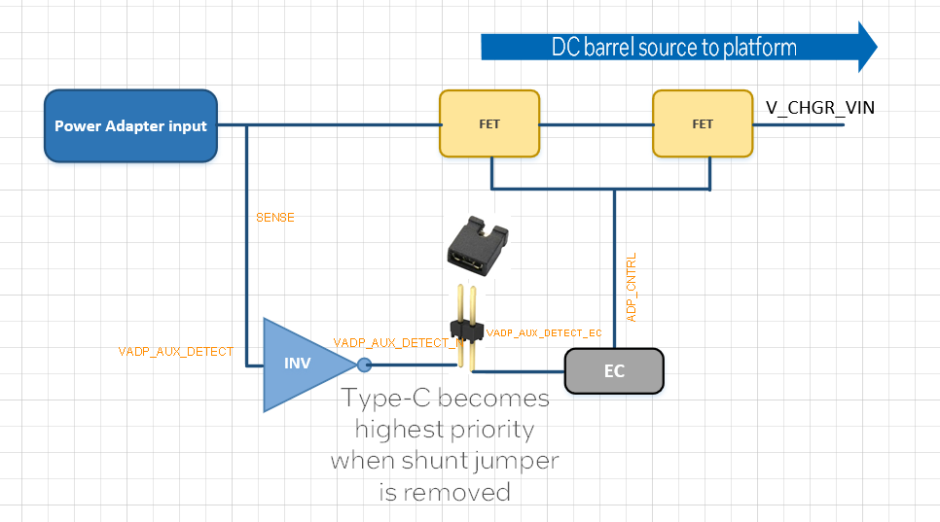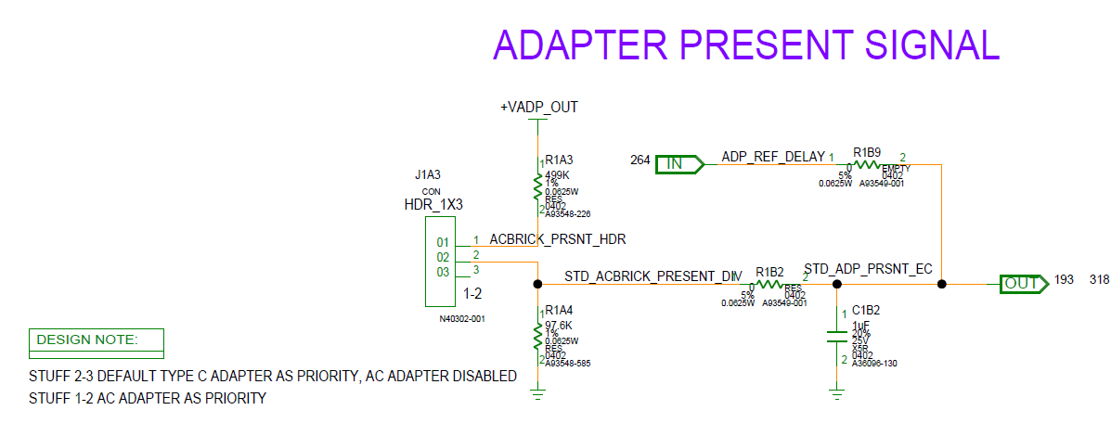

Figure 72: WCL RVP2 Jumper Solution to Set Type C as Higher Priority

## Key Power Delivery Subsystems

The platform power delivery has three key sub-systems which are Energy management, Rest of the platform (RoP) power delivery and CPU power Delivery (including IMVP9.3).

### Energy Management Sub-System

Battery charger and USB power delivery come under the energy management sub-system. A buck-Boost NVDC charger is used to charge the battery pack and to power the system with the input voltages from standard AC adapter and Type-C adapters. Battery charger PROCHOT# signal is connected to the SOC PROCHOT signal.

### Rest of the Platform Power Delivery

Discrete voltage regulators are required for powering the CPU (non-SVID), PCH and platform components, power sequencing and load switches form the RoP power delivery sub-system. The RoP power delivery circuitry is down on the mother board.

### IMVP9.3 Sub-system

WCL CPU requires four different SVID rails (VCC_PCORE, VCCGT, VCCSA and VCC_LP_ECORE). VCC_LP_ECORE is new VR compared to MTL-U/P/H. An IMVP9.3 compliant controller is used for generating these rails.

**Note:** The power delivery sub-systems are on the motherboard.

WCL RVP will be designed for 15W to support the silicon.

For tuning load line other than POR targets, reworks on board or IMVP FW change or both may be required depending on the selected IMVP9.3 controller IC.

Table 85: Processor Line Vs. Phase Count

|  |  |
| --- | --- |
| Processor Line | **Phase Count Required**  **(VCCPCORE+VCCGT+VCCSA+VCCLPECORE)** |
| Processor Base Power – 15W SKU | Baseline and Performance PD: 1+1+1+1 |

Iccmax, TDC and load line targets for different processor line is shown in Table 86.

Table 86: Processor Line Power Specifications

|  |  |  |  |
| --- | --- | --- | --- |
|  | 15W SKU (2P+0E+4e) | | |
| Rail Name | Icc_max | I_PL2 | LL (mΩ) |
| VCC_PCORE | 40A | 23A | 5.2 |
| VCCGT | 40A | 20A | 6.6 |
| VCC_LP_ECORE | 28A | 11A | 7.5 |
| VCCSA | 35A | 20A | 7.5 |

### UCIe LDO

The purpose of having UCIe MBVR LDO as backup option is to mitigate UCIe noise. The figure below shows the connection of MBVR LDO as backup option.

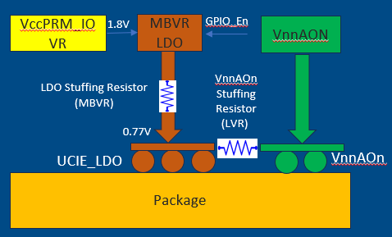

Figure 73: Connection of UCIe MBVR LDO.

In WCL, to switch the power source from VNNAON to LDO, resistor stuffing option is required.

|  |  |
| --- | --- |
| **Risk** | **Mitigation** |
| UCIe MBVR LDO validation with actual UCIe bus load conditions | ROP validation on LDO to ensure AC/DC specs are met. |
| UCIe power up/down sequence | Power sequence measurement on ERB in no/dummy load condition. |

## Critical Rails and Default Voltage Levels

The below table for all the critical rails and the default regulated voltages.

Table 87: Critical Voltage Rails with default regulated voltage

|  |  |  |
| --- | --- | --- |
| Voltage Regulator | Default Voltage | Comments |
| +VCC_PCORE | 0V (Boot Voltage)  0.52-1.52V | CPU adjusts the output voltage through SVID. |
| +VCCGT | 0V (Boot Voltage)  0.52V-1.26V | CPU adjusts the output voltage through SVID. |
| +VCCSA | 0V (Boot Voltage)  0.52V-1.23V | CPU adjusts the output voltage through SVID. |
| + VCC_LP_ECORE | 0V (Boot Voltage)  0.52V-1.52V | CPU adjusts the output voltage through SVID. |
| +VNNAON | 0.77V |  |
| +VCCST | 0.77V | MB PG From VNNAON |
| +VDD2H | 1.065V (LP5x Mem Down) | Shared rail (LP5x memory + CPU) in LP5x SKU |
| 1.1V (DDR5) | SoC Only (DDR5) |
| +VDDQ | 0.52V(LP5x Mem Down) | Shared rail (LP5x memory + CPU) in LP5x SKU |
| 1.1V Tied with +VDD2H | SoC Only (DDR5) |
| +VDD2L | 0.92V | Applicable for only LP5x memory (For DVFSC support) |
| +VDD1 | 1.8V (LP5x Mem Down) | LP5x Only |
| +VCCIO | 1.25V |  |
| +VCCPRIM_UCIE | 0.77V | UCIe LDO |
| +V3.3A | 3.3V |  |
| +V5A | 5.1V |  |
| +V1.8A | 1.8V |  |
| DDR5 rail | 5V | DRAM module only (DDR5 only) |

Table 88: Typical Voltage rail for different Memory technologies

|  |  |  |  |  |  |
| --- | --- | --- | --- | --- | --- |
| Memory Type | Supporting voltages on memory modules by RVP PD | | | | |
| VDD2H | VDD2L | VDD1 | VDDQ | V5A_MEM |
| LPDDR5x | 1.065V à SoC + LP5x | 0.92V | 1.8 V | 0.52 V | N/A |
| DDR5 | 1.1VàSoC | NA | NA | NA | 5V (DRAM) |

## Power Map for WCL

Updated WCL power map would be placed in [LINK](https://intel.sharepoint.com/sites/ccg_cpe_cps_wclsystempdt/Shared%20Documents/Forms/AllItems.aspx?csf=1&web=1&e=qJRrxX&OR=Teams%2DHL&CT=1732081086919&clickparams=eyJBcHBOYW1lIjoiVGVhbXMtRGVza3RvcCIsIkFwcFZlcnNpb24iOiI0OS8yNDEwMDMyNDkxNiIsIkhhc0ZlZGVyYXRlZFVzZXIiOmZhbHNlfQ%3D%3D&CID=459a4c6a%2D2689%2D45de%2D9bf3%2D218e08a95103&FolderCTID=0x0120009A78782013A8854299E042DA6DB64B8B&id=%2Fsites%2Fccg%5Fcpe%5Fcps%5Fwclsystempdt%2FShared%20Documents%2FRVP%20Engineering%20Docs%2FRVP%20Power%20Map)

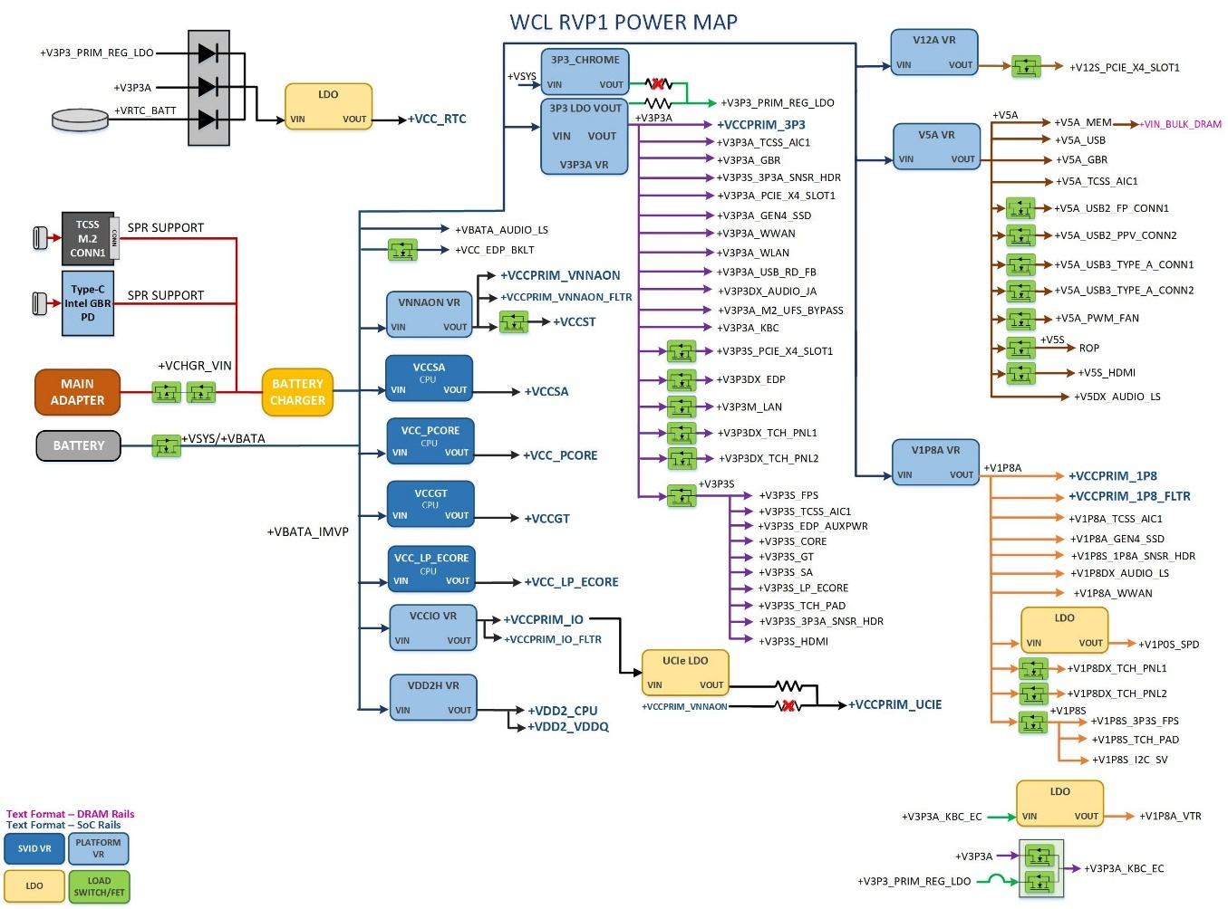

Figure 74: WCL RVP1 Power flow diagram.

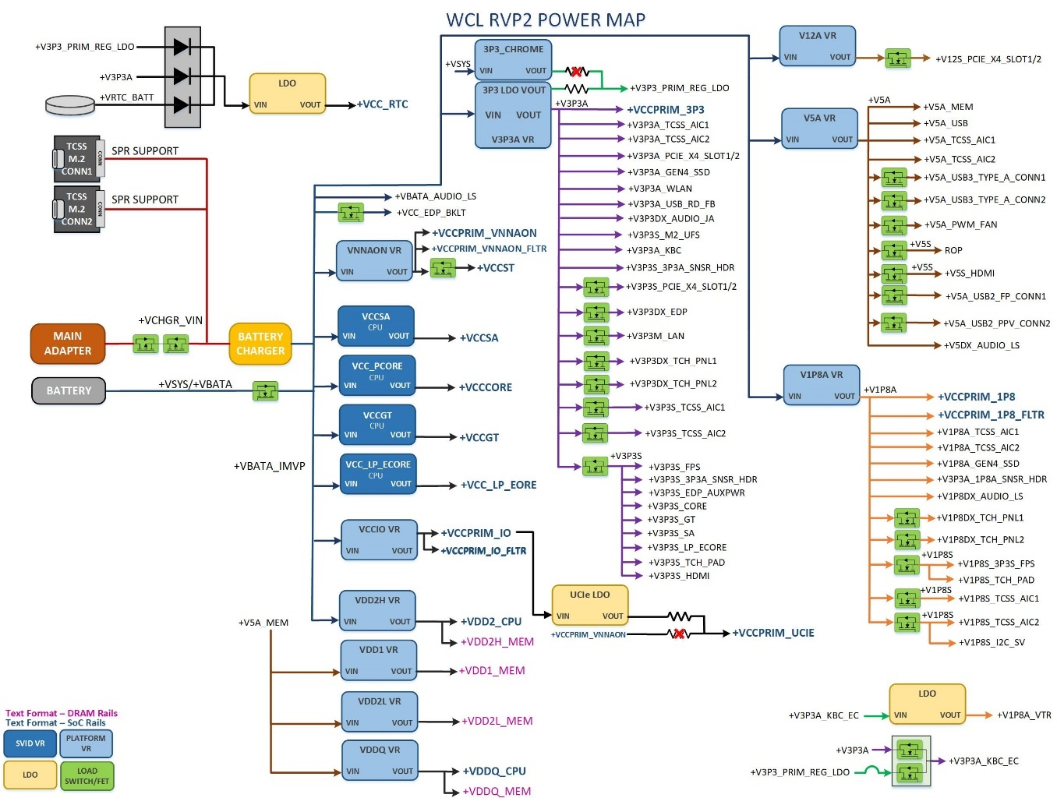

Figure 75: WCL RVP2 Power flow diagram.

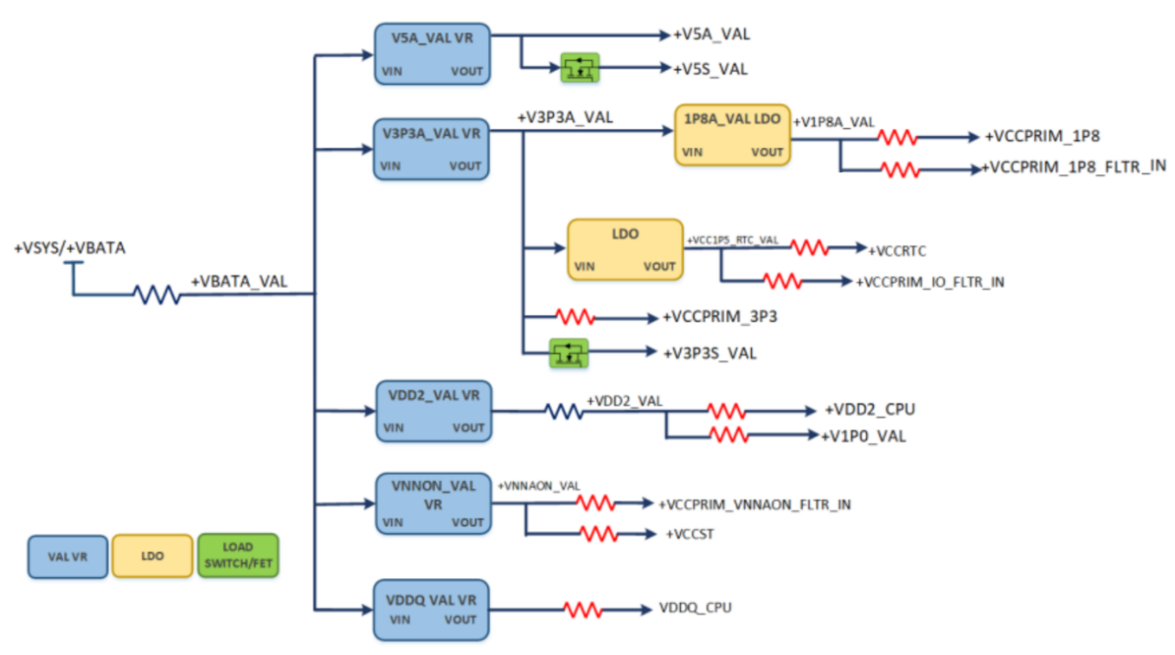

Figure 76: WCL VAL rails Power flow diagram.

## Power Sequencing

* WCL requires four IMVP9.3 rails.
* IMVP9.3 voltage regulators are enabled by ALL_SYS_PWRGD signal which indicates all the platform rails are stable.
* VCC_PCORE, VCCGT, VCCSA and VCC_LP_ECORE IMVP9.3 VRs have Zero boot voltage requirements.
* SVID communication is required to change the voltage of IMVP9.3 VRs.
* WCL platform supports Pseudo G3 state.

WCL RVP Power sequencing diagram is available at [LINK](https://intel.sharepoint.com/sites/ccg_cpe_cps_wclsystempdt/Shared%20Documents/Forms/AllItems.aspx?csf=1&web=1&e=qJRrxX&OR=Teams%2DHL&CT=1732081086919&clickparams=eyJBcHBOYW1lIjoiVGVhbXMtRGVza3RvcCIsIkFwcFZlcnNpb24iOiI0OS8yNDEwMDMyNDkxNiIsIkhhc0ZlZGVyYXRlZFVzZXIiOmZhbHNlfQ%3D%3D&CID=459a4c6a%2D2689%2D45de%2D9bf3%2D218e08a95103&FolderCTID=0x0120009A78782013A8854299E042DA6DB64B8B&id=%2Fsites%2Fccg%5Fcpe%5Fcps%5Fwclsystempdt%2FShared%20Documents%2FRVP%20Engineering%20Docs%2FRVP%20Power%20Map%2FPower%5FMap&viewid=d6627540%2Dda7d%2D4ccd%2Db520%2D50e2d336c8d5)

# Power n Performance

## PRD from PnP for power measurements

RVP team will follow all the requirements which are mentioned in WCL Power and Performance requirements document ([Link](https://intel-my.sharepoint.com/:w:/r/sites/ccgmtlclientsystempdt/ArchLZPRD/MTL_M_P_RVP_Architecture_HAS/Requirements/PnP/Next_CRD_PNP_Requirements_Document_WW33%2720_Rev_1_2.docx?d=wdefdef1c006441fb9fc7a7375cd3f057&csf=1&web=1)). RVP also follows PnP PMR [BKM](https://wiki.ith.intel.com/display/vjs/PMR+BKM?preview=/2076223581/2076223588/PMR_BKM.pptxdf) to select the resistors MPNs.

## Voltage margining

For the power and performance validation, margining is supported through Sinai Nevo connector and range of voltages supported are tabulated below. For SoC/PCH a separate +V3.3A _VAL is provided to support extensive range of margining than +V3.3A_VR.

Table 89: Voltage Margining support on WCL RVP

|  |  |  |  |  |  |  |
| --- | --- | --- | --- | --- | --- | --- |
| VR | VR controller | | Nominal | Voltage range support by VR | Iccmax | Margining Support |
| DDR5 | LP5x | Voltage |
| +V3.3A | RT6585AGQW | RT6585AGQW | 3.3 | 2.97V to 3.63V | 0.1A | Yes |
| +V5A | 5V | 4.5V to 5.5V | 2.5 | No |
| +V1.8A | RT6220A | RT6220A | 1.8V | 0.6V to 5.0V | 1.0A | Yes |
| +VNNAON | TPS51219RTER | TPS51219RTER | 0.77V | 0.7to3.3V | 11A | Yes |
| +VCCPRIM_IO | TPS51396A | TPS51396A | 1.25V | 0.6 to5.5V | 1.8A | Yes |
| +VDD1 | NA | RT5795AGQW | 1.8V | 1.8V Fixed | 0.25A | Yes |
| +VDD2H/ VDD2_CPU | RT6220A | RT8231AGQW | 1.065V | 1.065V Fixed | 6.5A | Yes |
| +VDD2L | NA | RT5795AGQW | 0.92V | 0.92V Fixed | 2.9A | Yes |
| VDDQ | NA | RT5795AGQW | 0.52V | 0.52V/0.32V (fixed) | 1.8A | Yes |
| +VCC1P5_RTC | TPS7A0215DQNR | TPS7A0215DQNR | 1.5V | 1.1 to 4.5V | 2mA | Yes |

## Additional Current support (for stress tests)

The IMVP VCC_PCORE, VCCGT, VCCSA and VCC_LP_ECORE VRs support additional +20% currents to POR PL2 currents to support stress tests on SoC.

The teams doing stress tests (that draw higher currents than POR) are expected to have external cooling (may be an external cooling fan) for VRs. Thermal solution on board does not support cooling requirements during stress tests for higher currents.

## PnP PMR resistor

Current sense resistors will be provided on critical rails and sense traces will be routed to the Sinai isense connections for Core, GT and SA. For critical rails like CPU core, 4-pin “Kelvin” resistors will be used so the solder resistance would not affect the current sense.

2x7 headers are provided on board which brings out voltage and current sense points from the board that can be used for Power and Performance measurement of different power rails for both PCH and CPU and different on-board interfaces. Few of 2x7 connection pairs are left spare, provision to wire for additional measurements on board.

SoC/PCH and CPU current sense lines from Power Measurement Resistor (PMR) are connected to dedicate 2x7 headers. 2x7 HDRs mapping to PMR resistors is available in [LINK](https://intel.sharepoint.com/sites/ccg_cpe_cps_wclsystempdt/Shared%20Documents/Forms/AllItems.aspx?id=%2Fsites%2Fccg%5Fcpe%5Fcps%5Fwclsystempdt%2FShared%20Documents%2FRVP%20Engineering%20Docs%2FRVP%20Power%20Map%2F2x7%5FMapping&viewid=d6627540%2Dda7d%2D4ccd%2Db520%2D50e2d336c8d5&csf=1&web=1&e=qJRrxX&OR=Teams%2DHL&CT=1732081086919&clickparams=eyJBcHBOYW1lIjoiVGVhbXMtRGVza3RvcCIsIkFwcFZlcnNpb24iOiI0OS8yNDEwMDMyNDkxNiIsIkhhc0ZlZGVyYXRlZFVzZXIiOmZhbHNlfQ%3D%3D&CID=459a4c6a%2D2689%2D45de%2D9bf3%2D218e08a95103&FolderCTID=0x0120009A78782013A8854299E042DA6DB64B8B). CPU and PCH rails assigned/grouped to 2x7 HDRs to optimize the cable connections to NI DAQ.

Special attention from PnP (CPU, SoC/ PCH & ROP PnP) team is required on type of the PMRs used in WCL RVP. Previous programs use the PMRs only from Vishay, WCL program follows different approach to enable PMRs from the multiple vendors includes Vishay. Approach in WCL is to select the PMRs from the different vendors with the criteria provided in the BKM below:

[PMR BKM Link](https://wiki.ith.intel.com/display/vjs/PMR+BKM?preview=/2076223581/2076223588/PMR_BKM.pptxdf)

## Power Accumulator

Power Accumulators (PAC1954T) provided for measure power in following rails. Each power accumulator has 4 channels, Per Channel 48-Bit Power Accumulators Capture 17 Minutes of Data at 1024sps. Also has per Channel 12-Bit Voltage Registers. The data can be read through PCH SM bus.

Power meter mapping for WCL RVPs is captured in following section. Power meter mapping is available at [LINK](https://intel.sharepoint.com/sites/ccg_cpe_cps_wclsystempdt/Shared%20Documents/Forms/AllItems.aspx?csf=1&web=1&e=qJRrxX&OR=Teams%2DHL&CT=1732081086919&clickparams=eyJBcHBOYW1lIjoiVGVhbXMtRGVza3RvcCIsIkFwcFZlcnNpb24iOiI0OS8yNDEwMDMyNDkxNiIsIkhhc0ZlZGVyYXRlZFVzZXIiOmZhbHNlfQ%3D%3D&CID=459a4c6a%2D2689%2D45de%2D9bf3%2D218e08a95103&FolderCTID=0x0120009A78782013A8854299E042DA6DB64B8B&id=%2Fsites%2Fccg%5Fcpe%5Fcps%5Fwclsystempdt%2FShared%20Documents%2FRVP%20Engineering%20Docs%2FRVP%20Power%20Map%2FPower%5FMeter%5Fmapping&viewid=d6627540%2Dda7d%2D4ccd%2Db520%2D50e2d336c8d5).

**Energy Telemetry Support**

Energy telemetry mapping is supported on RVP1 WCL DDR5 SODIMM SKU, RVP2 WCL LP5x MD SKU and RVP2 WCL LP5x Socketed SKU. However, the Energy Telemetry mapping is not finalized yet and will be updated in the next revision.

Table 90: DDR5 Energy telemetry mapping

|  |  |  |  |  |  |  |  |
| --- | --- | --- | --- | --- | --- | --- | --- |
|  | **ENERGY TELEMETRY (DDR5)** | | | | | | |
| S.No. | **Power meter PAC1954** | **CH** | **WCL Rails** | **Domain** | **SMBus Address** | **ADDRESL_RES(ohm)** | **I2C Bus Number** |
| 1 | 1 | 1 | +VBATA_VCC_PCORE_IN | SoC_VR_VIN | 0x18 | 13.3k | I2C3 |
| 2 | 2 | +VBATA_VCCGT_IN | SoC_VR_VIN |
| 3 | 3 | +VBATA_VCCSA_IN | SoC_VR_VIN |
| 4 | 4 | +VBATA_VCC_LP_ECORE_IN | SoC_VR_VIN |
| 5 | 2 | 1 | +VBATA_VNNAON_VR_IN | SoC_VR_VIN | 0x1E | 226k |
| 6 | 2 | +VBATA_VCCIO_VR_IN | SoC_VR_VIN |
| 7 | 3 | +VCCPRIM_3P3 | Soc |
| 8 | 4 | +VCCPRIM_1P8 | SoC |
| 9 | 3 | 1 | +V5A_SRC_TCP1 | type C provider path (port1) | 0x11 | 499 |
| 10 | 2 | +V5A_TCSS_AIC1 | type C provider path (port2) |
| 11 | 3 | +VBATA_VDD2_VR_IN | SoC |
| 12 | 4 | VCCIO_UCIE_VIN_R | SoC |
| 13 | 4 | 1 | +V3P3S_PCIE_X4_SLOT | PCIE | 0x15 | 3.24k |
| 14 | 2 | +V12S_PCIE_X4_SLOT | PCIE |
| 15 | 3 | +V3P3A_M2_UFS_BYPASS | STORAGE |
| 16 | 4 | +V1P8A_GBR | GBR |
| 17 | 5 | 1 | +VCC_EDP_BKLT | DISPLAY | 0x19 | 21.5k |
| 18 | 2 | +V3P3DX_EDP | DISPLAY |
| 19 | 3 | +V3P3A_WLAN | CONNECTIVITY |
| 20 | 4 | +V3P3A_GBR | GBR |
| 21 | 6 | 1 | +VBATA | SYSTEM_VBATA | 0x14 | 2.05k |
| 22 | 2 | +VBATA_IMVP | SYSTEM_VBATA |
| 23 | 3 | +V_CHGR_FETIN | SYSTEM_VBATA |
| 24 | 4 | +V3P3M_LAN | LAN |
| 25 | 7 | 1 | +VIN_BULK_DRAM | DRAM | 0x17 | 8.45k |
| 26 | 2 | +V3P3A_GEN4_SSD | STORAGE (M.2 Slot) |
| 27 | 3 | +V1P8A_GEN4_SSD | STORAGE (M.2 Slot) |
| 28 | 4 | +V5A_PWM_FAN | PWM_FAN |
| 29 | 8 | 1 | +VCCST | SoC | 0x16 | 5.23k |
| 30 | 2 | +VDD2_CPU | SoC |
| 31 | 3 | +VCCSA_PH2 | SoC |
| 32 | 4 | +VCCPRIM_1P8_FLTR_IN | SoC |
| 33 | **Power meter PAC1952** | **CH** | **Domain** | **Domain** | **SMBus Address** | **ADDRESL_RES(ohm)** |
| 34 |
| 35 | 1 | 1 | SENSE_VCC_PCORE | VCCCORE PKG SENSE | 0x12 | 806 |
| 36 | 2 | SENSE_VCCGT | VCCGT PKG SENSE |
| 37 | 2 | 1 | SENSE_VCCSA | VCCSA PKG SENSE | 0x1D | 140k |
| 38 | 2 | SENSE_VCC_LP_ECORE | VCC_LP_ECORE PKG SENSE |
| 39 | 3 | 1 | SENSE_VNNAON | VNNAON PKG SENSE | 0x1A | 34k |
| 40 | 2 | SENSE_VCCPRIM_IO | VCCPRIM_IO PKG SENSE |

Table 91: DDR5 PnP/SYSTEM METER mapping

|  |  |  |  |  |  |  |  |
| --- | --- | --- | --- | --- | --- | --- | --- |
|  | **PnP/SYSTEM METER (DDR5)** | | | | | | |
| S.No. | **Power meter PAC1954** | **CH** | **Rails** | **Domain** | **SMBus Address** | **ADDRESL_RES(ohm)** | **I2C Bus Number** |
| 1 | 1 | 1 | +VCC_PCORE | SoC | 0x18 | 13.3k | I2C3 |
| 2 | 2 | +VCCGT | SoC |
| 3 | 3 | +VCCSA_PH1 | SoC |
| 4 | 4 | +VCC_LP_CORE | SoC |
| 5 | 2 | 1 | +VCCPRIM_VNNAON | SoC | 0x1E | 226k |
| 6 | 2 | +VCCPRIM_IO | SoC |
| 7 | 3 | +VCCPRIM_3P3 | SoC |
| 8 | 4 | +VCCPRIM_1P8 | SoC |
| 9 | 3 | 1 | +VCCPRIM_IO_FLTR_IN | SoC | 0x11 | 499 |
| 10 | 2 | +VCCPRIM_VNNAON_FLTR | SoC |
| 11 | 3 | +VCCRTC | SoC |
| 12 | 4 | VCCIO_UCIE_VIN_R | SoC |
| 13 | 4 | 1 | +V3P3S_PCIE_X4_SLOT | PCIE | 0x15 | 3.24k |
| 14 | 2 | +V12S_PCIE_X4_SLOT | PCIE |
| 15 | 3 | +V3P3A_M2_UFS_BYPASS | STORAGE |
| 16 | 4 | +V1P8A_GBR | GBR |
| 17 | 5 | 1 | +VCC_EDP_BKLT | Display | 0x19 | 21.5k |
| 18 | 2 | +V3P3DX_EDP | Display |
| 19 | 3 | +V3P3A_WLAN | CONNECTIVITY |
| 20 | 4 | +V3P3A_GBR | GBR |
| 21 | 6 | 1 | +VBATA | SYSTEM_VBATA | 0x14 | 2.05k |
| 22 | 2 | +VBATA_IMVP | SYSTEM_VBATA |
| 23 | 3 | +V_CHGR_FETIN | SYSTEM_VBATA |
| 24 | 4 | +V3P3M_LAN | LAN |
| 25 | 7 | 1 | +VIN_BULK_DRAM | DRAM_VIN_BULK | 0x17 | 8.45k |
| 26 | 2 | +V3P3A_GEN4_SSD | STORAGE (M.2 Slot) |
| 27 | 3 | +V1P8A_GEN4_SSD | STORAGE (M.2 Slot) |
| 28 | 4 | +VCCPRIM_UCIE | SoC |
| 29 | 8 | 1 | +VCCST | SoC | 0x16 | 5.23k |
| 30 | 2 | +VDD2_CPU | SoC |
| 31 | 3 | +VCCSA_PH2 | SoC |
| 32 | 4 | +VCCPRIM_1P8_FLTR_IN | SoC |
| 33 | **Power meter PAC1952** | **CH** | **CPU SENSE** | **Domain** | **SMBus Address** | **ADDRESL_RES(ohm)** |
| 34 |
| 35 | 1 | 1 | SENSE_VCC_PCORE | VCCCORE PKG SENSE | 0x12 | 806 |
| 36 | 2 | SENSE_VCCGT | VCCGT PKG SENSE |
| 37 | 2 | 1 | SENSE_VCCSA | VCCSA PKG SENSE | 0x1D | 140k |
| 38 | 2 | SENSE_VCC_LP_ECORE | VCC_LP_ECORE PKG SENSE |
| 39 | 3 | 1 | SENSE_VNNAON | VNNAON PKG SENSE | 0x1A | 34k |
| 40 | 2 | SENSE_VCCPRIM_IO | VCCPRIM_IO PKG SENSE |

Table 92: LP5x Energy telemetry mapping

|  |  |  |  |  |  |  |  |
| --- | --- | --- | --- | --- | --- | --- | --- |
|  | **ENERGY TELEMETRY (LP5x)** | | | | | | |
| S.No. | **Power meter PAC1954** | **CH** | **WCL Rails** | **Domain** | **SMBus Address** | **ADDRESL_RES(ohm)** | **I2C Bus Number** |
| 1 | 1 | 1 | +VBATA_VCC_PCORE_IN | SoC_VR_VIN | 0x18 | 13.3k | I2C3 |
| 2 | 2 | +VBATA_VCCGT_IN | SoC_VR_VIN |
| 3 | 3 | +VBATA_VCCSA_IN | SoC_VR_VIN |
| 4 | 4 | +VBATA_VCC_LP_ECORE_IN | SoC_VR_VIN |
| 5 | 2 | 1 | +VBATA_VNNAON_VR_IN | SoC_VR_VIN | 0x1E | 226k |
| 6 | 2 | +VBATA_VCCIO_VR_IN | SoC_VR_VIN |
| 7 | 3 | +VCCPRIM_3P3 | Soc |
| 8 | 4 | +VCCPRIM_1P8 | SoC |
| 9 | 3 | 1 | +VCCRTC | SoC | 0x11 | 499 |
| 10 | 2 | +VCCST | SoC |
| 11 | 3 | +VDD2_CPU | SoC |
| 12 | 4 | +VDDQ_CPU | SoC |
| 13 | 4 | 1 | +VBATA_VDD2H_VR_IN | DRAM | 0x15 | 3.24k |
| 14 | 2 | +V5A_VDD2L_VR_IN | DRAM |
| 15 | 3 | +V5A_VDDQ_VR_IN | DRAM |
| 16 | 4 | +V5A_DS3_VDD1_VR_IN | DRAM |
| 17 | 5 | 1 | +VCC_EDP_BKLT | DISPLAY | 0x19 | 21.5k |
| 18 | 2 | +V3P3DX_EDP | DISPLAY |
| 19 | 3 | +V3P3A_WLAN | CONNECTIVITY |
| 20 | 4 | +V1P8DX_AUDIO_LS | Audio |
| 21 | 6 | 1 | +VBATA | System VBATA | 0x14 | 2.05k |
| 22 | 2 | +VBATA_IMVP | System VBATA |
| 23 | 3 | +V_CHGR_FETIN | System VBATA |
| 24 | 4 | +V5A_PWM_FAN | FAN |
| 25 | 7 | 1 | +VCCPRIM_UCIE | SoC | 0x17 | 8.45k |
| 26 | 2 | VCCIO_UCIE_VIN_R | SoC |
| 27 | 3 | +VCCPRIM_VNNAON_FLTR | SoC |
| 28 | 4 | +VCCPRIM_1P8_FLTR_IN | SoC |
| 29 | 8 | 1 | +VCCPRIM_IO_FLTR_IN | SoC | 0x16 | 5.23k |
| 30 | 2 | +V3P3DX_AUDIO_JA | Audio |
| 31 | 3 | +VCCSA_PH2 | SoC |
| 32 | 4 | +V5DX_AUDIO_DMIC_JH | Audio |
| 33 | **Power meter PAC1952** | **CH** | **Domain** | **Domain** | **SMBus Address** | **ADDRESL_RES(ohm)** |
| 34 |
| 35 | 1 | 1 | SENSE_VCC_PCORE | VCCCORE PKG SENSE | 0x12 | 806 |
| 36 | 2 | SENSE_VCCGT | VCCGT PKG SENSE |
| 37 | 2 | 1 | SENSE_VCCSA | VCCSA PKG SENSE | 0x1D | 140k |
| 38 | 2 | SENSE_VCC_LP_ECORE | VCC_LP_ECORE PKG SENSE |
| 39 | 3 | 1 | SENSE_VNNAON | VNNAON PKG SENSE | 0x1A | 34k |
| 40 | 2 | SENSE_VCCPRIM_IO | VCCPRIM_IO PKG SENSE |

Table 93: LP5x PnP/SYSTEM METER mapping

|  |  |  |  |  |  |  |  |
| --- | --- | --- | --- | --- | --- | --- | --- |
|  | **PnP/SYSTEM METER (LP5x)** | | | | | | |
| S.No. | **Power meter PAC1954** | **CH** | **Rails** | **Domain** | **SMBus Address** | **ADDRESL_RES(ohm)** | **I2C Bus Number** |
| 1 | 1 | 1 | +VCC_PCORE | SoC | 0x18 | 13.3k | I2C3 |
| 2 | 2 | +VCCGT | SoC |
| 3 | 3 | +VCCSA_PH1 | SoC |
| 4 | 4 | +VCC_LP_CORE | SoC |
| 5 | 2 | 1 | +VCCPRIM_VNNAON | SoC | 0x1E | 226k |
| 6 | 2 | +VCCPRIM_IO | SoC |
| 7 | 3 | +VCCPRIM_3P3 | SoC |
| 8 | 4 | +VCCPRIM_1P8 | SoC |
| 9 | 3 | 1 | +VCCRTC | SoC | 0x11 | 499 |
| 10 | 2 | +VCCST | SoC |
| 11 | 3 | +VDD2_CPU | SoC |
| 12 | 4 | +VDDQ_CPU | SoC |
| 13 | 4 | 1 | +VDD2H_MEM | DRAM | 0x15 | 3.24k |
| 14 | 2 | +VDD2L_MEM | DRAM |
| 15 | 3 | +VDDQ_MEM | DRAM |
| 16 | 4 | +VDD1_MEM | DRAM |
| 17 | 5 | 1 | +VCC_EDP_BKLT | Display | 0x19 | 21.5k |
| 18 | 2 | +V3P3DX_EDP | Display |
| 19 | 3 | +V3P3A_WLAN | Connectivity |
| 20 | 4 | +V1P8DX_AUDIO_LS | Audio |
| 21 | 6 | 1 | +VBATA | System VBATA | 0x14 | 2.05k |
| 22 | 2 | +VBATA_IMVP | System VBATA |
| 23 | 3 | +V_CHGR_FETIN | System VBATA |
| 24 | 4 | +V5A_PWM_FAN | FAN |
| 25 | 7 | 1 | +VCCPRIM_UCIE | SoC | 0x17 | 8.45k |
| 26 | 2 | VCCIO_UCIE_VIN_R | SoC |
| 27 | 3 | +VCCPRIM_VNNAON_FLTR | SoC |
| 28 | 4 | +VCCPRIM_1P8_FLTR_IN | SoC |
| 29 | 8 | 1 | +VCCPRIM_IO_FLTR_IN | SoC | 0x16 | 5.23k |
| 30 | 2 | +V3P3DX_AUDIO_JA | Audio |
| 31 | 3 | +VCCSA_PH2 | SoC |
| 32 | 4 | +V5DX_AUDIO_DMIC_JH | Audio |
| 33 | **Power meter PAC1952** | **CH** | **CPU SENSE** | **Domain** | **SMBus Address** | **ADDRESL_RES(ohm)** |
| 34 |
| 35 | 1 | 1 | SENSE_VCC_PCORE | VCCCORE PKG SENSE | 0x12 | 806 |
| 36 | 2 | SENSE_VCCGT | VCCGT PKG SENSE |
| 37 | 2 | 1 | SENSE_VCCSA | VCCSA PKG SENSE | 0x1D | 140k |
| 38 | 2 | SENSE_VCC_LP_ECORE | VCC_LP_ECORE PKG SENSE |
| 39 | 3 | 1 | SENSE_VNNAON | VNNAON PKG SENSE | 0x1A | 34k |
| 40 | 2 | SENSE_VCCPRIM_IO | VCCPRIM_IO PKG SENSE |

Table 94: LP5x Chrome/SYSTEM METER mapping

|  |  |  |  |  |  |  |  |
| --- | --- | --- | --- | --- | --- | --- | --- |
|  | **Chrome/SYSTEM METER** | | | | | | |
| S.No. | **Power meter PAC1954** | **CH** | **Rails** | **Domain** | **SMBus Address** | **ADDRESL_RES(ohm)** | **I2C Bus Number** |
| 1 | 1 | 1 | +VCC_PCORE | SoC | 0x18 | 13.3k | I2C3 |
| 2 | 2 | +VCCGT | SoC |
| 3 | 3 | +VCCSA | SoC |
| 4 | 4 | +VCC_LP_CORE | SoC |
| 5 | 2 | 1 | +VCCPRIM_VNNAON | SoC | 0x1E | 226k |
| 6 | 2 | +VCCPRIM_IO | SoC |
| 7 | 3 | +VCCPRIM_3P3 | SoC |
| 8 | 4 | +VCCPRIM_1P8 | SoC |
| 9 | 3 | 1 | +VCCRTC | SoC | 0x11 | 499 |
| 10 | 2 | +VCCST | SoC |
| 11 | 3 | +VDD2_CPU | SoC |
| 12 | 4 | +VDDQ_CPU | SoC |
| 13 | 4 | 1 | +VDD2H_MEM | DRAM | 0x15 | 3.24k |
| 14 | 2 | +VDD2L_MEM | DRAM |
| 15 | 3 | +VDDQ_MEM | DRAM |
| 16 | 4 | +VDD1_MEM | DRAM |
| 17 | 5 | 1 | +VCC_EDP_BKLT | Display | 0x19 | 21.5k |
| 18 | 2 | +V3P3DX_EDP | Display |
| 19 | 3 | +V3P3A_WLAN | Connectivity |
| 20 | 4 | +V1P8DX_AUDIO_LS | Audio |
| 21 | 6 | 1 | +VBATA | System VBATA | 0x14 | 2.05k |
| 22 | 2 | +VBATA_IMVP | System VBATA |
| 23 | 3 | +V_CHGR_FETIN | System VBATA |
| 24 | 4 | +V5A_PWM_FAN | FAN |
| 25 | 7 | 1 | +V3P3A_KBC_EC | EC | 0x17 | 8.45k |
| 26 | 2 | +V1P8A_VTR | EC |
| 27 | 3 | +V3P3A_EC_VTR | EC |
| 28 | 4 | +V3P3A_KBC_AIC | H1 |
| 29 | 8 | 1 | +VBATA_AUDIO_JA | Audio | 0x16 | 5.23k |
| 30 | 2 | +V3P3DX_AUDIO_JA | Audio |
| 31 | 3 | +VCCSA_PH2 | SoC |
| 32 | 4 | +V5DX_AUDIO_DMIC_JH | Audio |
| 33 | 9 | 1 | +V3P3S_TCH_PAD | Touchpad | 0x13 | 1.27k |
| 34 | 2 | +V1P8S_TCH_PAD | Touchpad |
| 35 | 3 | +V3P3DX_TCH_PNL2 | Touch panel |
| 36 | 4 | +V1P8DX_TCH_PNL2 | Touch panel |
| 37 | 10 | 1 | +V5A_USB3_TYPE_A_CONN1 | USB | 0x1B | 54.9k |
| 38 | 2 | +V5A_USB3_TYPE_A_CONN2 | USB |
| 39 | 3 | +V5A_USB2_FP_CONN1 | USB |
| 40 | 4 | +V5A_USB2_FP_PPV_CONN2 | USB |
| 41 | **Power meter PAC1952** | **CH** | **Rails** | **Domain** | **SMBus Address** | **ADDRESL_RES(ohm)** |
| 42 |
| 43 | 1 | 1 | SENSE_VCC_PCORE | VCCCORE PKG SENSE | 0x12 | 806 |
| 44 | 2 | SENSE_VCCGT | VCCGT PKG SENSE |
| 45 | 2 | 1 | SENSE_VCCSA | VCCSA PKG SENSE | 0x1D | 140k |
| 46 | 2 | SENSE_VCC_LP_ECORE | VCC_LP_ECORE PKG SENSE |
| 47 | 3 | 1 | SENSE_VNNAON | VNNAON PKG SENSE | 0x1A | 34k |
| 48 | 2 | SENSE_VCCPRIM_IO | VCCPRIM_IO PKG SENSE |

# PPV (Processor/Product Platform Validation)

WCL RVP is used in PPV environment for silicon screening.

## PPV support on WCL RVP

WCL shall support the necessary mechanical and PPV specific socket KOZs required for PPV environment without deviating from POR platform requirements. IO Assignment is covered in the respective IO section. That should be referred to know the exact mapping.

***PPV SKUs key board level interface requirements :***

1. Side band header – for key control signals
   1. Pins 35/37/39 go to the FRU ROM after the "isolation" jumpers, so we can remove jumpers and FRU connects ONLY to STHI, not to MB SMBUS
   2. There are 4 EDM pins, connect to DUT as appropriate: for U Package for example, 2 to CPU, 1 to EDRAM, with stuffing option for second PCH if applicable, and one to primary PCH.
   3. Pins 4/6 are the SMBUS connected to the Port80 PLD
2. InTEC header – for thermal connection
3. SINAI2 header – for analog voltage and current sense and a couple DIOs
4. SPI TPM header – For BIOS emulator / programming with stuffing option to allow disconnecting SPI down to have emulator ONLY
5. Debug log capability using either DB9 connector or via uUSB
6. PPV socket specific PDBOM implementation.
7. Header for I2C CLK/DATA connecting to on board FRU EEPROM.
8. PCIe x4 slot – One PCI-E x4 slot on the board to cable PCI-E to host system to connect other PCIe devices down-stream from a bridge.
9. PPV BOM ID should retain as 0X05 as per BKM

***PPV SKUs custom BRD requirements :***

1. CPU pad must have Solder Resist Opening (SRO) 25um radius / 50um diameter larger than the pad, example 250um pad would need 300um SRO. This is to optimize socket alignment.
2. No silk-screen under socket zero height KOZ area, to avoid silk screen lifting socket slightly off board, impacting socket reliability.
3. NiPdAu plating (aka ENEPIG) with Nickel, Palladium, and Gold on surface for the PPV specific builds PCB to make more durable for use in factory.
4. Must review DFx (DFM/DFT) with SIMS team to enable smooth transfer of PPV builds to SIMS to support future builds past PRQ.
5. Mechanical & Socket KOZ / KIZ

# Mechanical

## Form Factor

The WCL RVP will follow LNL-Mx RVP Form Factor à Board size: 7.35”x 11.1”. RVP will provide mounting holes such that it aligns to EPS as well as PPV chassis. Each of the holes will follow the standard ATX Mounting Hole specification (Diameter-156mils) & KOZ.

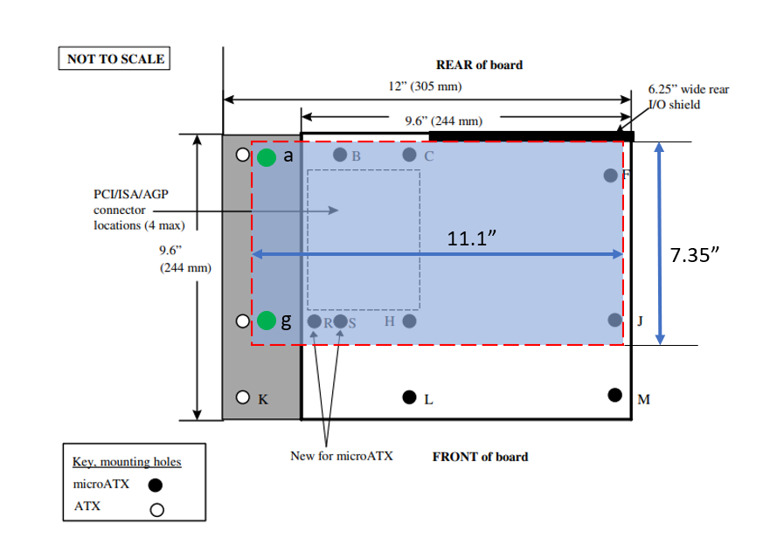

Figure 77: WCL RVP Form factor details

# Chrome Requirements

Chrome architecture varies a little from Windows architecture and Chrome teams need a mechanism to validate delta hardware requirements on the WCL RVP. Delta subsystems include,

* Chrome EC
* Audio
* Chrome security chip (Dauntless or Nuvotitan) TBD – Nuvotitan pending CCB.
* Chrome debug header SERVO
* TCSS Modular AIC
* Fingerprint sensor.
* Memory support
* SPINOR flash support

## Chrome EC support on WCL RVP

WCL RVP supports chrome requirements using Microchip EC on-board and MECC (Modular Embedded controller card) based EC AIC from different vendor like ITE, Nuvoton. EC to support many other features – WOV, TCPM, Integrated Sensor hub for sensor attach, TCSS PD controller, chrome keyboard device. These features are different from Windows EC.

Chrome EC AIC is the POR for enabling the Chrome EC on the MECC connector in WCL RVP. RVP also supports the Chrome EC part MEC1727N-B0-I/SZ-CHR0 on-board with some BoM changes for Chrome requirement.

Google security IC (GSC) and servo debug feature will be supported on the chrome RVP using the GSC AIC. GSC AIC on the RVP uses the 20-pin servo header and repurpose the TTK3 header. GSC AIC supports SMBUS based controller to support chrome keyboard validation.

Google security controller supported on WCL Chrome RVP is Nuvotitan controller (pending CCB approval) and chrome RVP use the Dauntless GSC AIC as fallback option.

A dedicated Chrome BOM SKU will be supported in **LP5x (RVP2)** SKU of WCL RVP to enable these features by default. Configuration support model planned for Chrome on WCL RVP as follow:

* Config 1: MECC EC AIC (ITE EC) + Nuvotitan GSC AIC + WCL M.2 TCSS module on two TCP ports. This config is POR for chrome and the BKC lead SKU.
* Config 2: onboard EC(Microchip) + Nuvotitan GSC AIC + WCL M.2 TCSS module on two TCP ports. This config is POC for chrome.

**Note:** Chrome requirements have slight changes and are yet to be confirmed. This section might have some modifications once confirmed from Chrome team.

High level block diagram for Chrome from RVP side is shown below.



Figure 78 : Chrome support High Level block diagram with MECC AIC based Chrome EC

## GSC-Servo AIC

GSC-Servo AIC is designed based on Nuvotitan GSC security chip and a fallback option provided with Dauntless AIC. This AIC includes,

* Chrome security chip: It communicates with EC & AP over I2C (SPI is provided as optional) and does following features.
* Reset functions
* Closed case debugging
* Verified boot
* Security features
* Battery cutoff
* Servo header:
* Access UARTs of EC, CPU, ISH, TPM, PD
* Flashing firmware like EC, Coreboot, PD, TPM
* Access device GPIOs like power button, cold reset, warm reset, volume buttons, keyboard pins, lid, etc
* SMBUS companion IC and keyboard connector to support chrome keyboard validation.

TTK3 & H1 connector pinout details are shared over [Link](https://intel-my.sharepoint.com/personal/ccgmtlclientsystempdt/ArchLZPRD/MTL_M_P_RVP_Architecture_HAS/GPIO_Mappin_SoC_EC/2021_Chrome_TTK3_H1_Servo_Mapping_MTL_Rev0p8.xlsx?d=wb88e2dd93c90457ebd8cd4be461ba09f)

Table 95: TTK3 & H1 Connector

|  |  |  |
| --- | --- | --- |
| MFG | Mfg. Part Number | IPN Number |
| Samtec | ASP-203744-03 | K18833-001 |
| Samtec | ASP-159358-09 | G25403-004 |

## Chrome USB-C support

WCL Chrome planned to support M.2 Modular AIC on two ports. TCSS module details are provided in link <https://goto/tcssmodule>

TCSS module is supported to enable the Type C on Chrome WCL RVP. TCSS module consists of PD controller, retimer, USB C connector on-module. SBU mux shall be added on this AIC for considering SBU signals for DP/debug alternate modes. There is no PD AIC support on Chrome WCL RVP SKU. Total of 3 I2C’s are provided on RVP to support TCP0, TCP1 module enablement for Chrome. Refer to chrome EC I2C mapping block diagram for TCSS support.

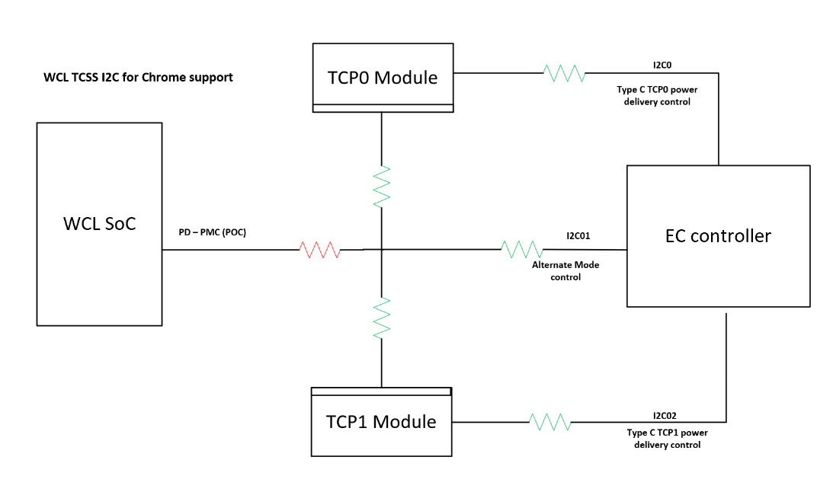

Figure 79 : Chrome EC I2C mapping block diagram for TCSS support.

The chrome CCD debug is supported on the TCSS module for TCP0 only. To support Chrome CCD functionality, PD controller internal Mux is used to route SBU signal to GSC controller based on debug cable detection and CCD_MODE_ODL signal from PD GPIO will be trigger from PD to EC and GSC controller indicating CCD cable detection to GSC and EC.

An external 2:1 SBU mux shall be provided on the Motherboard to support Chrome CCD mode or the I3C debug.

Below block diagram shows the WCL USB-C TCSS Chrome support.



Figure 80 : WCL Chrome CCD support.

## Fingerprint Sensor

WCL RVP supports chrome FPS requirement by repurposing the existing FPS header. For Windows configuration USB2 will be the default interface supported on FPS. Test points on the RVP FPS connector are repurposed to enable the chrome requirement. Chrome use the SPI based interface to enable the chrome specific FPS module over adapter card which will be plugged to FPS connector on RVP end.

* 1. TCH_SPI port 1
  2. Few WCL SOC GPIO’s
  3. WP_ODL, User_presence and UART from GSC connectors.

Below is the Block diagram.



Figure 81: WCL Chrome FPS support

## Memory Support

The Chrome WCL RVP supports DDR5 memory on WCL RVP1 which is only in ERB and LP5x Solder down memory on WCL RVP2 which is Chrome RVP lead SKU. Chrome LP5x socketed memory SKU will used different memory part than RVP. The Chrome WCL RVP SKU memory configuration support would be as follows.

Table 96: Memory Module Supported on Chrome RVP

|  |  |  |  |  |  |  |  |
| --- | --- | --- | --- | --- | --- | --- | --- |
| **Memory Type** | **Package** | **Manufacturer Part Number**  **(Intel Part Number)** | **iPOR Speed**  **(MT/s)** | **ePOR Speed**  **(MT/s)** | **Module/**  **DRAM density** | **Memory Config** | **Mfg** |
| DDR5 | SODIMM | ​ MTC4C10163S1VC64BD1 | 7200 | 6400 | 8GB | 1R x16 | Micron |
| LPDDR5x | DDP 315b | H58G56BK8BX068 | 8000 | 6800 | 4GB | 1R x16 | SK Hynix |

## SPINOR Flash support.

Chrome RVP has the requirement of QUAD IO and #WP signal support in their flash SPINOR chip. Chrome use different SPINOR 32MB W25Q256JWEIM which has Write protect (WP) feature.

Chrome has the requirement to protect firmware by disabling the write access to SPINOR and EC internal EEPROM. GSC and SoC can disable the write access to SPINOR and the #WP signal design implementation is shown in below block diagram.



Figure 82 : WCL SPINOR #WP control implementation.

## Chrome TCSS Module support.

Below TCSS Module cards are supported for Chrome in RVP1 and RVP2.

Table 97 : WCL CHROME RVP’s TCSS Type-C and display port configuration

|  |  |  |  |
| --- | --- | --- | --- |
| **Silicon Interface** | **Platform config requirement**  **(all inputs)** | **RVP1: WCL - T3 PCB - DDR5 SODIMM** | **RVP2: WCL - T3 PCB - LP5x MD** |
| TCP0 MB Short length | Type C USB4.0 / Thunderbolt Support Options- 1. TBT4 40G w/ single re-timer 2. USB4 20Gbps with single re-timer 3. USB4 20Gbps re-timer less (includes USB3/DP) 4. USB3/DP(HBR3) retimerless 5. TBT4 40G w/ Dual re-timer 6. TBT4 40G w/ cable topology 7. Discrete Barlow Ridge - Native DP2.1 UHBR20 retimerless FFC. 8. TypeC Port - USB/DP- 3rd Party 9. Type-A Con USB 3.2 Gen2 x1 10G without Redriver (form TCSS) | **Config 1:** M.2 Modular TCSS: USB-C Retimer Module.(Gothic Bridge Retimer) | **Config 1:** M.2 Modular TCSS: Third Party, Type C port - USB3/DP2.1 (HBR3) – Retimerless  (Third party - Texas instrument) |
| **Config 2**: M.2 Modular TCSS - TBT 40G Single Re-Timer. (Single Retimer HBR)  Realtek PD – TCSS 106 Module | **Config 2:** M.2 Modular TCSS - TBT 40G Single Re-Timer. (Single Retimer HBR )  Realtek PD – TCSS 106 Module |
| **Config 3:** M.2 Modular TCSS: TBT 40G Single Re-Timer. (Gothic Bridge Retimer) |
| TCP1 MB Long Length | **Motherboard Down** Type C port - TBT 40G Single Re-Timer. (Single Retimer GBR Motherboard down) | **Config 1:** M.2 Modular TCSS: Third Party Redriver - USB3/DP 2.1 (HBR3)(Third party - Texas instrument) |
| **Config 2:** M.2 Modular TCSS - TBT 40G Single Re-Timer.(Single Retimer HBR)  Realtek PD – TCSS 106 Module |
| **Config 3:** M.2 Modular TCSS: TBT 40G Single Re-Timer.(Gothic Bridge Retimer) |

# Regulatory & Product Ecology

The following items must be satisfied to meet regulatory and ecology requirements for the WCL RVP.

* An unauthorized device label needs to be attached/tied to the RVP board at the factory. Intel part number K21553-005 (or later) should be used.
* A safety flyer must be shipped with the RVP board. Intel part number N60435-001 should be used and the flyer should be included in the packaging box of RVP board.
* Review batteries (including coin cell) being shipped/used with the RVP for proper shipping and safety compliance. The following certificates should be obtained in cooperation with SSC (MSO): UN38.3/MSDS/1.2m drop, CSTCG (Dangerous good), CB (IEC62133), UL1642, REACH SVHC, and EU battery directive. Please refer to DocLocator document “Battery Selection and Approval Procedure” [DL-0002566](https://doclocator.intel.com/?ID=05E2F93A38D044A8AF962E352E24369D&Dir=Objects&preview=1) (legacy SNAP 227-0029), for details.
* Review power supply being shipped/used with the RVP for safety and energy efficiency compliance in the region it is being shipped. For previous RVPs, power supplies with NRTL certification and US Dept. of Energy Level VI efficiency rating have been used. Please refer to DocLocator document “Mains Connected Power Supply Selection and Approval Procedure” [DL-0002565](https://doclocator.intel.com/?ID=F8354A5602B34C8597713300842C2C85&Dir=Objects&preview=1) (legacy SNAP 227-0028), for details.
* Intel Pre-lease Loan Agreement (IPLA) “One Pager” must be shipped with the RVP board. It communicates the important legal information about the DV to customer. Intel part number M21973 should be used and included in the packaging box of RVP board.
* When shipping with a battery, there needs to be a battery warning label on the packaging. Li Metal Battery Warning Label (including coin cell if shipped from China): IPN: J72126-004 and/or Li Ion Battery Warning Label: IPN: J72128-004.
* The RVP BOM needs to be reviewed and undergo a risk assessment by a Product Ecology Engineer and given a ship approval. The results will be documented in the product regulatory plan.
* Ecology labeling needs to be attached to the packaging to show compliance to CA perchlorate requirements. Perchlorate label, (sample IPN: D85237-001), needs to be affixed to the packaging of the board containing coin cell battery shipping to CA. Please refer to DocLocator document [DL-0002372](https://doclocator.intel.com/?ID=3BF541B5FDC74026BBB252C5F6463494&Dir=Objects&preview=1) “Environmental Product Content Specification for Suppliers & Outsourced Manufacturers” (legacy SNAP 18-1201), 3.5 for details.
* Review components containing laser emitters for eye safety compliance before usage. shall follow distribution requirements outlined in the Laser Regulatory and Product Safety Requirements [DL-0002555](https://doclocator.intel.com/?ID=B91F24BE10E0498C9EE8B042F60461CC&Dir=Objects&preview=1) (legacy SNAP 227-0009).
* Review radio (Wi-Fi, WiGig, cellular, BT, NFC, etc.) components for regulatory staging and carrier access compliance in the regions it will be used in.
* Complete radiated emissions (EMI) scans to the limits of the regions it will be shipped to ensure no harmful interference (shall be performed with assistance from the PRE). A schematic and layout review for EMC and RF by PRE is recommended.
* Undergo a Safety Review by a qualified Product Regulations Engineer (PRE) or 3rd party certified safety testing organization and found to be "reasonably safe" as defined in the Intel Corporation “Product Regulations Methodology Specification”, [DL-0002650](https://doclocator.intel.com/?ID=5C489DB75539441EB16632E57D23BABC&Dir=Objects&preview=1) (legacy SNAP 227-GS0021). The criteria used for the safety review are based on the current version of “Information Technology Equipment - Safety”, IEC 62368 or other relevant product specific safety standard.

DocLocator documents can be found here:  
<https://doclocator.intel.com/>

# RVP Health DAC

## RVP Health DAC: A novel way to access remote hardware & accelerate debug

The product development life cycle is accelerating at fast pace and platform design complexity continues to increase exponentially. The platforms continue to evolve rapidly, to address aggressive schedules and products time to market goals. A reduced overall silicon development cycle warrants a faster and efficient validation environment. But root-causing platform failures in these circumstances becomes a huge challenge. Accessing and debugging remote deployed systems, becomes a big herculean task. In this challenging ecosystem, it’s extremely important to innovate efficient mechanisms for faster debug, to enable high quality validation and bug fixes.

RVP Health DAC (Debug Acceleration card) is a novel approach that facilitates faster remote debug monitoring & root cause of platform issues. It gives a completely new dimension to diagnostics, remote platform access and validation. It’s a pluggable kit solution, which reduces main platform design dependency. Thoughtfully designed as a scalable/reusable solution across big & small core products.

## RVP DAC (Debug Acceleration Card) Goal is to enable “Remote debug and accessibility” of deployed RVP to validation customers.

RVP Health DAC is based on Intel Altera based MAX10 FPGA (Field programmable gate array) for probing and processing of debug signals. Main goal of DAC (Debug Acceleration card) is to facilitate faster remote debug, monitoring, and root cause of issues. All these features are enabled via user friendly GUI (Graphical user interface).

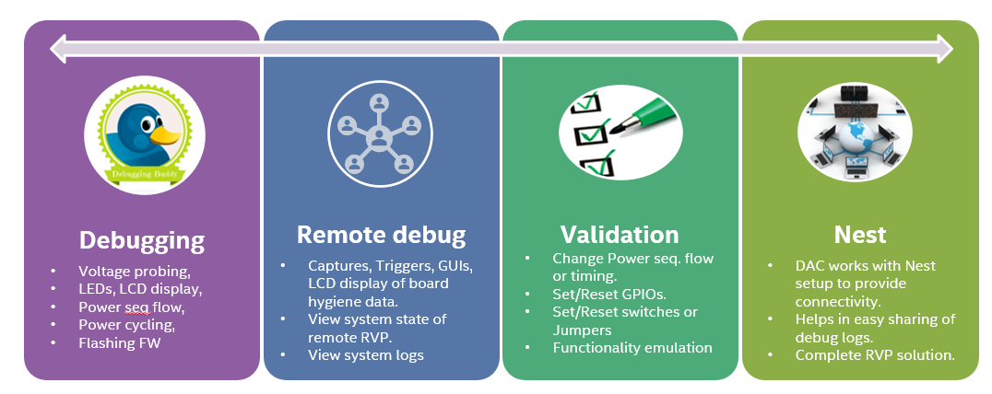

Figure 83 : Strategy for debug acceleration card

## The RVP Health DAC solution can be divided into two parts:

### Hardware Interface

The DAC (Debug acceleration card) does not need any special header to connect on RVPs.

The overhead is avoided by using existing headers to tap the signals from RVP to provide all the features. This salient unique feature of DAC makes it scalable across all the RVP segments of S, P, M and atom segment N too. There is a single custom designed 100-pin cable on DAC side for ease of connectivity. The HW unit is assembled and shipped in a chassis and a 100-Pin cable, AC-Brick adaptor is included in packaging box. All the soft collaterals and list of key contact are available at <https://goto.intel.com/rvpdac>.

The detailed block diagram of RVP Health DAC is as given below:

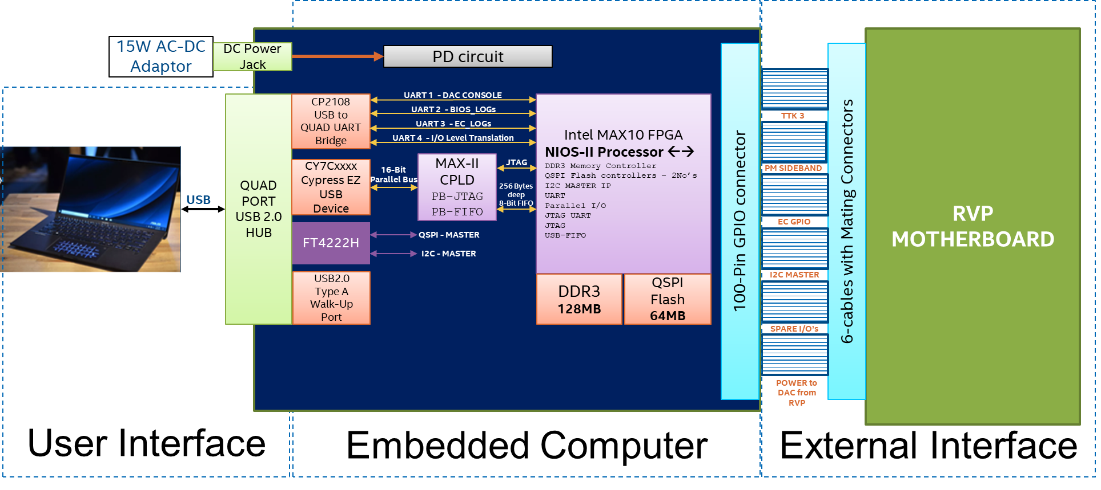

Figure 84 : RVP DAC Block Diagram

The RVP Health DAC snapshot is as given below:

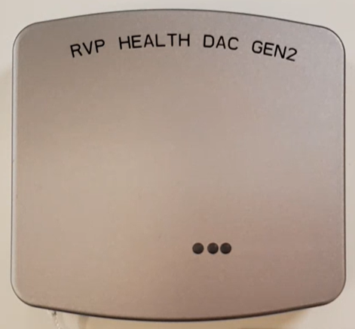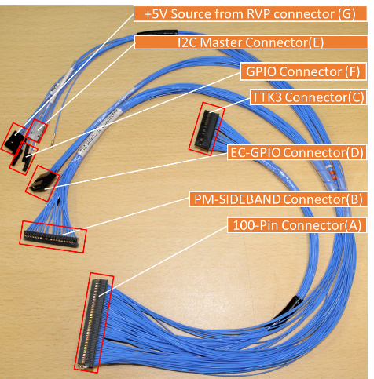

Figure 85 : Snapshot of RVP DAC with Cable

### Software interface

For the ease of debug for validation customers, instead of console command-based interface, DAC has been designed with simple, light weight Python based windows GUI application. Below picture of DAC GUI depicts the post code displayed in red, on right side. The console down shows the status of RVP boot and COM port detection. The power monitor shows the status of signals on RVP on successful DAC connection.

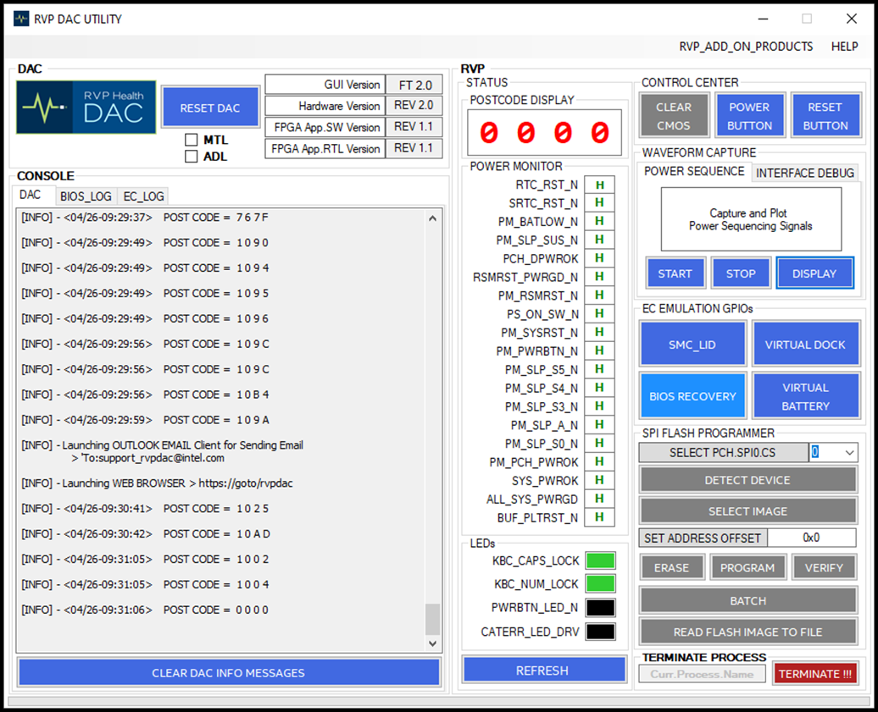

Figure 86 : Debug acceleration graphical user interface and features

Here are the main features that DAC supports -

* 1. **Communication between HOST and RVP DAC** over USB-UART
  2. **Reset the RVP DAC** from HOST
  3. **Configure RVP DAC** from HOST
  4. **Control RVP** power-button & reset-button
  5. **Interface RVP DAC to Target motherboard**
     1. **Clear CMOS** operation
     2. **Sniff and Display**

1. POST Codes over PORT 80
2. Num-Lock LED
3. Caps-Lock LED
4. CAT_ERR_LED
5. PWR_BTN_LED
   * 1. **Control EC Emulating GPIOs**
6. Lid Close/Open
7. Battery Charger Connect/Disconnect
8. Dock Connect/Disconnect
9. Set BIOS Recovery Mode ON/OFF
   * 1. **Read and Plot**
     + Power Monitoring signals
     + Interface debug signals
     1. **SPI FLASH Programming**
     2. **Read or Program PSS data <WIP>**
     3. **Capture and save debug Logs** over

* BIOS UART
* EC UART

**For more info on RVP Health DAC, please refer below links:**

Link to Intro video : [DAC_Introduction.mp4](https://intel-my.sharepoint.com/:v:/s/ccgcpecpsrvpdaconestop/EXbeSt-zbJxKpYFbl0m4h-YBjCnkmIYZaRULZLlh7Y92OQ?e=h4VAB7)

Link to User Guide : [RVP_DAC_UG_Gen2_REV1p0.docx](https://intel-my.sharepoint.com/:w:/s/ccgcpecpsrvpdaconestop/EX_dafmNq9lMlAKKDY8mw7cB-4BuboivaDIRY6f64SjFrg?e=k2CJ9y)

Link to I/O connector details : [M37690-001.xlsx](https://intel-my.sharepoint.com/:x:/s/ccgcpecpsrvpdaconestop/EYEyqsF2Aw9ChfTQQKhlnSQBcn8otcI-5rO2KDF6oXe8zA?e=fZevXW)

# UCP-SQUID

## Low cost, Multi-Protocol and Remote programming solution

Intel RVP motherboard is the primary validation hardware for Intel CPUs and these motherboards host various ROM devices that store the firmware required. During debug and validation there is frequent need for updating these components and validation engineers need to identify the programming dongle for the ROM device, install the software utilities and drivers, identify where and how to connect the external programming dongle to the motherboard and then proceed for programming.

Traditionally, updating firmware on to each programmable components on Intel RVP motherboard users require different external programming hardware based on the communication protocol supported by the component like SPI NOR Flash for BIOS, I2C EEPROMs for Retimer, PD-Controllers, Firmware Records Unit, Programmable Voltage Regulator Controllers etc., on motherboard and these hardware modules when left attached to motherboard they gate systems from boot.

UCP SQUID is one tool supporting programming over SPI, I2C, SWD and JTAG. It also has GPIOs that connect to Front Panel HDR of RVP and help to get or set the system states. UCP SQUID also has tiny paddle boards and cables designed for needs of Intel RVPs as part of Hardware KIT. The paddle boards host FET devices which enable for systems to boot with UCP SQUID programmer connected to the platform, thus enabling the remote programming hardware tool for Validation teams.

A GUI software package to be installed on HOST PC that can identify the Intel RVP model name, List the reference designators of programming headers, and allows users to program each component individually or all devices in a single click of button. It also allows seamless integration to automation setups through APIs developed in Python, C#, and C++.

With UCP-SQUID **cost savings of about 75%** can be achieved by replacing the multiple programming hardware tools with single hardware module and GUI software significantly reduces time and effort of the users in identifying the ref.des of programming headers on motherboard, identifying the right programming dongle and Installation of each tool’s software and drivers.

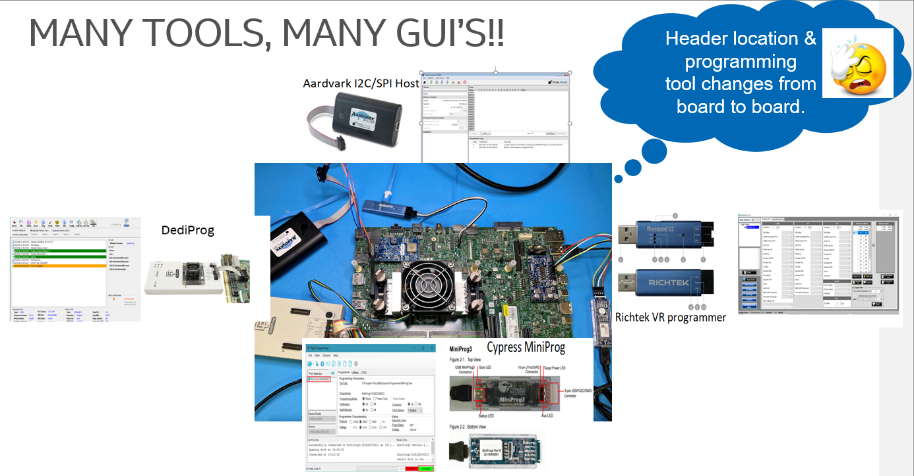

Figure 87 : RVP Eco System: UCP SQUID

Current day changes to work models such as Hybrid / Remote increase the need for remote access to hardware and the current day third party programming tools limit this functionality as they are not system state aware and gate the SUT to proceed for boot. This problem is partially address by In-System programming approach by software, but they are dependent on functional status of hardware.

## Solution

UCP (Universal Configurable Programmer) is the vision of Platform and Systems Engineering RVP (CCG-CPS-CPE-PSE-RVP) Team to address the problem statement and is realized using the SQUID Hardware developed by Intelligent Validation Tools Engineering Team(iVE-IDC).

|  |  |  |  |  |
| --- | --- | --- | --- | --- |
| **UCP - VISION** | + | **SQUID HARWARE** | = | UCP-SQUID |
|  |  |

Figure 88 : UCP-Solution

### Hardware

UCP-SQUID is a Micro-Controller based hardware that can support programming of up to 7-SPI Devices, 4 – I2C Devices, 3 – SWD Devices and 1 JTAG Interface port. It is connected to HOST as a USB device and the device and using the cables specifically developed for the requirement are used to connect to programming headers on the DUT. For the solution to system state aware a 2x3 pin header is provided on the hardware which can be cabled to Front Panel of the RVP to control the power button, reset button, and get the system power status. The Paddle boards mentioned in the Kit items host a FET isolation circuit that will allow to disconnect the programming cable connection load on to the RVP traces when not in use. Thus, enabling true remote programming operation for the system under test.

#### Block Diagram

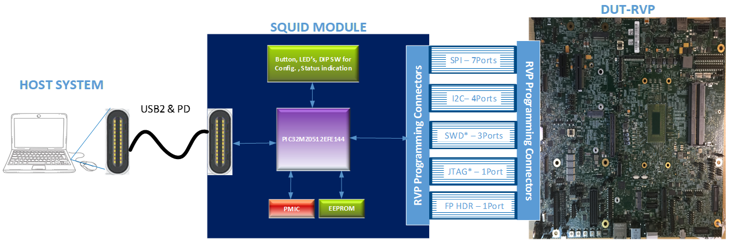

Figure 89 : UCP-Block diagram

#### Kit-Items

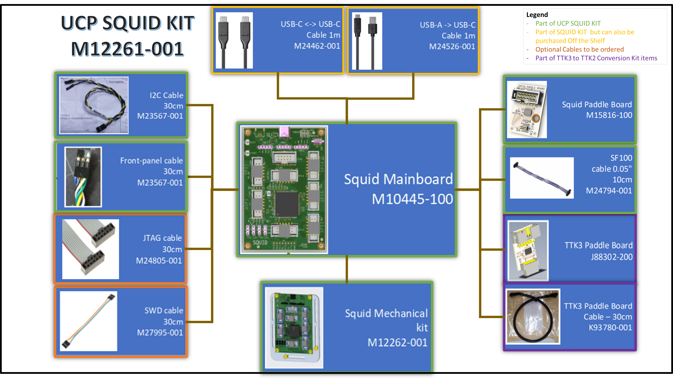

Figure 90 : UCP-Kit item

### Software

UCP-SQUID can be accessed through HOST PC either in API mode or GUI utility. The GUI utility automates scan for SQUID USB devices connected at launch and upon successful detection proceeds to identity the RVP Motherboard model by accessing the RFID/I2C Tag EEPROM chip on the motherboard. Once the detection is successful it lists all the programmable ref.des header on the platform from which user can select choice of device then select the firmware image to programmed or request to readback content of the ROM device to file

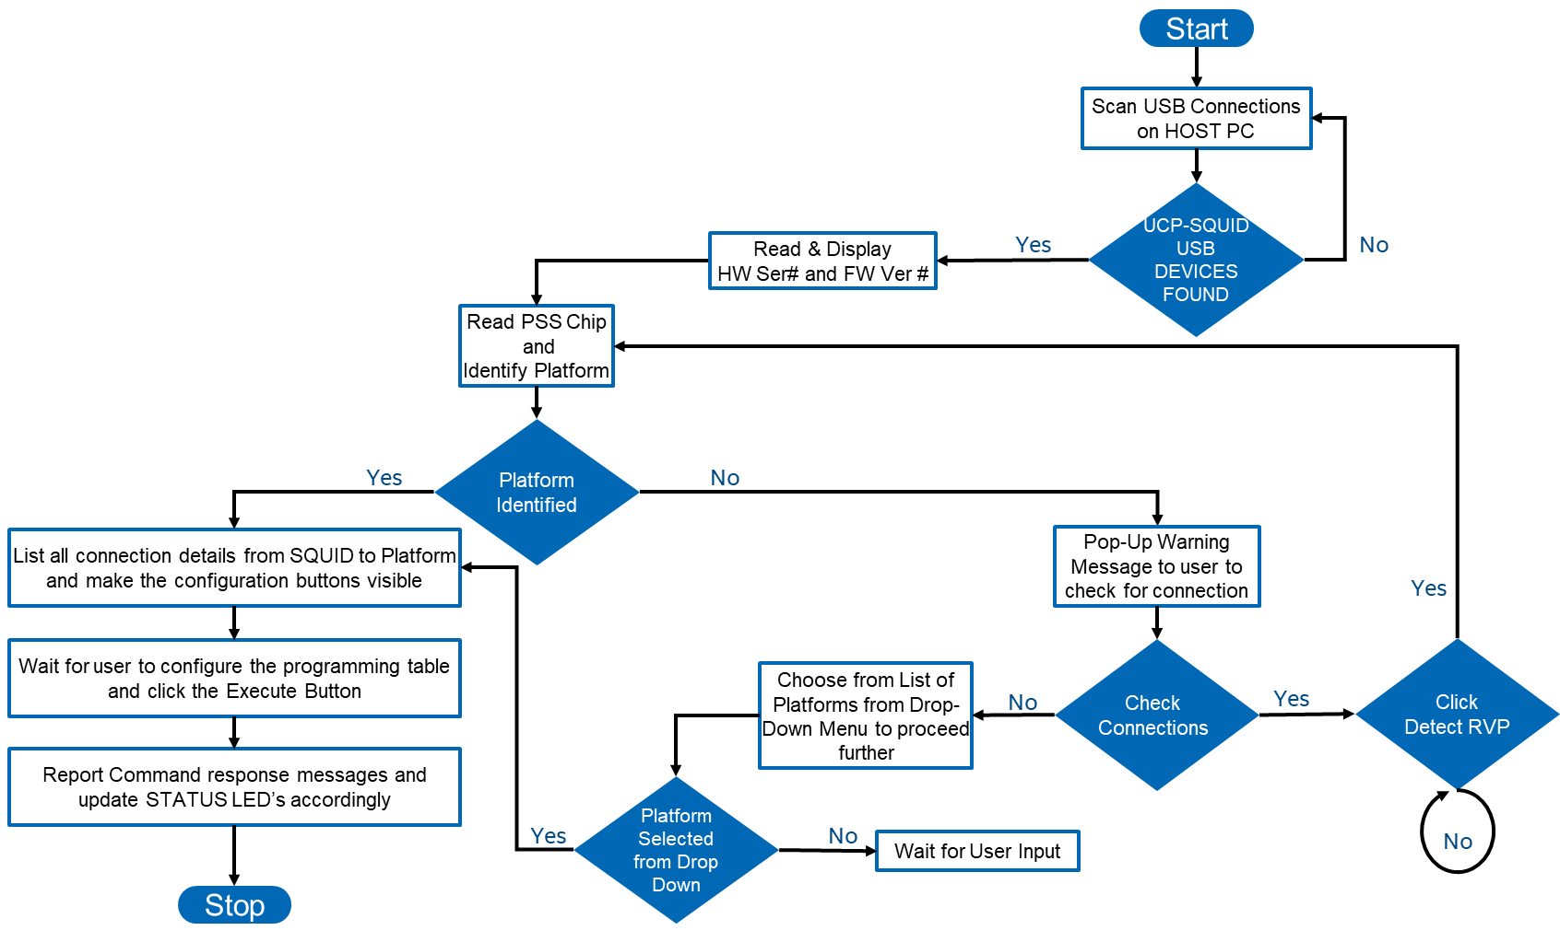

Figure 91 : UCP-SW flow

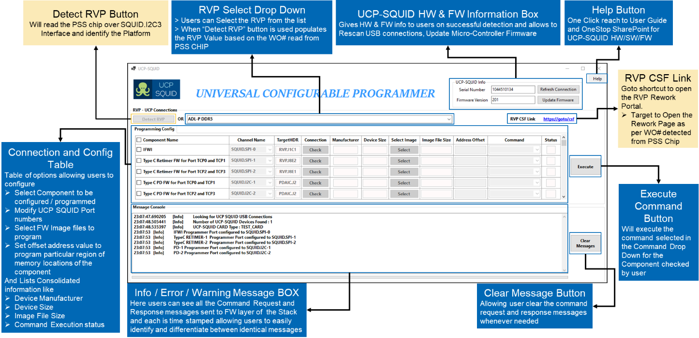

Figure 92 : UCP-GUI

## Cost of Solution

Today the solution is priced at $ 250 including all required ingredients. However, we are working on a “low-cost” reduced version of SQUID. The final price should be defined soon.

More details about UCP SQUID can be accessed at below link:

1. [UCP_SQUID_Abstract_Demo.pptx](https://intel-my.sharepoint.com/:p:/s/ccgcpecpsrvp-UCP_SQUID/Edltybsz7_9MtUMPnKJBkbQBlhuvZU9hDzNMKZx6WVuUUA?e=M3iKxH)

|  |  |
| --- | --- |
| **PLATFORM VALIDATION SETUP WITHOUT UCP SQUID** | **PLATFORM VALIDATION SETUP WITH UCP SQUID** |
|  |  |

Figure 93 : SNAPSHOT OF UCP SQUID SETUP

# RVP NEST

## Introduction

RVP NEST is a remote access farm hosted and maintained by RVP Team. Goal of RVP NEST is to enable early access to platform for the RVP users. RVP NEST gives the in-lab user experience and allows to remotely control the RVP by logging-in through Host PC.

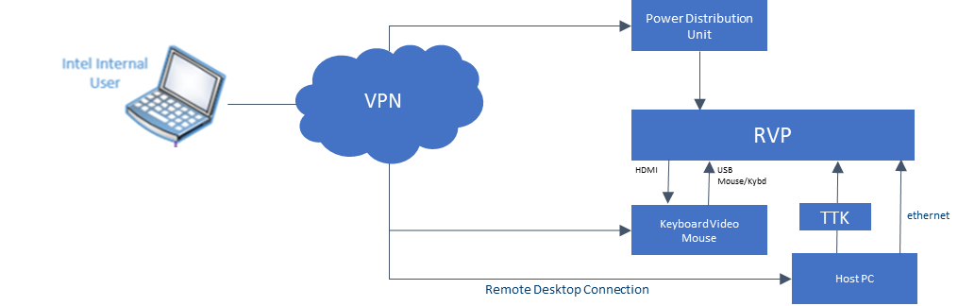

Figure 94 : RVP NEST Connection diagram

By default, each setup has dedicated host in which KVM, IFWI flashing tool (e.g. TTK3 or DAC or UCP), BIOS serial cable, G3 Cycling support through IP PDU connected to RVP. On need basis, we shall support

1. Setups can be made fully loaded GC or DC configs
2. ITP-XDP debug tools shall be connected
3. Flexible to any OS (Ubuntu/Centos/SVOS) on SUT
4. Peripherals/3PE shall be connected
5. Debug Acceleration Card (DAC) can be connected to platform, UCP, CBS
6. Support post PRQ
7. Optional/Feature Reworks will be supported

For more details on the RVP Nest User Guide, please visit the below wiki link:

<https://goto.intel.com/rvpnestwiki>